Report: Short-term wind prediction using ALADIN and Prediktor

Author: Kristian Horvath, PhD
Host: Dr. Gregor Giebel, RISOE DTU
Funding: The WINDEX project (www.windex.hr)

Work performed during research stay at RISOE: 10 May – 16 June

1. Introduction

Nowadays short-term prediction of wind speed (up to 72 hours) typically utilizes a mesoscale numerical weather prediction (NWP) models, such as ALADIN, HIRLAM, WRF, MM5, LM and others. These models are normally run on horizontal grid resolutions from 2 km – 10 km and provide reliable wind speed/power forecasts at scales they are designed for. However, that they don’t account for sub-grid scale wind varability, apart from the parametrizations related with PBL, and therefore are only partially adopted to site-specific wind forecasting for wind farms, especially over the complex terrain. One way to resolve this problem is to run the models at higher resolution – however – running these models at ~100 m scales in operational forecasting is yet not an undertaken challenge. The other, currently more feasible ways, include some kind of statistical, physical or statistical-physical forecasting method. Model output statistics (MOS) is one of the common statistical methods. Besides MOS, RISOE’s software Prediktor utilizes orographic model (besides roughness and obstacle models) for producing the local wind speed effects due to orography. Therefore, Prediktor is combined statistical-physical wind forecasting software, based on mesoscale NWP output.
The primary goal of the research stay is to test the Prediktor model for 2 case sites in complex terrain of Croatia, including testing the statistical and physical modules separately.

2. The short descriptiption of the Prediktor model

The Prediktor model roughly consists of the following:

- Input – mesoscale model output
- Horizontal refinement – orographic flow and roughness models
- Model output statistics
- Wind Turbine power output
- Output - wind Power

Therefore, Prediktor consists of the 3 main modules. The horizontal refinement based on the orographic flow model utilizes the potential flow equations to solve the differential equations in the area (typically 10 km x 10 km). This means that the solutions are dependant only on the properties of the terrain and not the atmospheric properties. This is a linearized model that is unable to produce some of the phenomena relevant in complex terrain, such as flow separation, gravity waves, gravity wave breaking etc., but is extremely efficient. The level of terrain complexity where solutions start to significantly differ from the true ones is often considered for slopes of 0.3 and higher. Second, roughness model is used to account for the changes in roughness and its influence on the wind speed and direction that are not resolved by the background mesoscale model roughness lower boundary condition. This part of the analysis is done within the framework of WaSP.

Than, model output statistics is applied, often for combined effect of wind speed and wind power. There are several MOS types available:
A. The standard MOS (mostype0):
PowerPred = aMOS + Pow(bMOS * sectMOS * localWind)
B. A 1st variant of the MOS (mostype1):
PowerPred = aMOS + Pow(bMOS * localWind + sectMOS)
C. A 2nd variant of the MOS (mostype2):
PowerPred = aMOS + bMOS * Pow(localWind * sectMOS)
D. A 3rd variant of MOS without offset (mostype3):
PowerPred = aMOS * Pow(bMOS * localWind + sectMOS)

PowerPred is the predicted Power, aMOS, bMOS and sectMOS are the overall and sectorwise MOS parameters, and localWind is the result of the physical considerations coming from the NWP wind and scaling it to hub height, using the WAsP correction matrix for orographic flow effects. If power curve is linear, the whole system is linear as well. The optimal parameters are sought with an iterative downhill simplex alghoritm, based on the minimization of mean absolute error. This is controlled by coded convergence criteria or maximum number of iterations.

In short, the Prediktor software requires Java (and some additional Java libraries), Jython (Phython interpreter for Java) and WaSP.

3. Description of experiments

As a NWP output, we used ALADIN/HR (a Croatian version of the ALADIN model) full physics model runs at 8 km resolution and ALADIN/HR dynamical adaptation to 2 km grid resolution for 2 stations: Pometeno brdo, in the hinterland of Split, and Split Marjan. Available measurements included 10-min wind speed and direction at 60 m AGL at Pometeno brdo and 10-min wind speed and direction at 10 m AGL at Split Marjan. Both data was available during the period 1.9.2008.-31.8.2009. The model data was run daily, and forecast horizons from +6 to +30 were extracted for the study. 4 nearest point were selected for analysis, both for ALHR and HRDA datasets (an example for the station Split Marjan is shown on Fig. 1). The prediction consisted of 2 main steps:
- applying the WaSP the get orography and roughness effects (for that purpose roughness maps needed to be created in WaSP Map Editor)
- Running Prediktor with a pre-set convergence criteria (mos.getAmoeba().ftol = 3E-4) or a maximum of 1250 iterations.
The analysis of results included the analysis of: mean absolute error, root-mean square error, mean error, correlations, decomposition of RMSE, prediction skill score, time lagging and comparison to persistency. The main results shown here describe the amplitude (lower bound and upper bound for all forecast ranges) of mean absolute error, since this is the quantity actually minimized. Decomposition of RMSE follows:
RMSE² = BIAS² + SDE²
RMSE² = BIAS² + STDBIAS² + DISP²
where BIAS := e, SDE := σ(e),
STDBIAS := σ(upred) - σ(umeas) and
DISP := sqrt[2σ(upred)σ(umeas)(1- r_{p,m})]
with r_{p,m} denoting the cross-correlation coefficient between the two time series and σ(upred) and σ(umeas) their standard deviations, respectively. The BIAS accounts the systematic difference between the prediction and the measurement. The SDE measures the fluctuations of the error around its mean (the BIAS) and has two contributors: i) The STDBIAS is the difference between the standard deviations of u(pred) and u(meas) evaluating errors due to wrong predicted variability. The STDBIAS together with the BIAS indicate amplitude errors which are typically related to site specific effects. ii) The dispersion, DISP, involves the crosscorrelation coefficient weighted with both standard deviations. Hence DISP accounts for the contribution of correlation (“phase”) errors to the RMSE, reflecting global properties of the prediction system.

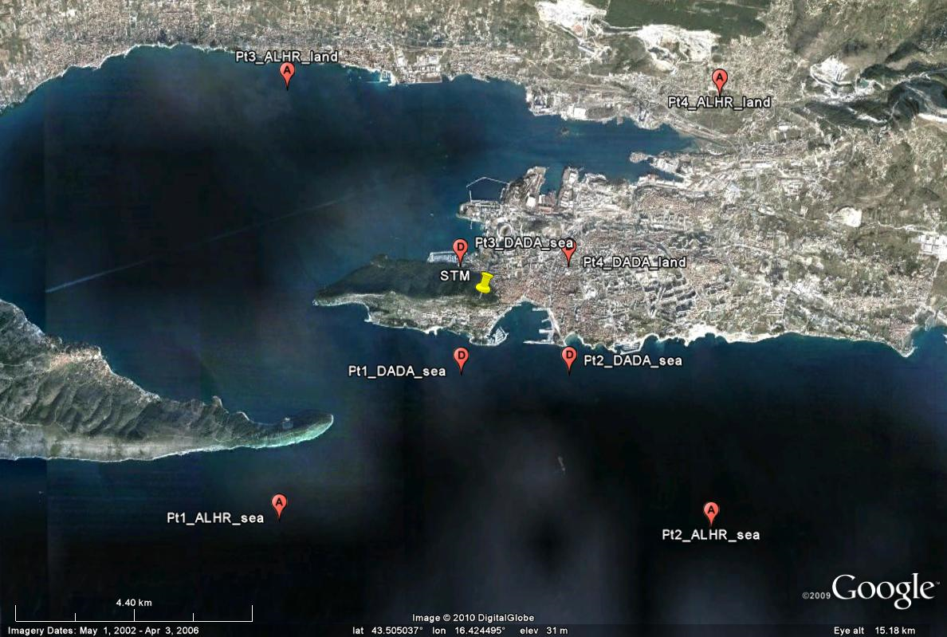
Figure 1: Location of the Split Marjan station (yellow mark), 4 surrounding model points from the ALHR model (red marks denoted “A”) and HRDA model (red marks denoted “D”). Description of each point specifies whether in the model it is over the sea or land. The same framework was used for the location of Pometeno brdo.
4. Results

4.1. The case study of Pometeno brdo

The main results shown here describe the amplitude (lower bound and upper bound for all forecast ranges) of mean absolute error, since this is the quantity actually minimized. Results for experiments for mostype 0 for ALADIN/HR model input at 8 km resolution (ALHR), and no sectMOS parameters – thus no dependency on wind sector – are shown on Table 1. The orography and roughness effects (in this case none since roughness is mostly uniform throughout the calculation domain) as diagnosed by WaSP (Table2) show orographic speed-ups over 50%. The sensitivity experiments included full orographic effects, as well as 50% and 75% or the values. It is evident that MOS reduces the model error for roughly 10-20%. The application of speed-up effects also reduces the model error as well as the subsequent use of the of MOS. However, compared to MOS without the speedup, there seems to be no significant difference. The best results are achived for point 3, which is the model point the closest to the very location of Pometeno brdo.Figs. 2 and 3 show an example of errors for NOSPEEDUP experiment and RMSE decomposition. While the first shows a clear improvement in statistical scores, the second indicates that the greatest part of the error comes from the phase errors.

Table 1: Mean absolute errors without MOS (NOMOS) for NOSPEEDUP (direct model output), 50%, 75% and 100% speedup as diagnosed by WaSP and with mostype0 for station Pometeno brdo.
Mostype0 | NOSPEED-UP |  | 50% SPEEDUP |  | 75% SPEEDUP |  | 100% SPEEDUP
PT | NOMOS | abMOS | NOMOS | abMOS | NOMOS | abMOS | NOMOS | abMOS
1 | 2.2-2.7 | 1.95-2.15 | 2.05-2.4 | 2.0-2.2 | 2.1-2.4 | 2.0-2.2 | 2.15-2.5 | 2.05-2.25
2 | 2.35-2.85 | 2.0-2.2 | 2.15-2.55 | 2.05-2.25 | 2.15-2.45 | 2.05-2.25 | 2.15-2.45 | 2.1-2.3
3 | 2.2-2.8 | 1.8-2.15 | 1.95-2.45 | 1.85-2.15 | 1.95-2.4 | 1.8-2.15 | 2.0-2.4 | 1.8-2.15
4 | 2.35-2.85 | 1.9-2.15 | 2.05-2.5 | 1.85-2.2 | 2.0-2.45 | 1.9-2.15 | 2.05-2.45 | 1.9-2.3

Table 2: Speed-up effects for the location of Pometeno brdo. Wind sectors are 30 degrees wide.
Sector | Sector | Roughness | Roughness | Roughness | Obst. | Orography | Orography | Orography
# | a [°] | ch | ref. [m] | sp [%] | sp [%] | sp [%] | tu [°] | RIX
1 | 0 | 0 | 0.15 | 0 | 0 | 27.43 | 8.8 | 2.5
2 | 30 | 0 | 0.15 | 0 | 0 | 46.51 | 5.8 | 17.4
3 | 60 | 0 | 0.15 | 0 | 0 | 51.75 | -1.7 | 10.1
4 | 90 | 0 | 0.15 | 0 | 0 | 39.15 | -8 | 6.8
5 | 120 | 0 | 0.151 | 0 | 0 | 18.9 | -7.2 | 2.1
6 | 150 | 0 | 0.151 | 0 | 0 | 12.13 | 2.4 | 7.6
7 | 180 | 0 | 0.151 | 0 | 0 | 27.44 | 8.8 | 8.8
8 | 210 | 0 | 0.151 | 0 | 0 | 46.53 | 5.8 | 7.6
9 | 240 | 0 | 0.151 | 0 | 0 | 51.77 | -1.7 | 2.6
10 | 270 | 0 | 0.15 | 0 | 0 | 39.15 | -8 | 0
11 | 300 | 0 | 0.15 | 0 | 0 | 18.89 | -7.2 | 0
12 | 330 | 0 | 0.15 | 0 | 0 | 12.13 | 2.4 | 0.8
All |  |  |  |  |  |  |  | 5.5

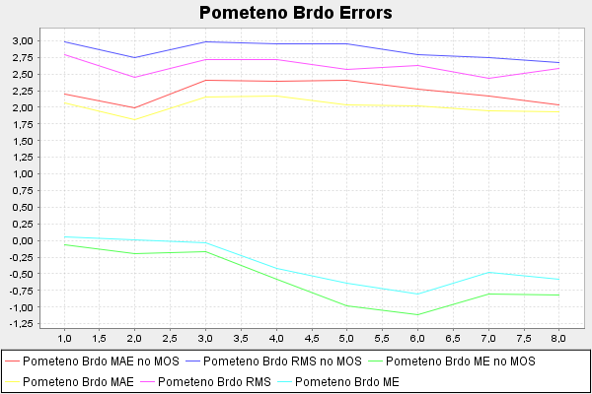
Figure 2: MAE, RMSE, ME at Pomteno brdo for ALHR model input and NOSPEEDUP for point 3.

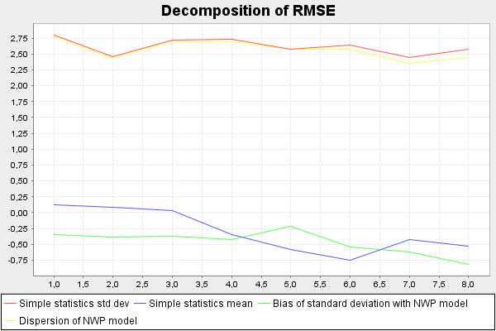
Figure 3: Decomposition of RMSE at Pomteno brdo for ALHR model input and NOSPEEDUP for point 3.

Furthermore, the sectMOS parameters were used in minimization of MAE, resulting in sector dependent bMOS parameter. The results for the best point (3) are shown in Table 3.

Table 3: The mean absolute error with sectMOS dependency for mostype 0 with ALHR model as input and different orographic speed-up influences.

< NO SPEED-UP >
NOMOS_1 | MOS_1 | MOS_2 | MOS3 | AVGMOS
2.2-2.8 | 1.8-2.4 | 1.8-2.25 | 1.8-2.05 | 1.8-2.25
< WITH SPEED- UP >
NOMOS_1 | MOS_1 | MOS_2 | MOS3 | AVGMOS
2.0-2.4 | 1.75-2.3 | 1.8-2.25 | 1.8-2.3 | 1.8-2.3
< WITH 50% SPEED- UP >
NOMOS_1 | MOS_1 | MOS_2 | MOS3 | AVGMOS
1.95-2.45 | 1.8-2.1 | 1.75-2.2 | 1.75-2.35 | 1.75-2.3
< WITH 75% SPEED- UP >
NOMOS_1 | MOS_1 | MOS_2 | MOS3 | AVGMOS
1.95-2.4 | 1.75-2.65 | 1.8-2.1 | 1.75-2.4 | 1.75-2.4

First, the deterministic result is no more preserved. It is however not clear why the convergence is reached at sometimes very different MAE values. For each setup and each point 3 different experiments were performed, and results averaged. A comparison with no MOS dependency on the sectors shows no improvement had been achieved. This unfavorable results might be due to the fact that in mostype0, aMOS corresponds to offset and bMOS to the tilt of the line. Therefore, any dependency of the offset on the wind sector, which seem reasonable for the region e.g. considering bora and jugo flows, might diminish the results of the current sector dependency of the mostype0 formulation.

Equivalent results for ALHR model input and mostype3 are shown below. Table 4. shows statistical scores of the model output are not improved by model output statistics performed with no respect to sectors – indeed, the results are significantly worse no matter whether there is a speed up or not.

Table 4: Mean absolute errors without MOS (NOMOS) for NOSPEEDUP (direct model output), 50%, 75% and 100% speedup as diagnosed by WaSP and with mostype3.
Mostype3 | NOSPEEDUP |  | 50% SPEEDUP |  | 75% SPEEDUP |  | 100% SPEEDUP
PT | NOMOS | abMOS | NOMOS | abMOS | NOMOS | abMOS | NOMOS | abMOS
1 | 2.2-2.7 | 2.65-3.0 | 2.05-2.4 | 2.7-3.05 | 2.1-2.4 | 2.65-3.05 | 2.15-2.5 | 2.7-3.05
2 | 2.35-2.85 | 2.6-2.95 | 2.15-2.55 | 2.65-3.0 | 2.15-2.45 | 2.65-3.05 | 2.15-2.45 | 2.7-3.05
3 | 2.2-2.8 | 2.6-2.9 | 1.95-2.45 | 2.65-3.0 | 1.95-2.4 | 2.7-3.0 | 2.0-2.4 | 2.7-3.05
4 | 2.35-2.85 | 2.55-2.95 | 2.05-2.5 | 2.6-3.0 | 2.0-2.45 | 2.6-3.0 | 2.05-2.45 | 2.6-3.05

The opposite results are present when introducing the sector dependency (bMOS only) – here shown in Table 5 for one of the two points with the least MAE, point 4 (point 3 is equally good). The results are significantly improved compared to the model output. Nevetheless, the comparison with the mostype0 suggests no relevant differences between the two.

Table 5: The mean absolute error with sectMOS dependency for mostype 3 with ALHR model as input and different orographic speed-up influences.
< NO SPEED-UP >
NOMOS_1 | MOS_1 | MOS_2 | MOS3 | AVGMOS
2.35-2.85 | 1.75-2.25 | 1.85-2.3 | 1.8-2.4 | 1.8-2.3
< WITH SPEED- UP >
NOMOS_1 | MOS_1 | MOS_2 | MOS3 | AVGMOS
2.05-2.45 | 1.8-2.45 | 1.8-2.15 | 1.85-2.2 | 1.8-2.25
< WITH 50% SPEED- UP >
NOMOS_1 | MOS_1 | MOS_2 | MOS3 | AVGMOS
2.05-2.5 | 1.8-2.2 | 1.8-2.2 | 1.8-2.15 | 1.8-2.2
< WITH 75% SPEED- UP >
NOMOS_1 | MOS_1 | MOS_2 | MOS3 | AVGMOS
2.0-2.45 | 1.8-2.85 | 1.85-2.5 | 1.85-2.4 | 1.85-2.6

The second source of model output data is the result of the so-called dynamical adaptation to 2 km resolution with a simplified model version (HRDA). The respective results for mostype0 are shown in Table 6.

Table 6: Mean absolute errors without MOS (NOMOS) for NOSPEEDUP (direct model output), 50%, 75% and 100% speedup as diagnosed by WaSP and with mostype0 for HRDA model results.

mostype0 | NOSPEEDUP |  | 50% SPEEDUP |  | 75% SPEEDUP |  | 100% SPEEDUP
PT | NOMOS | abMOS | NOMOS | abMOS | NOMOS | abMOS | NOMOS | abMOS
1 | 2.2-2.85 | 1.9-2.05 | 2.05-2.5 | 1.85-2.1 | 2.05-2.55 | 1.9-2.1 | 2.15-2.6 | 1.9-2.15
2 | 2.1-2.8 | 1.85-2.1 | 2.05-2.6 | 1.9-2.2 | 2.15-2.7 | 1.9-2.2 | 2.3-2.85 | 1.95-2.25
3 | 2.1-2.85 | 1.85-2.0 | 2.0-2.55 | 1.85-2.1 | 2.0-2.6 | 1.85-2.15 | 2.1-2.7 | 1.9-2.2
4 | 2.05-2.75 | 1.8-2.05 | 1.95-2.65 | 1.8-2.15 | 2.05-2.7 | 1.85-2.2 | 2.25-2.9 | 1.85-2.25

First, comparing the direct model output scores (NOMOS, NOSPEEDUP), it appears the results are somewhat better compared to the ALHR model. Among different versions of the speedup, the best results are achieved with no use of orographic effects, with only slightly worse results with orographic effects included. The speed up here does not bring an improvement as was the case for the ALHR data. This might be due to several reasons, such as errors in the potential flow model, bias in the DADA model or independency of the orography model on the mesoscale model of terrain. The analysis of the RMSE suggest that the main source of RMSE is again the phasing (Fig. 4), however it seems that model bias is slightly bigger than for ALHR model as well.

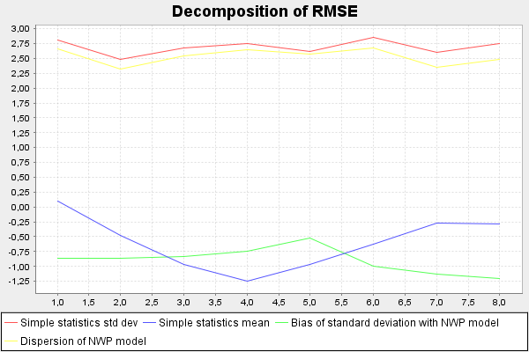
Figure 4: Decomposition of RMSE at Pomteno brdo for HRDA model input and NOSPEEDUP for point 4.

The results on the MOS dependency on the sector (again only bMOS dependency) are shown in Table 7. Compared to the use of ALHR data and mostype0, though direct model output is slightly better, there is no significant difference in the final results after MOS, whether or not orographic speed effects are included.

Table 7: The mean absolute error with sectMOS dependency for mostype 0 with HRDA model as input and different orographic speed-up influences.
< NO SPEED- UP >
NOMOS_1 | MOS_1 | MOS_2 | MOS3 | AVGMOS
2.05-2.75 | 1.75-2.4 | 1.85-2.35 | 1.75-2.35 | 1.8-2.35
< WITH SPEED- UP >
NOMOS_1 | MOS_1 | MOS_2 | MOS3 | AVGMOS
2.25-2.9 | 1.8-2.4 | 1.8-2.35 | 1.8-2.45 | 1.8-2.4
< WITH 50% SPEED- UP >
NOMOS_1 | MOS_1 | MOS_2 | MOS3 | AVGMOS
1.95-2.65 | 1.8-2.35 | 1.8-4.55 | 1.8-2.6 | 1.8-3.15
< WITH 75% SPEED- UP >
NOMOS_1 | MOS_1 | MOS_2 | MOS3 | AVGMOS
2.05-2.7 | 1.8-2.5 | 1.8-2.5 | 1.75-2.4 | 1.8-2.45

The analysis for mostype3 and HRDA results are shown in Tables 8 and 9. Similar to ALHR results, using MOS with no dependency on sector significantly diminishes the scores, regardless of whether the oropgraphic influence is included or not. However, once the dependency on the sector (bMOS only) is included, the results are improved compared to the direct model output. Indeed, the results with mostype3 and HRDA seem to be the best of all combinations (HRDA+mostype0, ALHR+mostype0, ALHR+mostype3), though the differences are quite limited.

Table 8: Mean absolute errors without MOS (NOMOS) for NOSPEEDUP (direct model output), 50%, 75% and 100% speedup as diagnosed by WaSP and with mostype3 for HRDA model results.

mostype3 | NOSPEEDUP |  | 50% SPEEDUP |  | 75% SPEEDUP |  | 100% SPEEDUP
PT | NOMOS | abMOS | NOMOS | abMOS | NOMOS | abMOS | NOMOS | abMOS
1 | 2.2-2.85 | 2.65-3.05 | 2.05-2.5 | 2.65-3.05 | 2.05-2.55 | 2.65-3.05 | 2.15-2.6 | 2.05-2.25
2 | 2.15-2.8 | 2.65-3.05 | 2.05-2.6 | 2.65-3.1 | 2.15-2.7 | 2.7-3.1 | 2.3-2.85 | 2.1-2.3
3 | 2.1-2.85 | 2.7-3.05 | 2.0-2.55 | 2.75-3.1 | 2.0-2.6 | 2.85-3.1 | 2.15-2.7 | 1.8-2.15
4 | 2.05-2.75 | 2.7-3.05 | 1.95-2.65 | 2.75-3.1 | 2.05-2.7 | 2.8-3.1 | 2.25-2.9 | 1.9-2.3

Table 9: The mean absolute error with sectMOS dependency for mostype 3 with HRDA model as input and different orographic speed-up influences.
< NO SPEED- UP >
NOMOS_1 | MOS_1 | MOS_2 | MOS3 | AVGMOS
2.05-2.75 | 1.75-2.15 | 1.75-2.1 | 1.75-2.3 | 1.75-2.2
< WITH SPEED- UP >
NOMOS_1 | MOS_1 | MOS_2 | MOS3 | AVGMOS
2.25-2.9 | 1.8-2.15 | 1.75-2.2 | 1.75-2.6 | 1.75-2.3
< WITH 50% SPEED- UP >
NOMOS_1 | MOS_1 | MOS_2 | MOS3 | AVGMOS
1.95-2.65 | 1.75-2.45 | 1.75-2.2 | 1.75-2.15 | 1.75-2.25
< WITH 75% SPEED- UP >
NOMOS_1 | MOS_1 | MOS_2 | MOS3 | AVGMOS
2.05-2.7 | 1.8-2.55 | 1.75-2.3 | 1.8-2.15 | 1.8-2.35

4.2. The case study of Split Marjan

The model success at the station Split Marjan (at height 10 m AGL) is verified within the same framework as the station Pometeno brdo. Table 10. presents MOS results with no dependency on wind sector and with different effects of orography. First, it is evident that for this station application of orographic (roughness) speed-up shows unfavorable, since the bigger the speed-up, the bigger the mean absolute error range, and by far the best results are achieved with no use of orography (roughness) model at all. The similar results are valid for MOS, where the best results are achieved for the case with no use of orography (roughness) model. This special case shows no increase in accuracy compared to the direct model output. The errors after MOS increases with the amount of speed-up used, though the differences are not so huge compared to the case without using MOS. Overall, slightly better results are achieved when using the model grid points above the sea as seen by the model (points 1 and 2) than points over the land in the model (points 3 and 4).

Table 10: Mean absolute errors without MOS (NOMOS) for NOSPEEDUP (direct model output), 50%, 75% and 100% speedup as diagnosed by WaSP and with mostype0 for station Split Marjan.
mostype0 | NOSPEED- UP |  | 50% SPEEDUP |  | 75% SPEEDUP |  | 100% SPEEDUP
PT | NOMOS | abMOS | NOMOS | abMOS | NOMOS | abMOS | NOMOS | abMOS
1 | 1.5-1.9 | 1.6-1.9 | 1.8-2.45 | 1.65-1.95 | 2.05-2.8 | 1.7-1.95 | 2.35-3.25 | 1.7-2.0
2 | 1.6-1.8 | 1.6-1.8 | 1.8-2.4 | 1.65-1.9 | 2.1-2.8 | 1.7-1.9 | 2.45-3.3 | 1.75-1.95
3 | 1.55-1.9 | 1.7-1.9 | 1.8-2.3 | 1.75-1.95 | 2.05-2.6 | 1.8-1.95 | 2.3-3.05 | 1.8-1.95
4 | 1.75-1.9 | 1.75-1.95 | 1.85-2.5 | 1.8-2.0 | 2.05-3.0 | 1.8-1.95 | 2.3-3.6 | 1.85-2.1

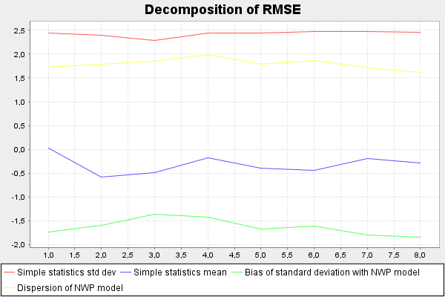
Figure 5: Decomposition of RMSE at Split Marjan for ALHR model input and NOSPEEDUP for point 2 (mostype0).

The decomposition of RMSE shows unlike the case of Pometeno brdo, a considerable part of the RMSE comes from other sources than phase error, such as bias of standard deviation which indicates the errors in modeled wind variability and to some extent bias itself.

Calculation of the sector dependent bMOS parameter yielded the results shown on Table 11 (shown for the best model grid point 2). The MOS NOSPEEDUP results are similar to direct model output, while results with any amount of orographic speed-up make the MAE higher that in NOSPEEDUP experiments.

Respective results for the mostype3 are shown on Tables 12. and 13. Results are similar to the mostype0 experiments. Since the speed-up strongly decreases the accuracy of results (with no MOS), MOS is unable to fully account for this influence. Therefore
Table 11: The mean absolute error with sectMOS dependency for mostype 0 with ALHR model as input and different orographic speed-up influences.
< NO SPEED-UP >
NOMOS_1 | MOS_1 | MOS_2 | MOS3 | AVGMOS
1.6-1.8 | 1.45-1.7 | 1.5-1.95 | 1.5-1.65 | 1.5-1.75
< WITH SPEED- UP >
NOMOS_1 | MOS_1 | MOS_2 | MOS3 | AVGMOS
2.45-3.3 | 1.5-2.1 | 1.45-1.75 | 1.5-1.85 | 1.5-1.9
< WITH 50% SPEED- UP >
NOMOS_1 | MOS_1 | MOS_2 | MOS3 | AVGMOS
1.8-2.4 | 1.5-2.6 | 1.5-2.0 | 1.45-1.8 | 1.5-2.15
< WITH 75% SPEED- UP >
NOMOS_1 | MOS_1 | MOS_2 | MOS3 | AVGMOS
2.1-2.8 | 1.5-2.1 | 1.55-2.35 | 1.5-2.15 | 1.5-2.2

Table 12: Mean absolute errors without MOS (NOMOS) for NOSPEEDUP (direct model output), 50%, 75% and 100% speedup as diagnosed by WaSP and with mostype3.
mostype3 | NO-SPEEDUP |  | 50% SPEEDUP |  | 75% SPEEDUP |  | 100% SPEEDUP
PT | NOMOS | abMOS | NOMOS | abMOS | NOMOS | abMOS | NOMOS | abMOS
1 | 1.5-1.9 | 1.5-1.85 | 1.8-2.45 | 1.65-1.9 | 2.05-2.8 | 1.6-1.95 | 2.35-3.25 | 1.65-1.95
2 | 1.6-1.8 | 1.55-1.75 | 1.8-2.3 | 1.65-1.8 | 2.1-2.8 | 1.7-1.9 | 2.45-3.3 | 1.7-1.9
3 | 1.55-1.9 | 1.6-1.9 | 1.8-2.3 | 1.7-1.95 | 2.05-2.6 | 1.7-1.95 | 2.3-3.05 | 1.75-2.0
4 | 1.65-1.9 | 1.65-1.85 | 1.85-2.5 | 1.75-1.9 | 2.05-3.0 | 1.75-1.95 | 2.3-3.6 | 1.8-2.0

again, the best results, similar to the direct model output, are achieved to the case of the NOSPEEDUP experiment.
The application of sector dependent bMOS parameter did not yield a significant improvement (Table 13.). The NOSPEEDUP MOS experiment yields the same results as a direct model output, with other experiments comparing unfavorable to the reference model values. Overall, there are no significant differences between mostype0 and mostype3 results.

Results for 4 surrounding points as inferred from HRDA model data are shown on Table 14. First, it is abvious that the HRDA data is slightly more accurate than direct model output of ALHR data. While the speed-up performs the same kind of MAE deteoriation as for ALHR model, we note that MOS results for the best NOSPEEDUP experiment are slightly better than for same ALHR experiment, showing the added value of HRDA data.
Table 13: The mean absolute error with sectMOS dependency for mostype 3 with ALHR model as input and different orographic speed-up influences.
< NO SPEED-UP >
NOMOS_1 | MOS_1 | MOS_2 | MOS_3 | AVGMOS
1.5-1.9 | 1.45-1.85 | 1.4-2.15 | 1.4-1.95 | 1.4-2.0
< WITH SPEED- UP >
NOMOS_1 | MOS_1 | MOS_2 | MOS_3 | AVGMOS
2.35-3.25 | 1.65-1.95 | 1.6-1.9 | 1.65-2.0 | 1.65-1.95
< WITH 50% SPEED- UP >
NOMOS_1 | MOS_1 | MOS_2 | MOS_3 | AVGMOS
1.8-2.45 | 1.4-2.1 | 1.65-2.0 | 1.55-1.95 | 1.55-2.0
< WITH 75% SPEED- UP >
NOMOS_1 | MOS_1 | MOS_2 | MOS_3 | AVGMOS
2.05-2.8 | 1.6-1.95 | 1.45-1.95 | 1.65-1.95 | 1.55-1.95

Table 14: Mean absolute errors without MOS (NOMOS) for NOSPEEDUP (direct model output), 50%, 75% and 100% speedup as diagnosed by WaSP and with mostype0 for HRDA model results.
mostype0 | NOSPEEDUP |  | 50% SPEEDUP |  | 75% SPEEDUP |  | 100% SPEEDUP
PT | NOMOS | abMOS | NOMOS | abMOS | NOMOS | abMOS | NOMOS | abMOS
1 | 1.5-1.75 | 1.55-1.7 | 2.05-2.35 | 1.65-1.75 | 2.4-2.9 | 1.65-1.75 | 2.8-3.45 | 1.65-1.8
2 | 1.5-1.75 | 1.55-1.7 | 2.0-2.35 | 1.6-1.8 | 2.35-2.9 | 1.65-1.8 | 2.75-3.45 | 1.65-1.85
3 | 1.55-1.8 | 1.6-1.75 | 2.0-2.3 | 1.7-1.85 | 2.3-2.75 | 1.7-1.85 | 2.65-3.3 | 1.75-1.9
4 | 1.6-1.8 | 1.6-1.85 | 2.0-2.35 | 1.7-1.9 | 2.3-2.8 | 1.7-1.95 | 2.65-3.3 | 1.75-1.95

Application of sector dependent bMOS (Table 15.) does not bring an improvement compared to the direct model output. The application of speed-up results in much weaker model accuracy that is in the largest part taken account for in MOS, which shows results only slightly worse than for NOSPEEDUP experiment. Overall, similar to for MOS which is not sector-dependent, the results are somewhat better than for the ALHR model data.

Equivalent results for the HRDA dataset and mostye3 are shown on Tables 16. and 17.
Table 15: The mean absolute error with sectMOS dependency for mostype 0 with HRDA model as input and different orographic speed-up influences for the most accurate model point 2.
< NO SPEED-UP >
NOMOS_1 | MOS_1 | MOS_2 | MOS3 | AVGMOS
1.5-1.75 | 1.4-1.65 | 1.4-1.85 | 1.45-1.85 | 1.4-1.8
< WITH SPEED- UP >
NOMOS_1 | MOS_1 | MOS_2 | MOS3 | AVGMOS
2.75-3.45 | 1.45-1.95 | 1.5-2.05 | 1.45-2.0 | 1.45-2.0
< WITH 50% SPEED- UP >
NOMOS_1 | MOS_1 | MOS_2 | MOS3 | AVGMOS
2.0-2.35 | 1.45-1.7 | 1.45-1.85 | 1.45-2.25 | 1.45-1.95
< WITH 75% SPEED- UP >
NOMOS_1 | MOS_1 | MOS_2 | MOS3 | AVGMOS
2.35-2.9 | 1.45-2.15 | 1.45-1.65 | 1.4-1.7 | 1.45-1.85

While for speed-up the same consideration hold as the above, the MOS in the NOSPEEDUP case performs slightly better than the direct model output. Indeed, the HRDA results for NOSPEEDUP experiment and mostype3 are the best results achieved for the station Split Marjan with MAE ranging from 1.4-1.65 m/s over all the forecast horizons. Again, the best model grid points 1 and 2 are located over the sea, and MOS account for the largest (but not 100%) part of the unfavorable orographic speed-up effect.

Table 16: Mean absolute errors without MOS (NOMOS) for NOSPEEDUP (direct model output), 50%, 75% and 100% speedup as diagnosed by WaSP and with mostype3 for HRDA model results.
Mostype3 | NOSPEEDUP |  | 50% SPEEDUP |  | 75% SPEEDUP |  | 100% SPEEDUP
PT | NOMOS | abMOS | NOMOS | abMOS | NOMOS | abMOS | NOMOS | abMOS
1 | 1.5-1.75 | 1.4-1.65 | 2.05-2.35 | 1.5-1.75 | 2.4-2.9 | 1.55-1.8 | 2.8-3.45 | 1.6-1.85
2 | 1.5-1.75 | 1.45-1.65 | 2.0-2.35 | 1.55-1.7 | 2.35-2.9 | 1.6-1.75 | 2.75-3.45 | 1.6-1.8
3 | 1.55-1.8 | 1.5-1.7 | 2.0-2.3 | 1.55-1.8 | 2.3-2.75 | 1.6-1.85 | 2.65-3.3 | 1.65-1.9
4 | 1.6-1.8 | 1.55-1.75 | 2.0-2.35 | 1.65-1.85 | 2.3-2.8 | 1.7-1.9 | 2.65-3.3 | 1.7-1.95

The results achieved with the inclusion of sector dependent bMOS parameter are shown on Table 17. The calculation of sector dependent bMOS parameter did not improve the results compared to experiments performed with no dependency on the sector. The best results are again achieved for NOSPEEDUP experiment, yielding amplitude of MAE from 1.45-1.65 over all forecast horizons which the best sector-dependent MOS result achieved for station Split Marjan including all model data and both mostypes 0 and 3.

Table 17: The mean absolute error with sectMOS dependency for mostype 3 with HRDA model as input and different orographic speed-up influences.
< NO SPEED- UP >
NOMOS_1 | MOS_1 | MOS_2 | MOS_3 | AVGMOS
1.5-1.75 | 1.45-1.65 | 1.45-1.6 | 1.5-1.65 | 1.45-1.65
< WITH SPEED- UP >
NOMOS_1 | MOS_1 | MOS_2 | MOS_3 | AVGMOS
2.75-3.45 | 1.65-1.75 | 1.55-1.65 | 1.65-1.8 | 1.6-1.75
< WITH 50% SPEED- UP >
NOMOS_1 | MOS_1 | MOS_2 | MOS_3 | AVGMOS
2.0-2.35 | 1.55-1.7 | 1.6-1.75 | 1.6-1.7 | 1.6-1.7
< WITH 75% SPEED- UP >
NOMOS_1 | MOS_1 | MOS_2 | MOS_3 | AVGMOS
2.35-2.9 | 1.65-1.8 | 1.65-1.8 | 1.55-1.65 | 1.6-1.75

Finally, experiments were designed in such a manner to calculate aMOS and bMOS first, and then use these values to optimize sectMOS paramteres in the second mos loop. However, this method showed considerably worse results than optimizing all parameters at once.

