Operational forecast and research in Croatia in 2015
Martina Tudor, Antonio Stanešić, Stjepan Ivatek-Šahdan, Alica Bajić, Mario Hrastinski, Tomislav Kovačić, Kristian Horvath and Iris Odak Plenković
The operational model version used is AL38T1 with ALARO0 physics for 8 and 4 km forecasts, AL29mxl for 2 km dynamical adaptation and AL36T1bf08 for 2 km NH run.. Operational forecast run for:
- 8 km resolution, 4 times per day, 3D var and surface OI, 6 h cycling, to 72 hours, coupled to IFS, 37 levels.
- 4 km resolution, 00 UTC up to 72 hours, surface OI, 6h cycling, coupled to IFS, 73 levels, to do: 3D var.
- 2 km dynamical adaptation, hourly, up to 72 hours,
- 2 km non-hydrostatic, 06 UTC up to 24 hours.

INTRODUCTION

1.1 Background surface fields

The “clim” files contain “climatological” background. The 12 monthly files per domain can be produced in Meteo France by running the configuration (e)923, the procedure requires the input databases. There are some features in the fields of climate files that are unrealistic and rather different from nature.
The usage of SURFEX PGD allows using new topography from the new database. Using the topography and land sea mask from the new file is invoked by setting LNORO=T in the namelist NAMCLA, and for new land sea mask (LNLSM=T). If PGD topography is imported (LIPGD=T), envelope is added to the topography.
Consequently, clim files are created as a combination from several databases. Land-sea mask and height of topography are taken from one database, but proportion of land, standard deviation of orography, roughness length and other parameters describing topography are taken from another database.

a)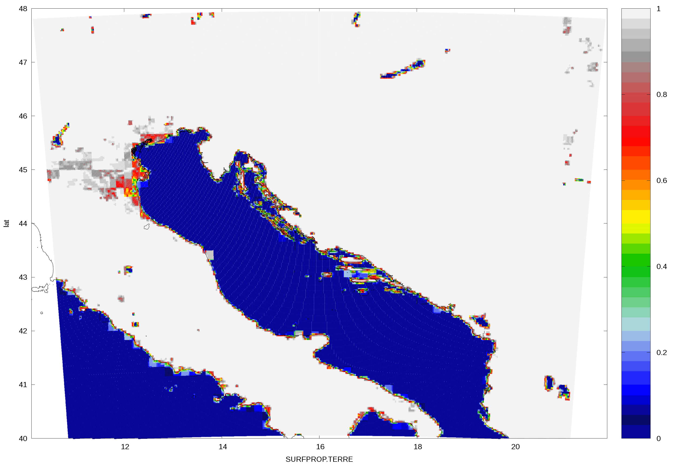 b)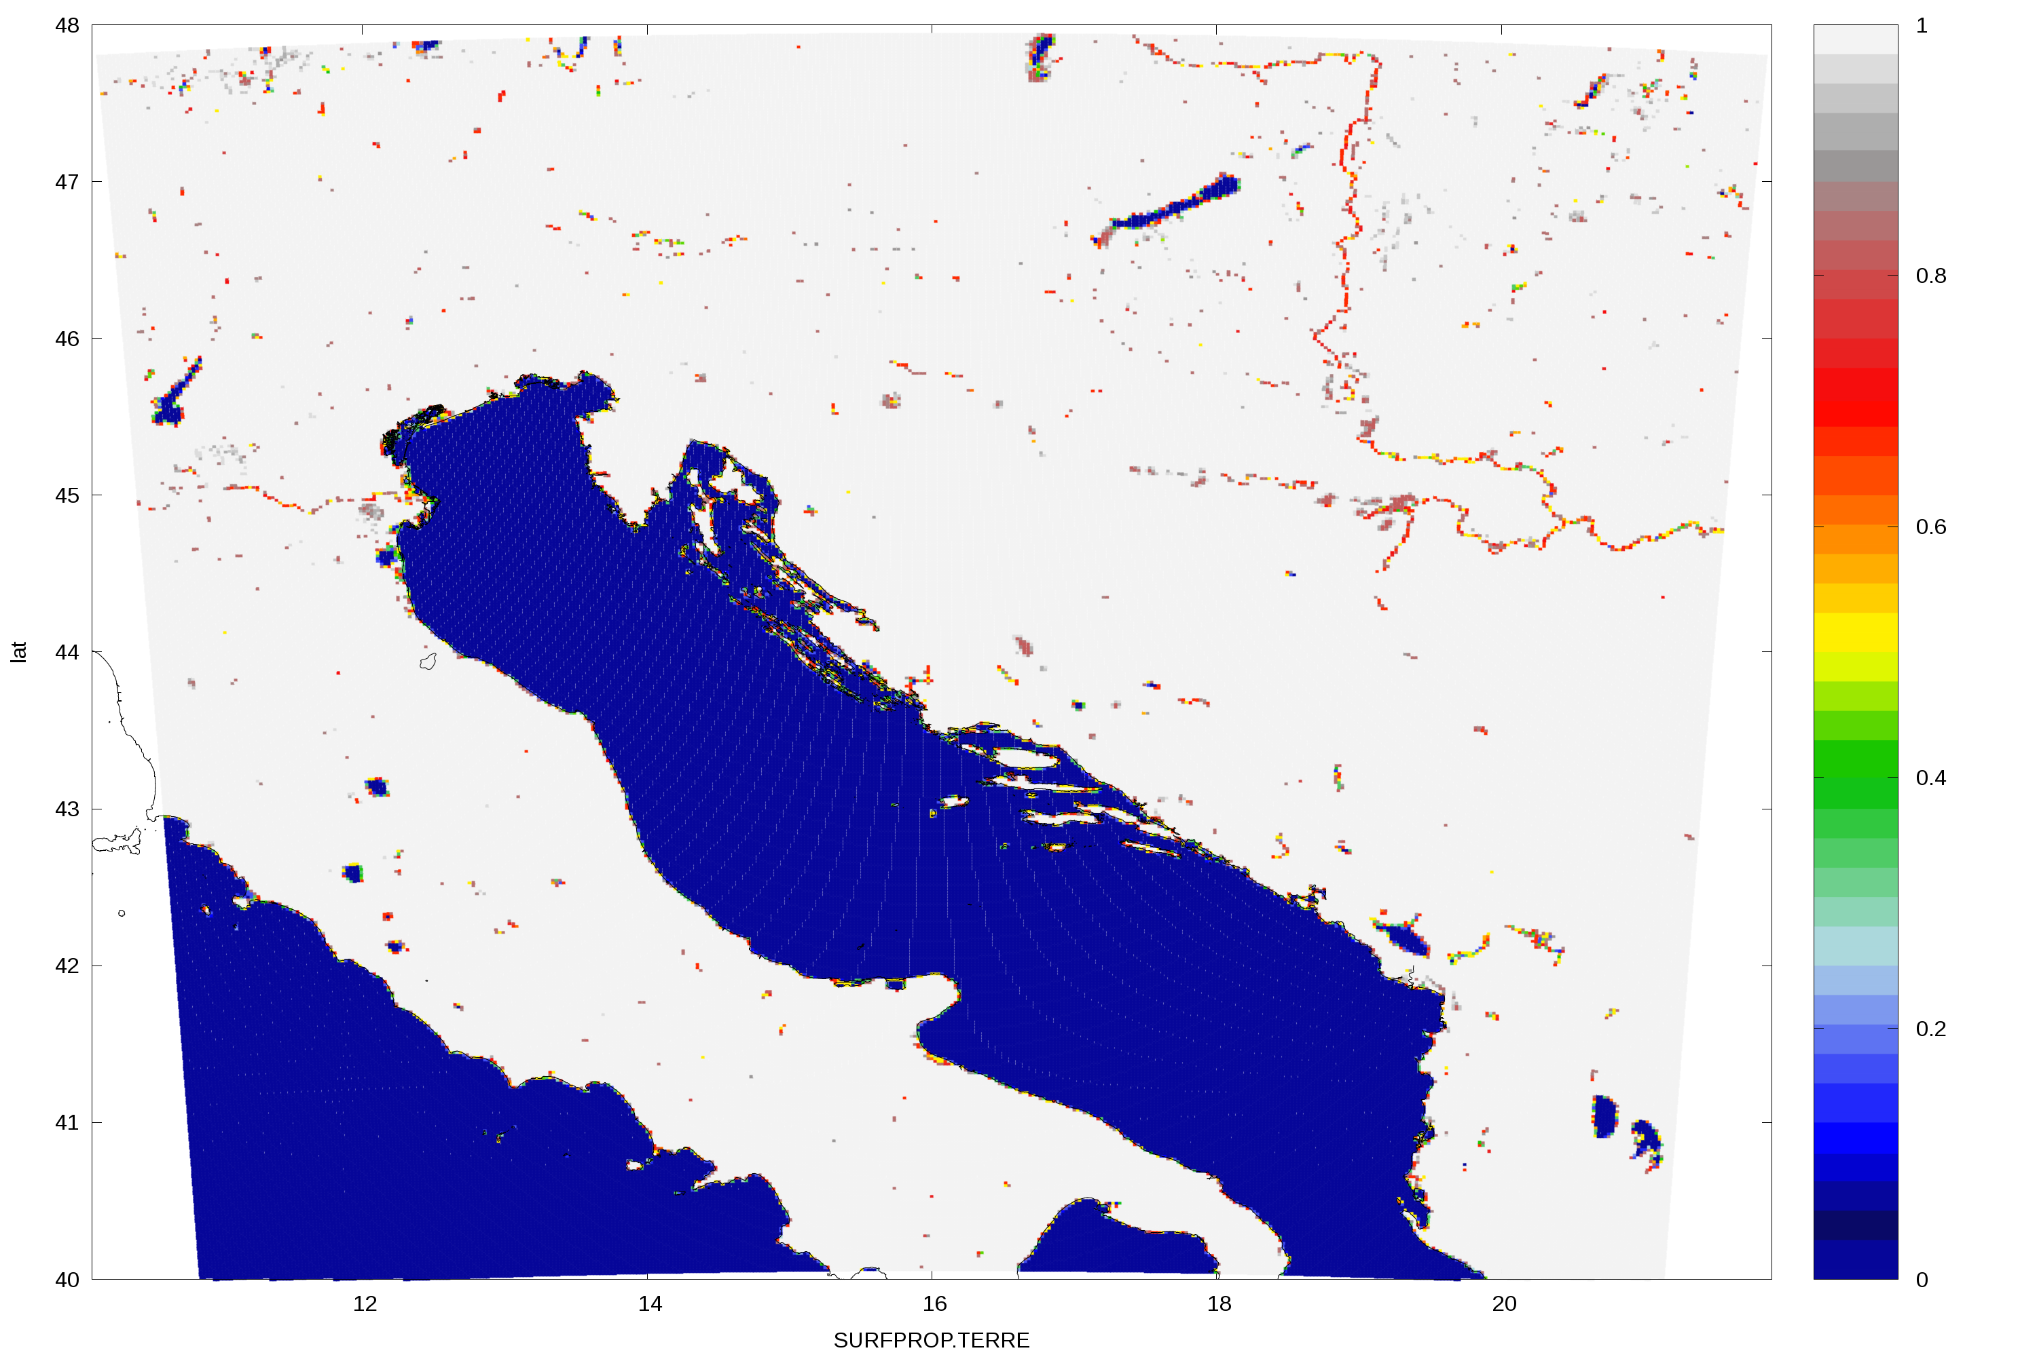
Fig. 1: Proportion of land after the Step1 (a) and computed from the SURFEX PGD file (b). These figures show data for 2 km resolution domain.

a)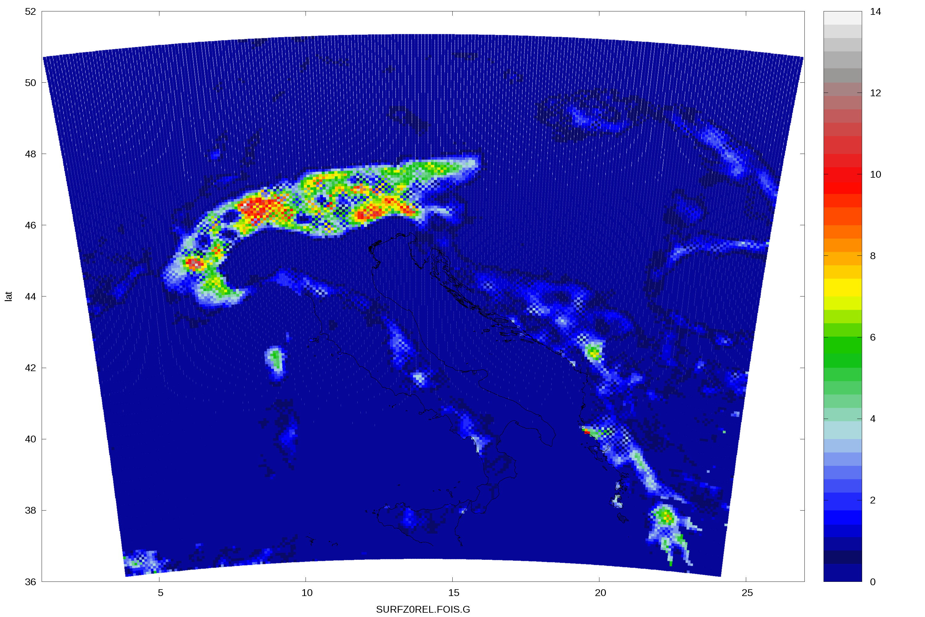 b)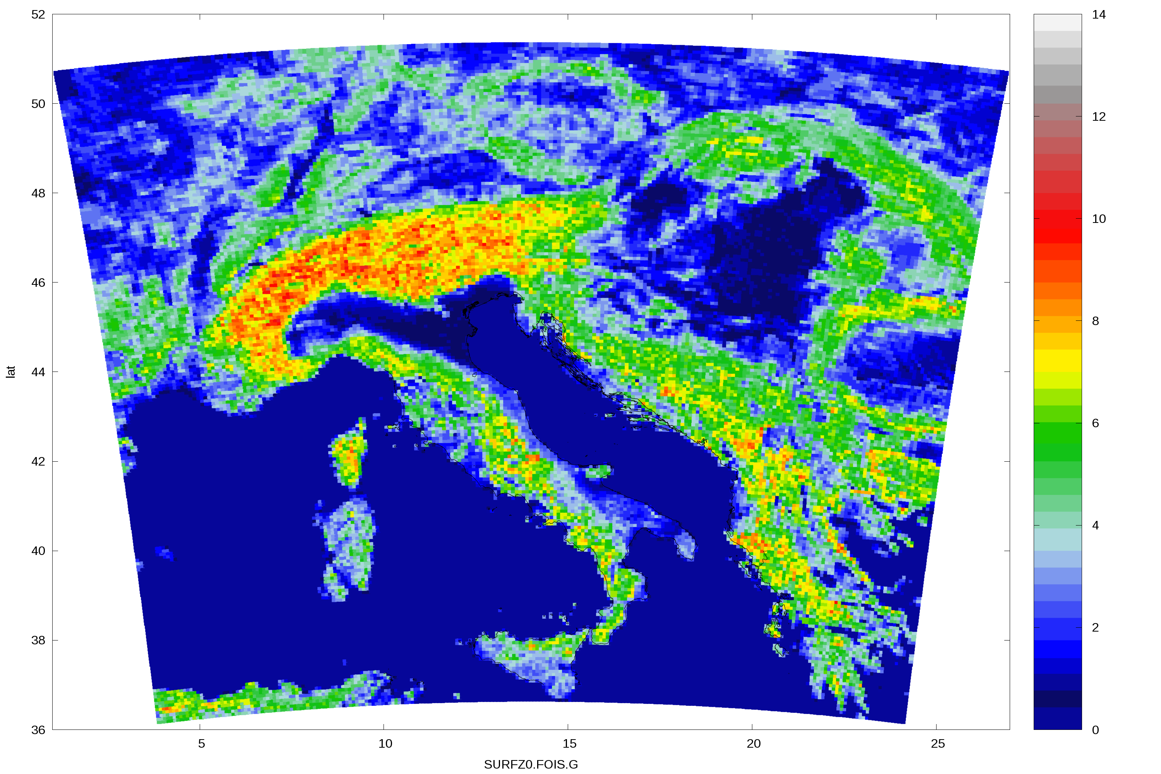
Fig. 2: Surface roughness length (a) and corrected field (b) in 8 km resolution (the values in the figures were divided by 9.81).

a)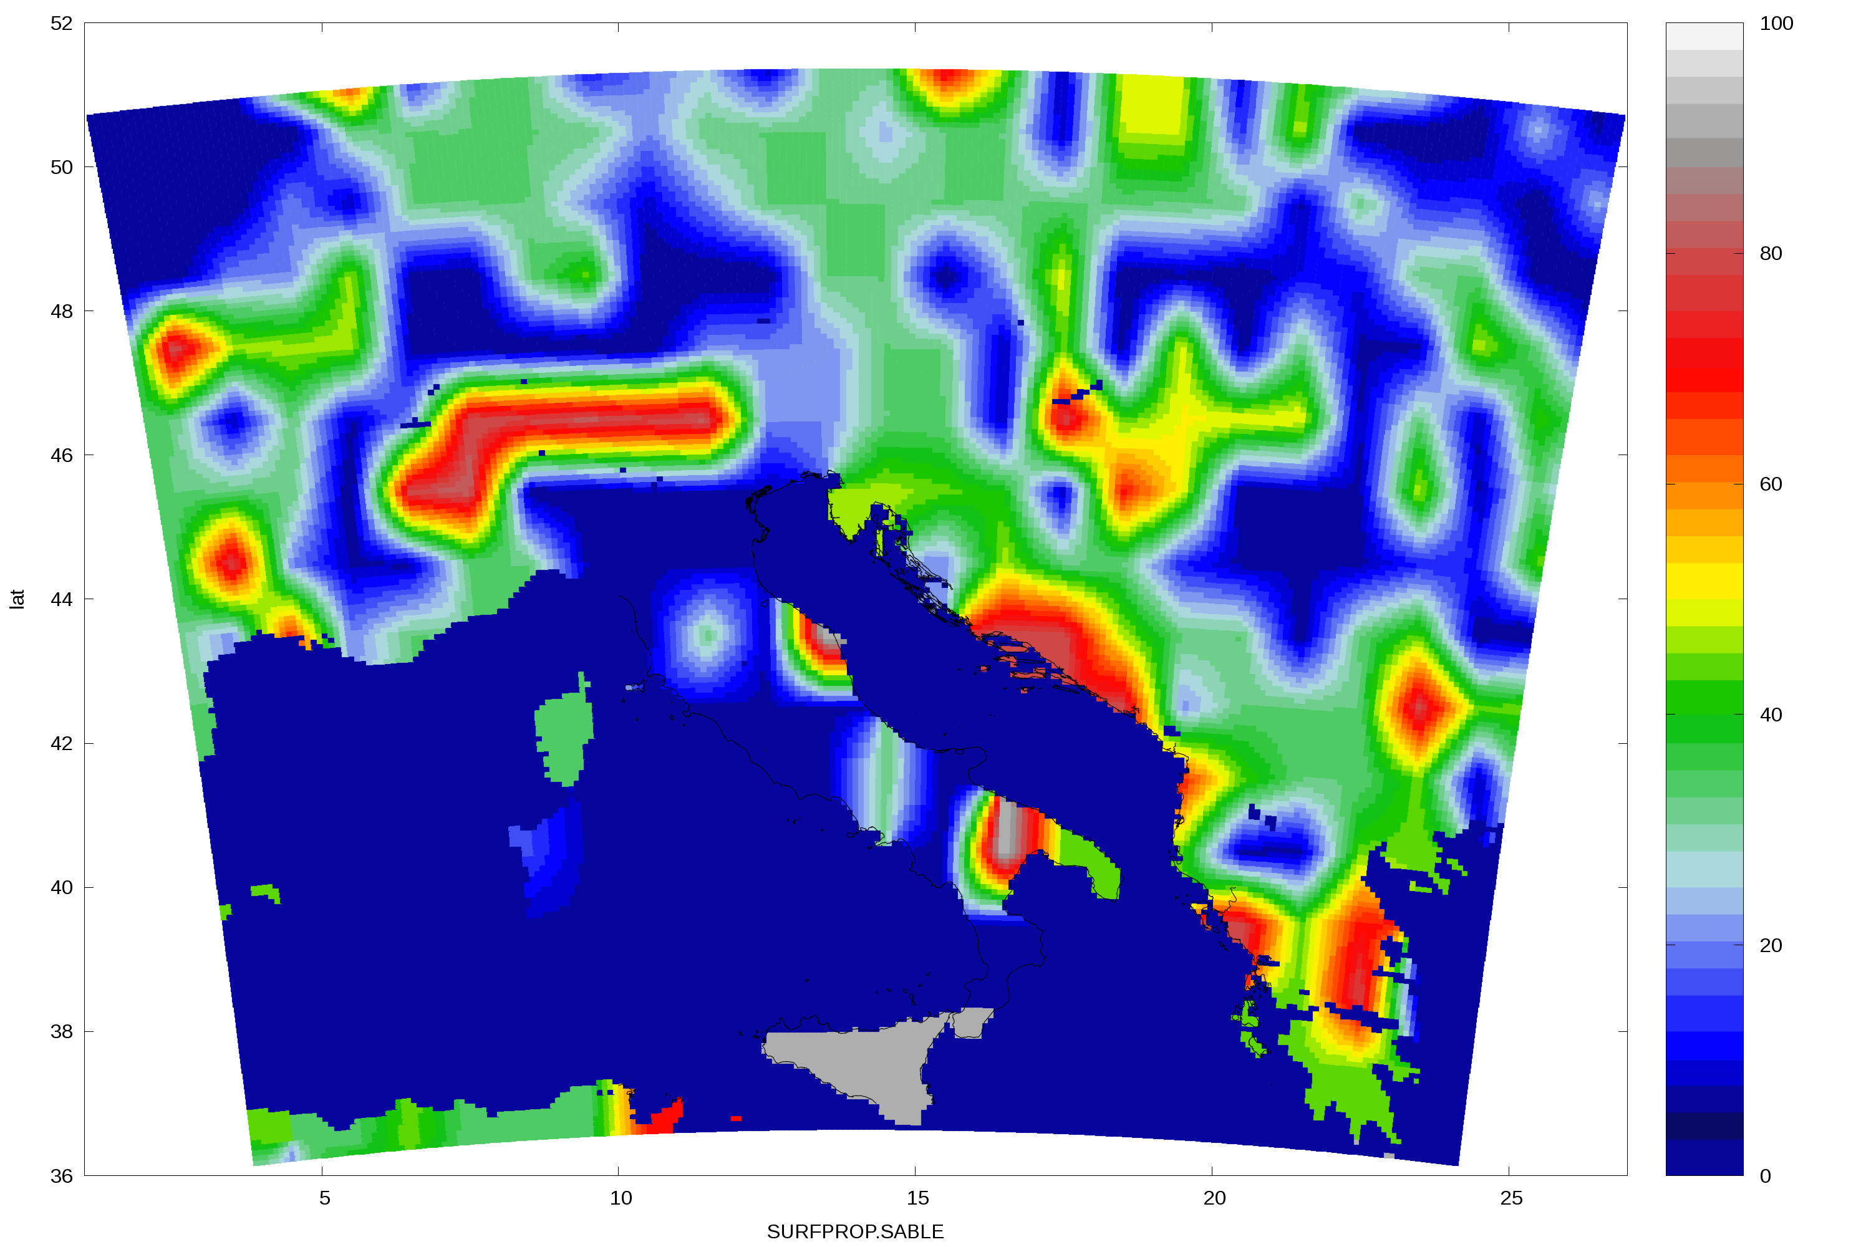 b)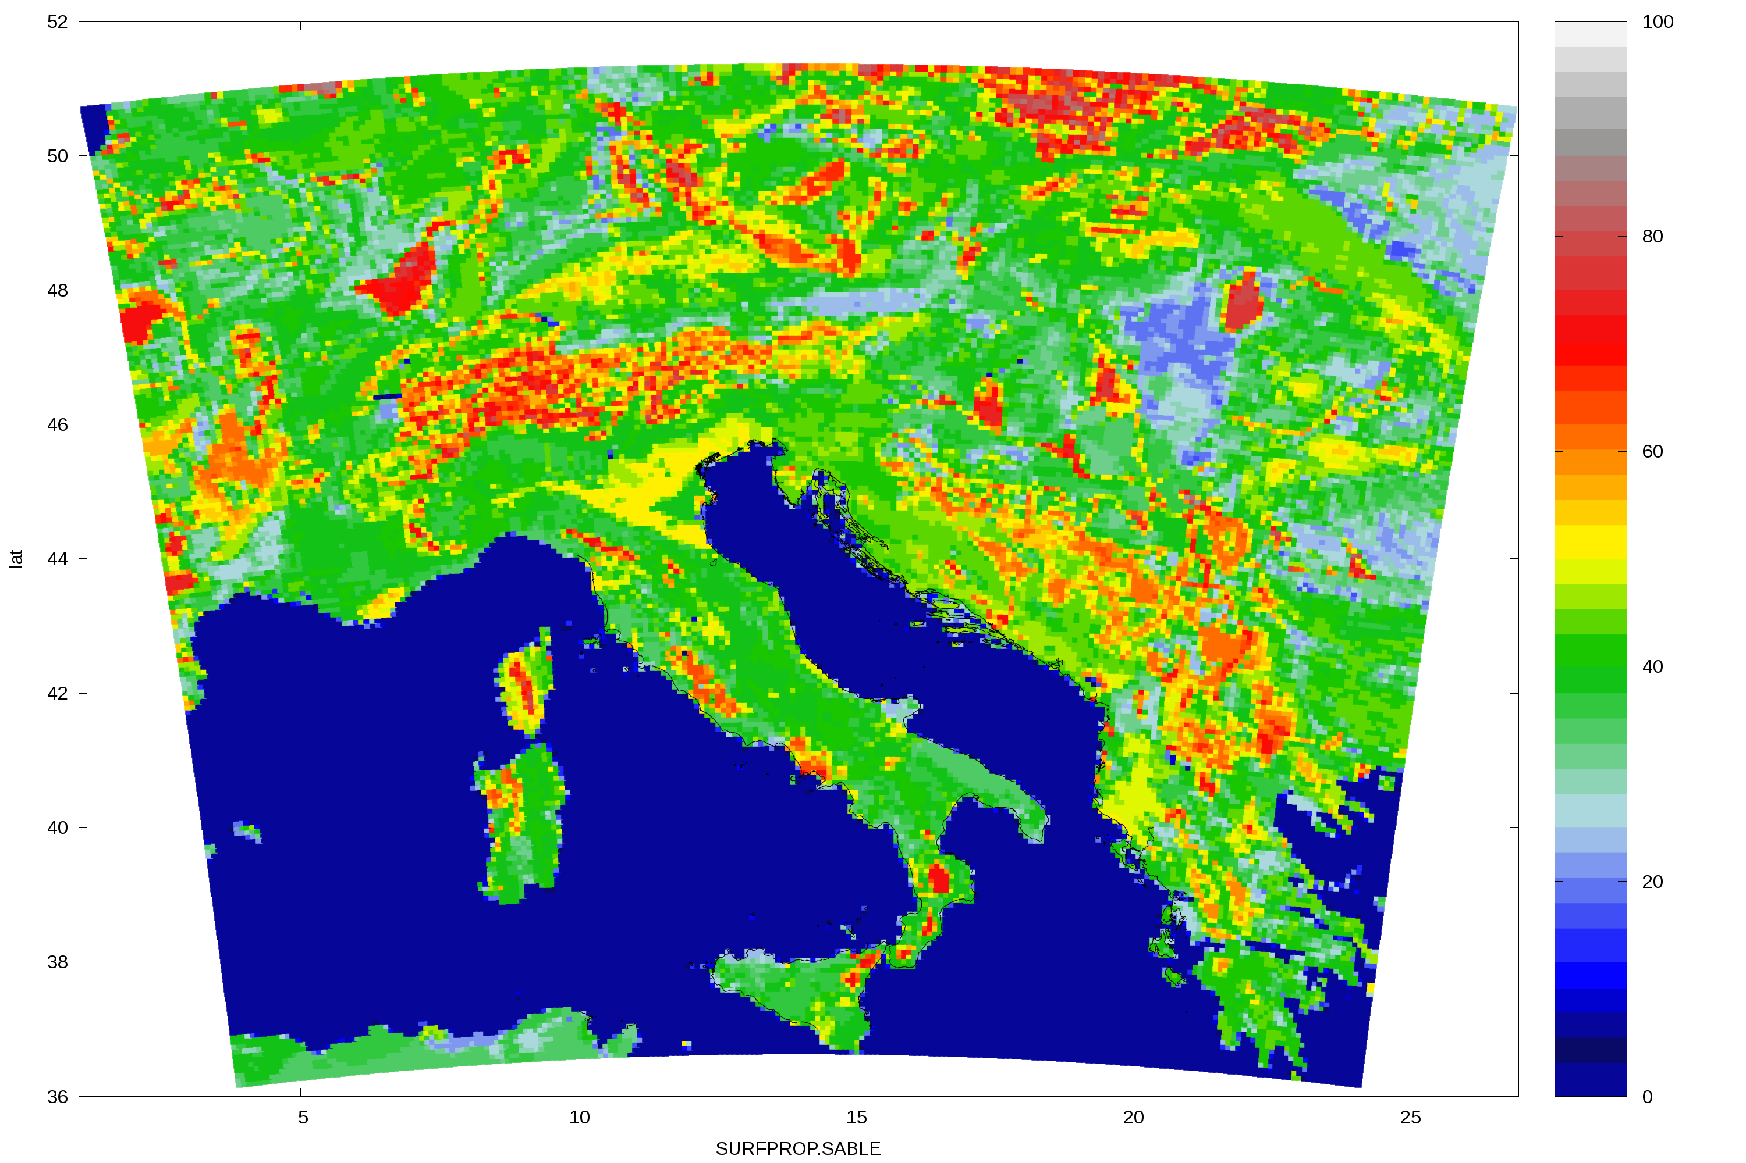
Fig. 3: Proportion of sand in the clim file (a) and after the correction using data from the SURFEX PGD file (b).

1.2 SST in the coupling files from ARPEGE and IFS
Sea surface temperature (SST) influences the model forecast of land/sea breeze and the intensity of precipitation downstream. SST is taken from initial file and remains constant during the model forecast, currently there is no local assimilation of SST.
There are two sets of SST fields provided in the coupling files, from operational forecasts of IFS and ARPEGE.
Here we compare the SST from the coupling files with the values measured on stations. Several of these unnatural features in SST have been fixed. However, there are still large discrepancies in measured and model SST in certain regions, especially in autumn and winter along western Adriatic coastline.

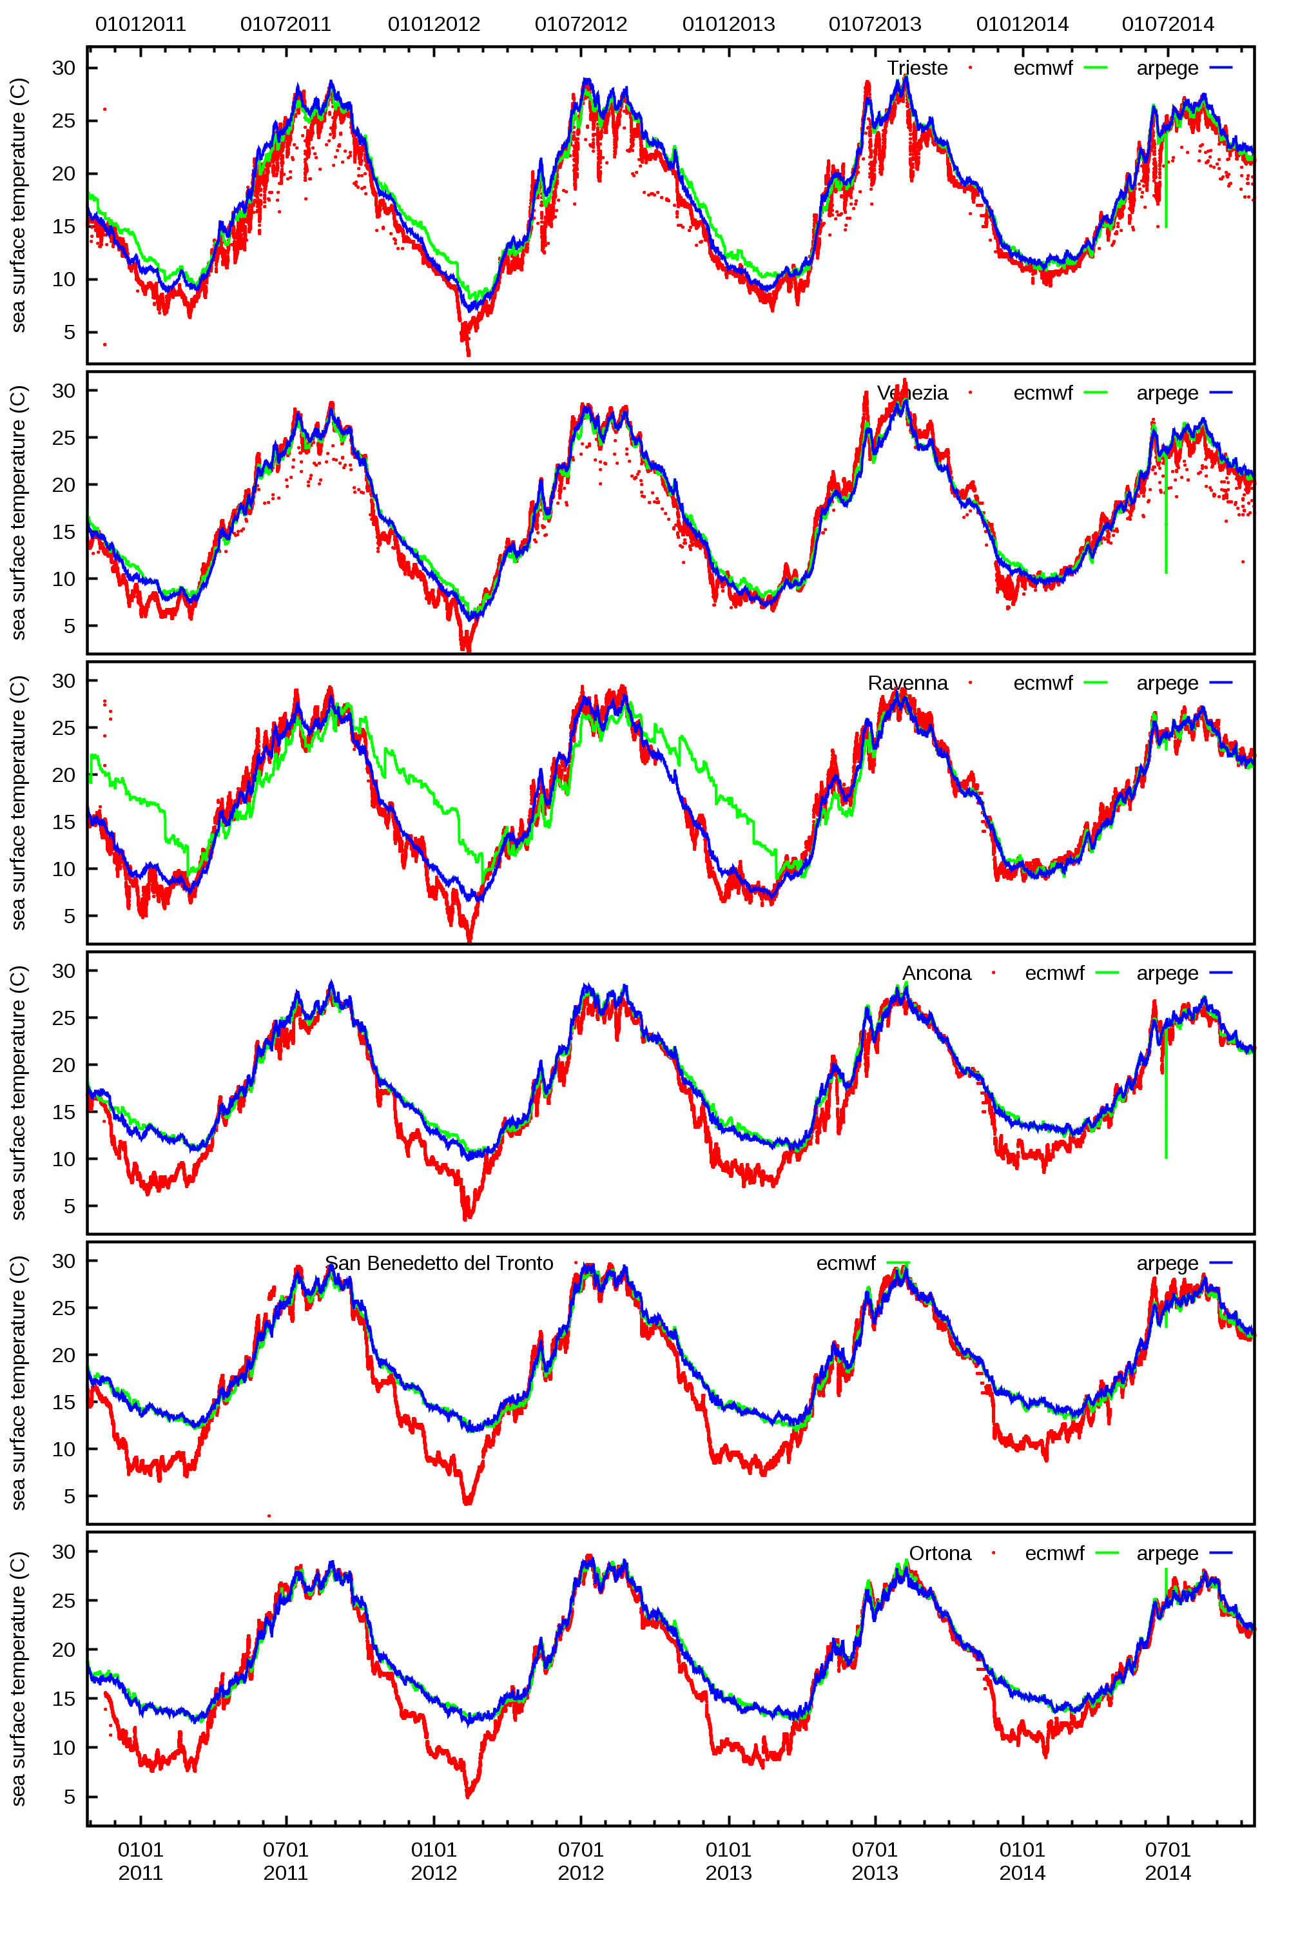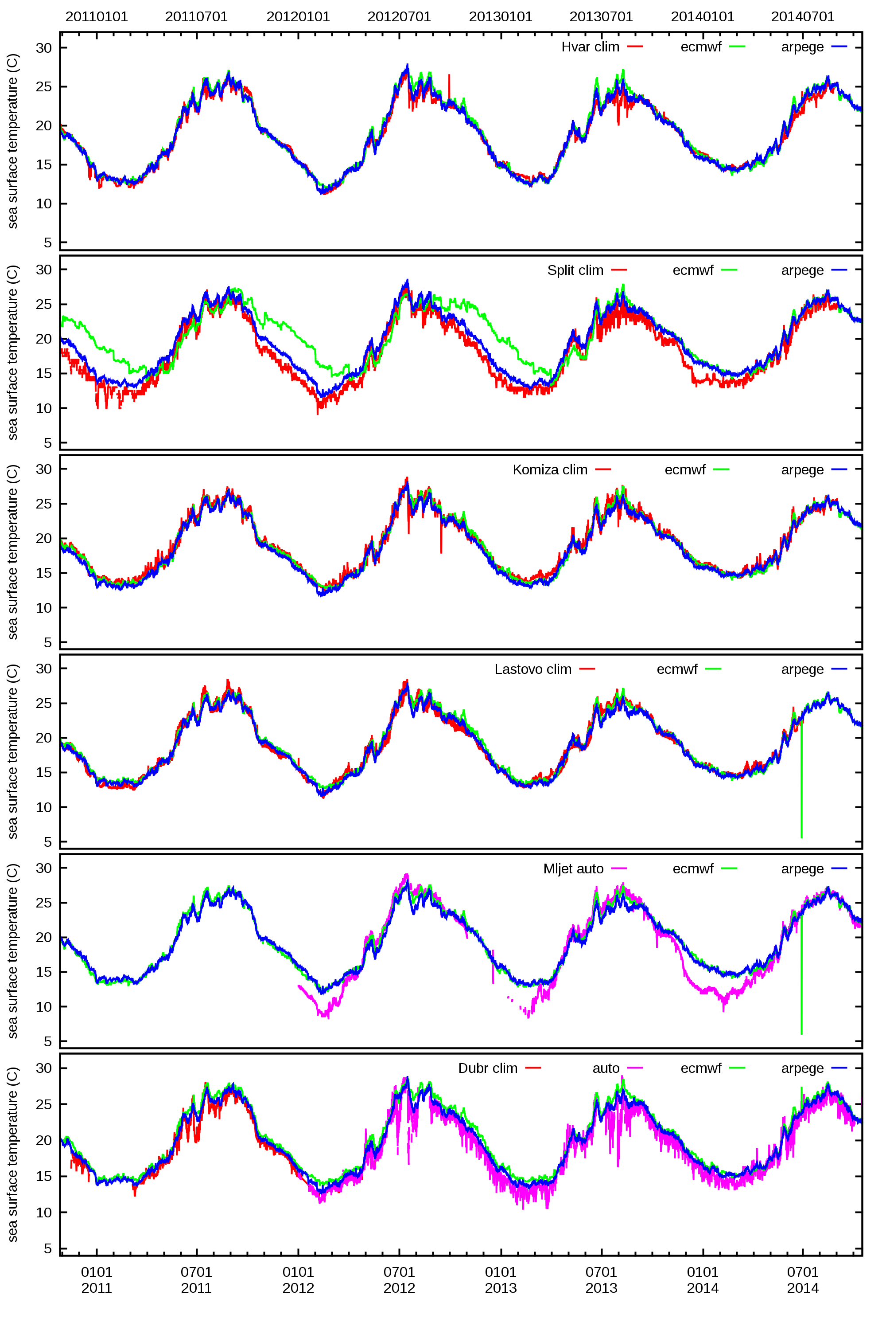
Fig. 4: SST measured on stations (red), and from the nearest sea point in ARPEGE (blue) and ECMWF (green) coupling files for stations in Italy (left) and Croatia (right) on Adriatic Sea for the period from 27th October 2010 to 16th October 2014.

Case with severe torrential rain and flash floods

In the middle of May 2014, severe torrential rain over mountains and the valley in the South-eastern Europe triggered flash floods, landslides and record levels of rivers (Bosnia and Herzegovina, Serbia and Croatia). The prognostic convection scheme yields less precipitation than the diagnostic one in 8 km but more in 2km resolution.
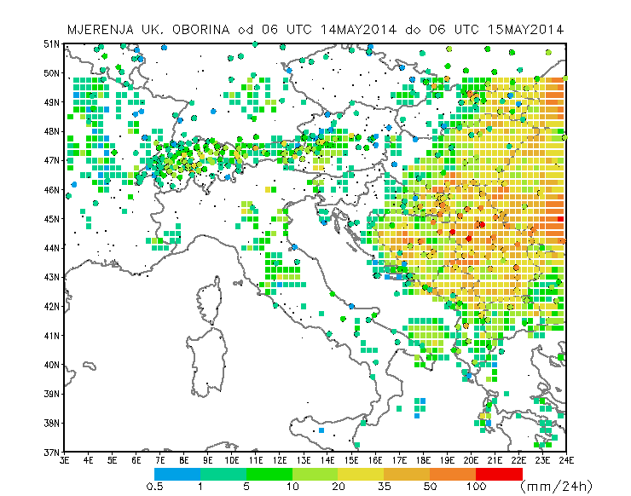
Fig. 5: Measured accumulated 24 hourly precipitation from TRMM estimates using satellite data 3B42RT (squares, no data north of 50N), and rain gauges (circles).

b)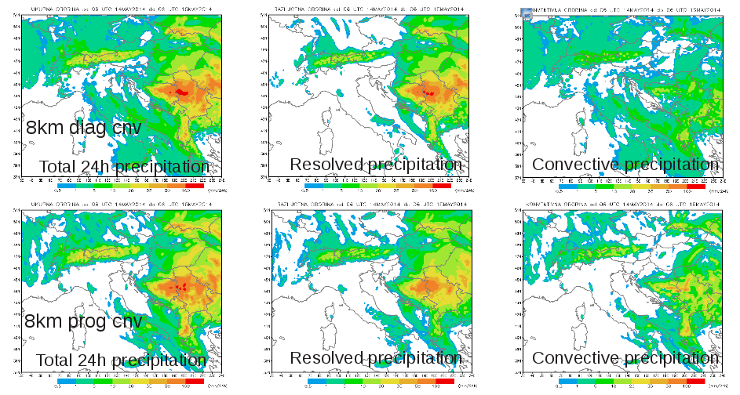
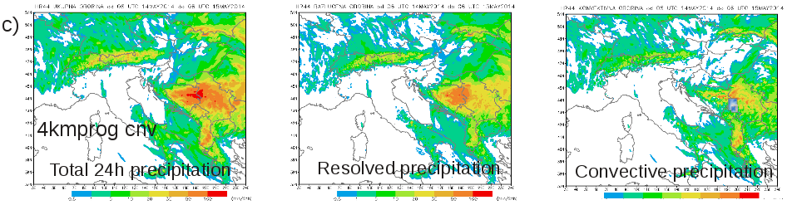
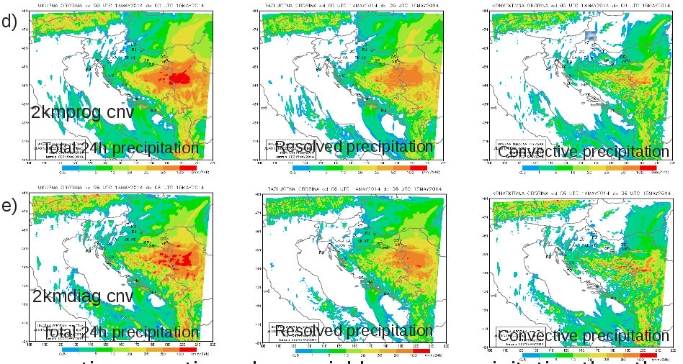Fig. 6: Forecast using diagnostic (a) and prognostic convection in 8 km (b), 4km (c) and diagnostic (d) and prognostic convection in 2km (e) resolution of the accumulated 24 hourly precipitation (total in the left column, resolved in the middle column and convective in the right column) for the case with severe flash floods in Bosnia and Herzegovina, Serbia and Croatia, that occurred on 15th May 2015.

The absence of convective precipitation (and clouds) from the model forecast is often interpreted as the absence of convection. This issue gets worse with increasing of the resolution. Parametrization of deep convection computes precipitation that is added to the resolved precipitation and plotted on a map as total precipitation and later validated against (in situ) measurements. But, it should be taken as subgrid variability in precipitation added to the resolved precipitation.

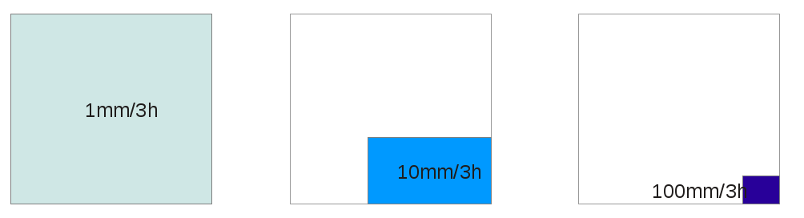Fig. 7: Usual interpretation of convective (unresolved) precipitation (left) and two alternatives (centre and right) depending on the convective mesh fraction.

ALADIN and IFS as background for NWC SAF

Numerical model information is mandatory for moisture and orographic corrections. Convective rainfall rate (CRR) product computed from MSG SEVIRI satellite data underestimates intensive precipitation and overestimates frequency of events with weak rain (compared to in situ measurements). When ALADIN is used as background, values are closer to the real ones than product that uses ECMWF fields as background.

a)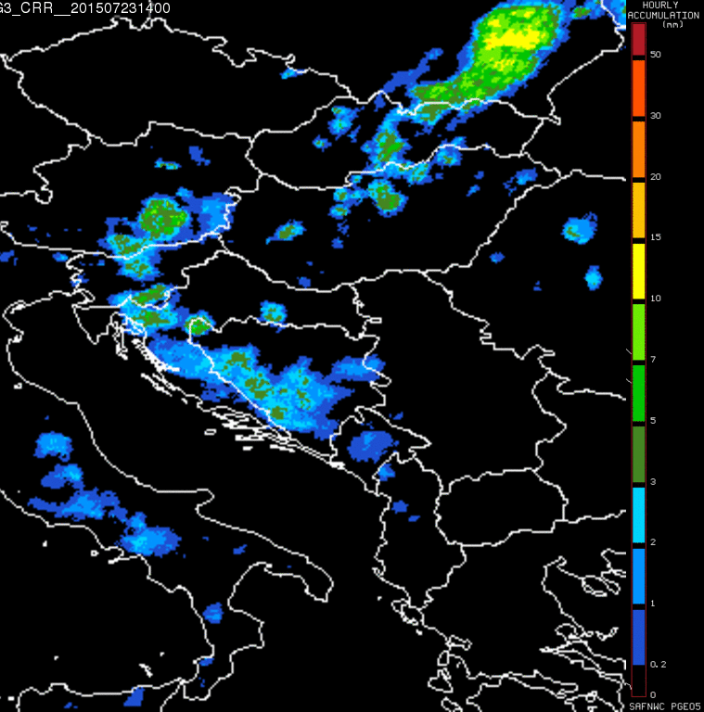 b)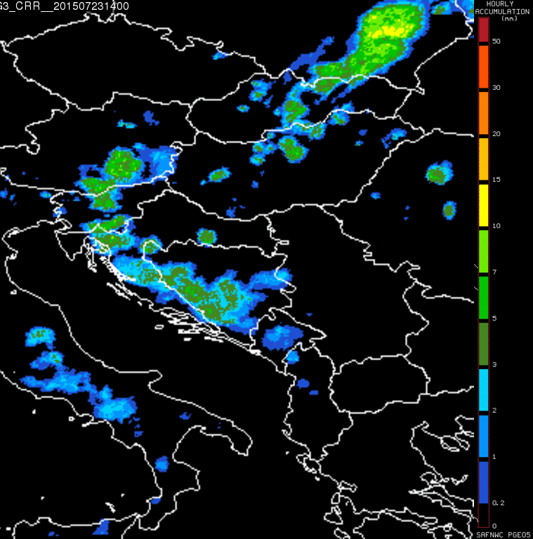
Fig. 8: 23 July 2015, 14:00 UTC PGE5 CRR (convective rainfall rate) hourly accumulation using IFS (a) and ALADIN/HR (b) fields as background. http://www.nwcsaf.org/HTMLContributions/SUM/SAF-NWC-CDOP2-INM-SCI-ATBD-05_v4.0.pdf.

When is 2 km NH forecast better?

Severe bura events in Makarska can be missed by dynamical adaptation but correctly predicted by non-hydrostatic forecast using the full physics package.

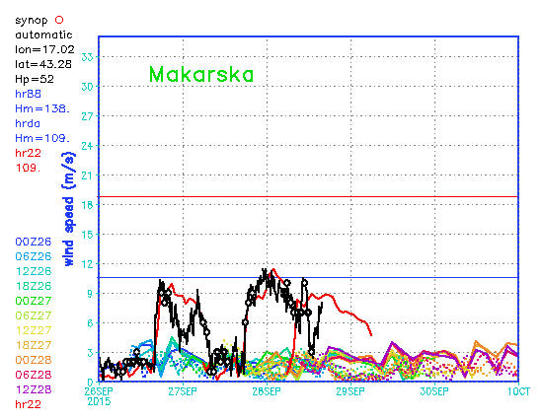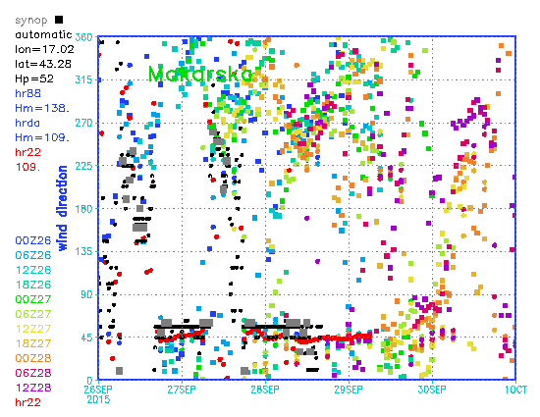
Fig. 9: Measurements (black) 8 km forecasts (full lines) 2 km DADA (dashed) and 2 km NH (red).

