Radni naslov: Changes in the ALADIN operational suite since the last published paper on that subject

Autori: MT, AS, SIS, MH, IOP, KH, AB, TK,.... (moram to permutirati malo)

Abstract
National weather services issue weather forecasts based on the output from the numerical weather prediction models. Particular weather phenomena that have significant effect on safety can be characteristic of a certain country or region and may require specific model set-up in terms of model resolution and complexity to be forecast. However, the computational expenses of model set-up for operational purposes are limited by the available computer resources.
The operational numerical weather prediction uses ALADIN model. This paper describes the changes introduced to the operational suite during the last few years. The operational suite in 8 km resolution and the dynamical downscaling of the wind field to 2km resolution is run more often, the large scale model that provides the prognostic lateral boundary conditions has changed, operational forecast uses new model version with changes in model physics, dynamics and vertical discretization, and 4 km resolution forecast using ALADIN model has been introduced.

Introduction
An accurate weather forecast relies on the operational output from the numerical weather prediction (NWP) models. Global NWP models provide weather forecast fields covering the whole planet for seven and more days in advance, but often miss details characteristic for weather at a particular location. National weather services often rely on forecast provided by limited area models (LAMS) that focus on the particular region. These details can be important since they can contain high impact weather events that affect local population and require warning.

ALADIN (Aire Limitée Adaptation Dynamique développement InterNational, ALADIN International Team, 1997) LAM is used for the operational weather forecast in the Croatian Meteorological and Hydrological Service (CMHS). Details of the operational suite were described in Tudor et al. (2013). However, since 2013, considerable changes have been introduced to the operational forecast suite enabled by the increase in the available computer resources. This article describes these changes with respect to the forecast performance and high impact weather phenomena that are typical for this region.

In order to provide a weather forecast, LAMsneed forecast data along the lateral boundaries. The lateral boundary conditions (LBC) data contribute to the quality of the weather forecast. LBCs are usually taken from a NWP model covering larger geographical area run in lower resolution, and there are two sources that provide LBC data to CMHS. One set of LBCs is from the Integrated Forecast System (IFS) run operationally in the European Centre for Medium-Range Weather Forecast (ECMWF) and the alternative is from the ARPEGE (Action de Recherche Petite Echelle Grande Echelle, http://www.cnrm.meteo.fr/ gmapdoc/meshtml/guide_ARP/arpege.html) global NWP model run in Meteo-France.

LBC fields do prvided by ECMWF and Meteo-France do not cover the whole globe, the global forecast fields are interpolated to a limited-area Lambert projection grid covering a slightly wider geographical area than the local LAM (that uses them) to optimize the data transfer and storage. LBCs are in a resolution similar to the one of the global model. The number of levels in the vertical is reduced since the atmospheric processes as high as the stratosphere top and mesosphere that affect weather forecast in the range of 10 to 15 days have a negligible impact in the 72 hour forecast range used for LAM. LBC fields contain the meteorological data covering the whole model domain in the form of spectral coefficients, and not only the data on the lateral boundaries because ALADIN is a spectral model. This is particularly useful for verification purposes, as will ve explained later.

The operational forecast run in 8km resolution is initialized using the data assimilation (DA) procedure that produces the analysis (“best possible” approximation of atmospheric conditions). DA requires measured data as input. The time span between the availability of the measured data and the production of the LAM NWP forecast products should be kept as short as possible since the value of the products quickly degrades with time. The time required for each forecast step is determined by technical limitations such as the capacity of data transfer and storage, the size and grid resolution of the model domain, model time step and the speed of the mainframe computer. This requirement poses a restriction on the amount of measured data used in the data assimilation as well as on the level of complexity utilized in the model set-up used for operational forecast. However, considerable improvements in the available computing power enable us to research possible improvements gained by introducing more data to the data assimilation and more complex model set-ups.

The operational forecast suite consists of forecast in 8km resolution on 37 levels (HR88, domain shown in Figure 1) and dynamical adaptation of wind field to 2km resolution (DADA). Both of these features used to be run twice per day, for 00 and 12 UTC analyses up to 72 hours forecast. The number of runs per day has increased, so both HR88 and DADA are run four times per day, starting from 00, 06, 12 and 18 UTC analyses since 1 January 2014.

2. The operational suite and introduced changes

Here we describe the operational forecast suite in CMHS that uses ALADIN model with an emphasis on recently introduced changes.

2.1 The new computer

As mentioned before, an increase in computer power, storage availability and capacity of communication lines enables introduction of higher levels of complexity in the operational forecast suite that were omitted before due to computational demands. In February 2013, CMHS upgraded its mainframe computer to SGI UV 2000 (shared memory system) with Numalink 6 interconnect consisting of 28 Intel Xeon E5 processors with 6core 2,9GHz and 15MB cache CPUs, total 608 GB RAM with total 228 cores. These cores are pre-defined so that 6 are dedicated to the operational system, 6 are for interactive work, 24 are for mono jobs (both operational and research) and the remaining 192 cores are for multi-processor jobs (both operational and research). Working disks are 6.6TB, installed are Intel compilers version 13.1.0 20130121 and scheder PBSPro, SGI management software, Fibre Channel, Gigabit etherneth.

2.2 Model domains

All operational ALADIN domains in CMHS are in Lambert conformal projection and all have a 11 points wide extension zones towards north and east and 8 points wide coupling zones along all the lateral boundaries. The 8km resolution domain is 240x216 points, out of these 11 points in both directions are the extension zone and the remaining number also contains the two belts of 8 points wide coupling zones. The 4 km resolution domain is 480x432 points, and the 2 km resolution domain used for dynamical adaptation and nonhydrostatic forecast is 450x450 points.

a)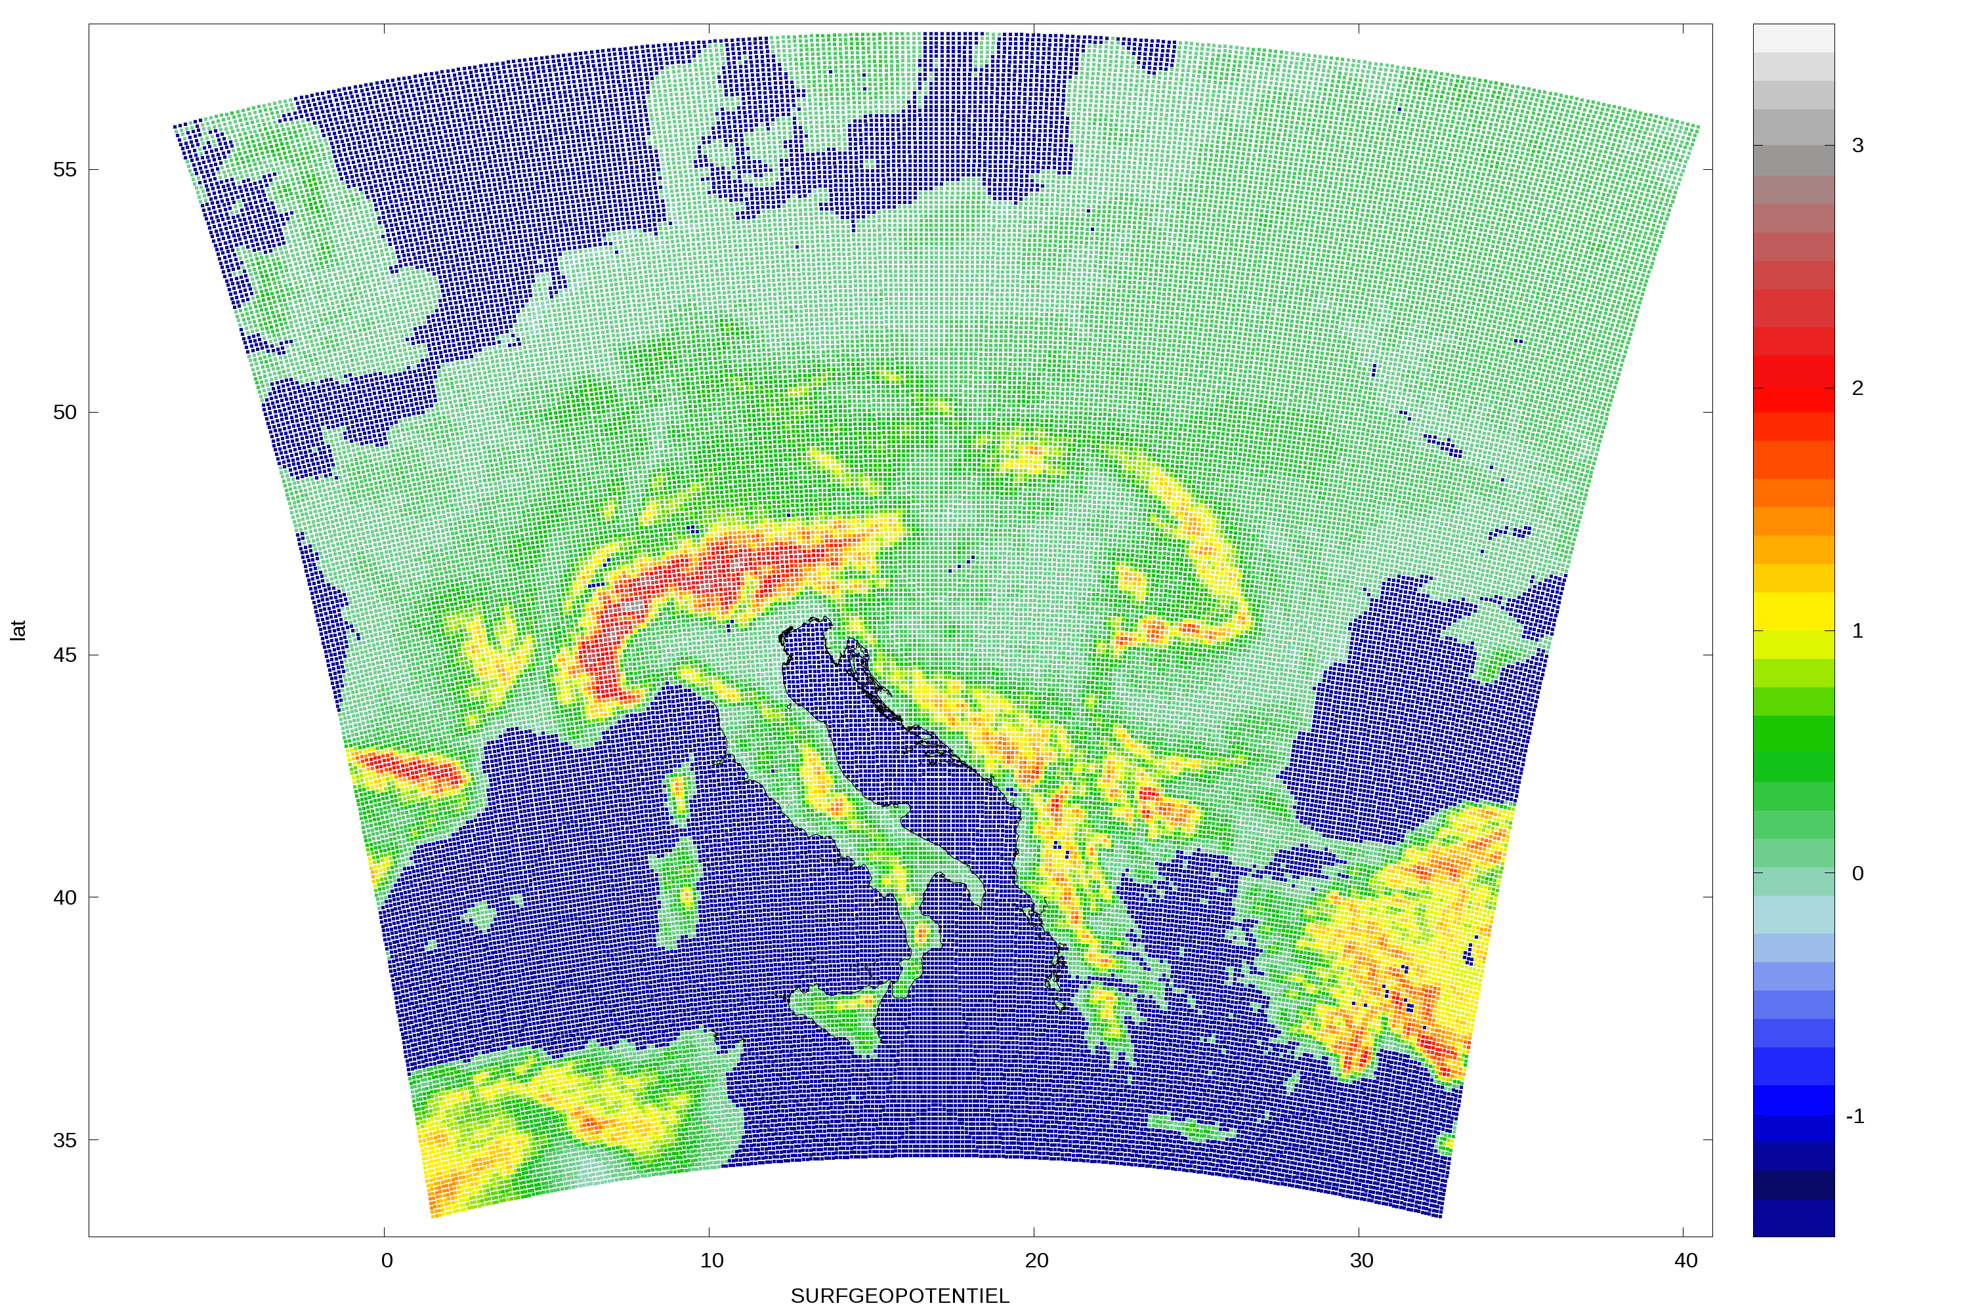 b)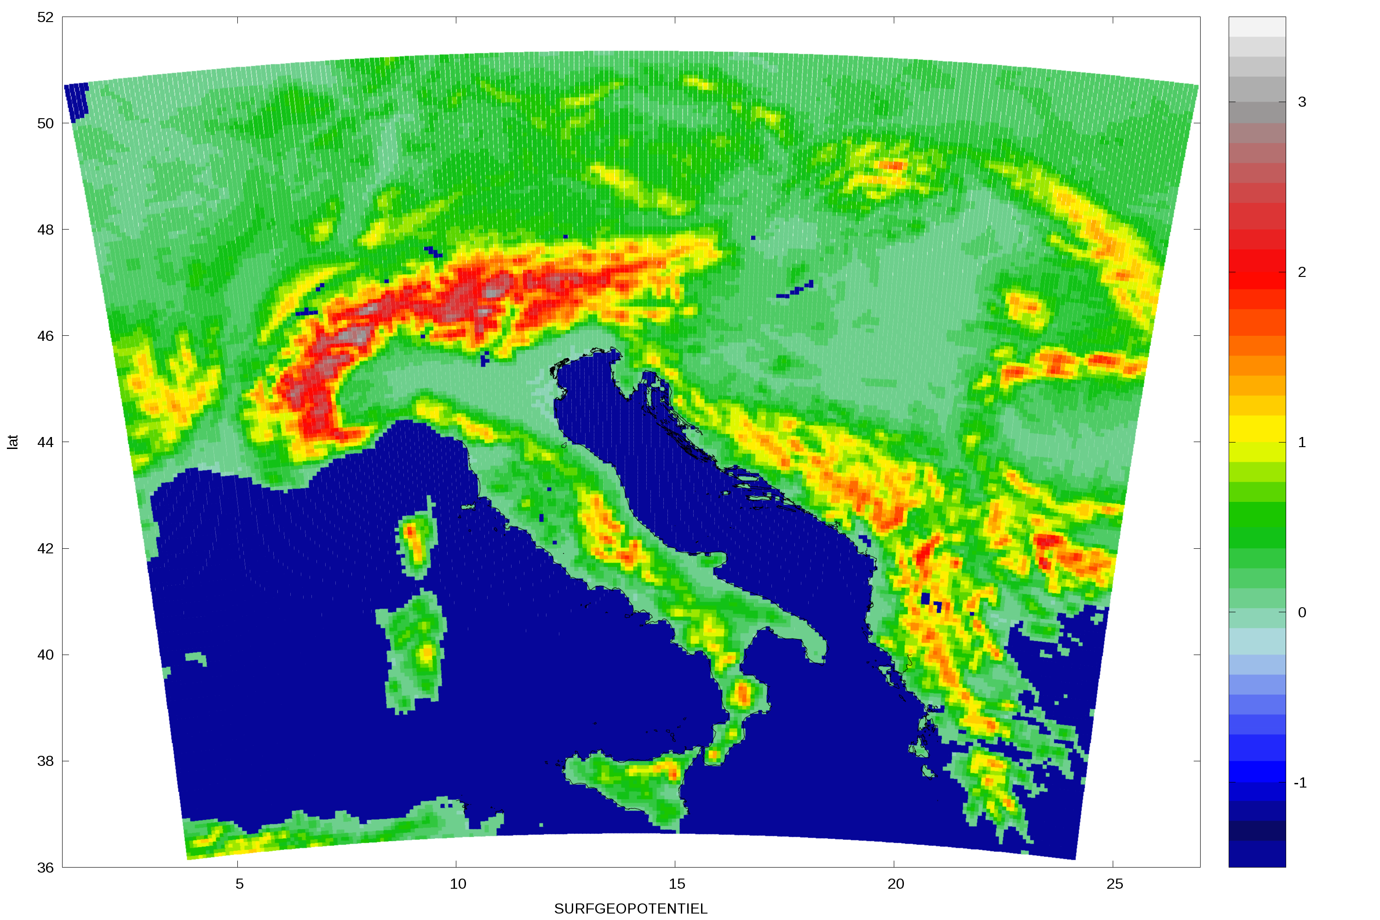
Figure dd1. The domain and terrain height (shaded in km, water points forced to blue) in the coupling file from ARPEGE (a) and 8 km resolution domain (b).

a)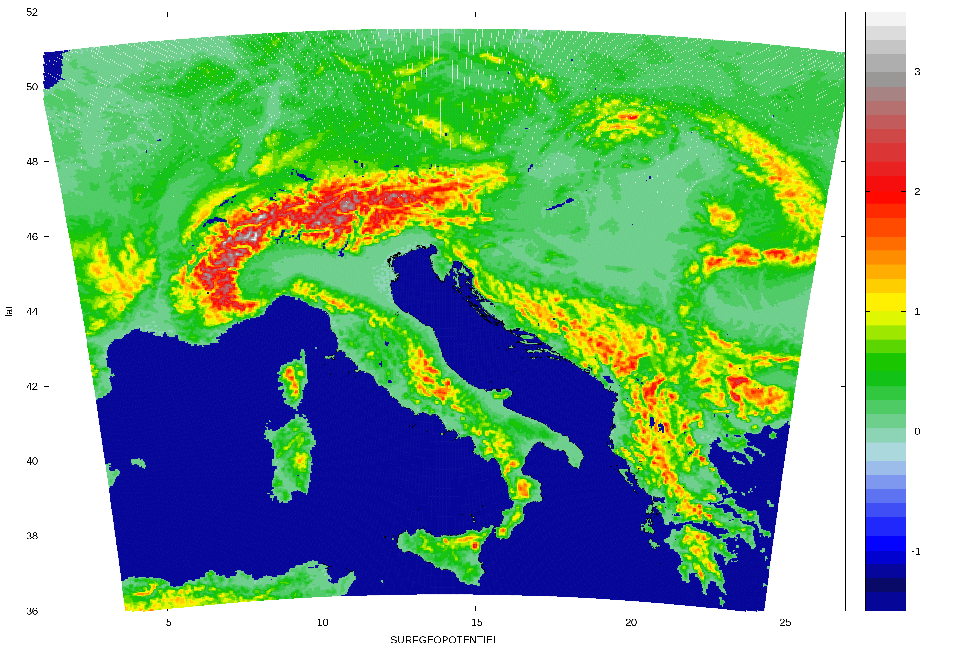 b)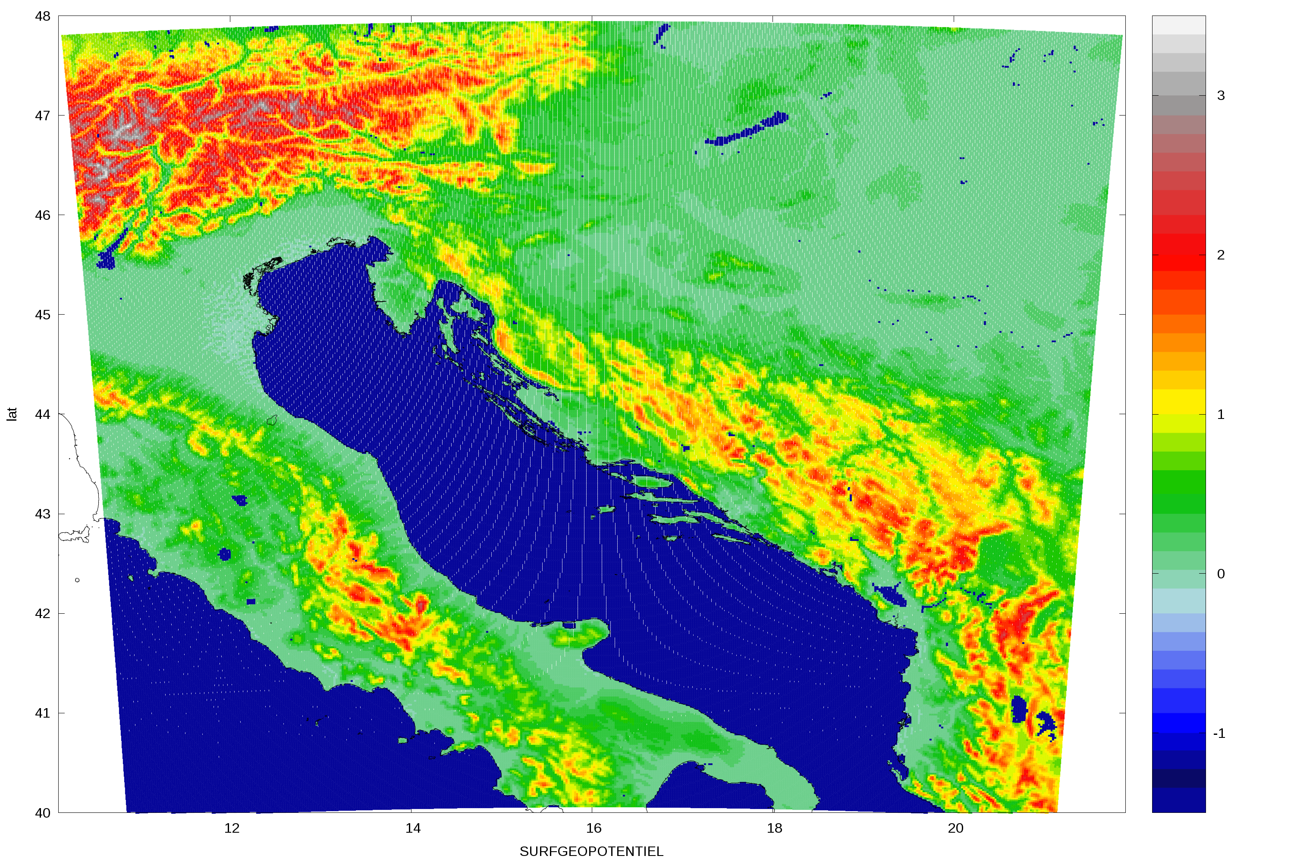
Figure dd2. The domain and terrain height (shaded in km, water points forced to blue) in the 4 km resolution domain (a) and 2 km resolution domain (b).

2.3 Lateral boundary conditions

On 1 January 2014, the operational ALADIN forecast suite in CMHS has switched from ARPEGE to IFS forecast data for LBCs. ARPEGE model data used to be the primary choice since it is available earlier than the IFS model data (the data assimilation procedure of operational IFS waits longer to assimilate more measured data).

LBCs from both IFS and ARPEGE are available with an interval of 3 hours, but the data from IFS are stretch up to 78 hours in advance, while the data from ARPEGE reach 72 hour forecast, and 18 UTC run reaches only 60 hour forecast.

However, the IFS LBC data are provided in 15.4 km resolution on 60 levels in the vertical (operational IFS currently runs in 16 km resolution on 137 levels), while the ARPEGE data are provided in 10.61 km resolution on 70 levels (allowed by the stretched grid of ARPEGE that has higher resolution above Europe). Meteo-France announced a plan to move to 8 km resolution LBC data provided on 105 levels by the summer 2015.

The ALADIN forecast is coupled to LBC fields from IFS in delayed mode. This means that LBC for 6 hour forecast from 18 UTC run of IFS is used for initial LBC for 00 run of the next day, 9 hour forecast from 18 UTC run of IFS is used for 3 hour forecast LBC for 00 run of the next day, and so on.

The coupling at the lateral boundaries is performed in a zone 8 gridpoints wide using Davies (1976) relaxation scheme. LBCs have to be time dependent and periodic (Haugen & Machenhauer, 1993) and applied at the very beginning or end of the grid-point computations (Radnoti, 1995). An overview of LAM defficiencies caused by LBCs is given in Werner et al. (1997). However, the largest error arrives from linear interpolation of LBC data in time (Tudor & Termonia, 2010) due to a long interval (3 hours) between available large scale data that are applied at lateral boundaries every LAM timestep (5.5 minutes). The operational nonhydrostatic forecast run in 2km resolution uses hourly LBC data from the operational 8 km resolution forecast.

2.4 The schedule of the operational forecast (molim pogledati I korigirati sto treba, SIS AS)

The operational ALADIN forecast used to be run twice per day, starting from 00 and 12 UTC analyses until the end of 2013. Since 1 January 2014, it runs four times per day, with two additional forecast starting from 06 and 18 UTC analyses. All 8km resolution forecasts are run up to 72 hours in advance. The domain is in a Lambert-projection with 8 km horizontal resolution on 37 hybrid sigma-pressure levels in the vertical. Operational forecast produces forecast fields with hourly output (as opposed to 3 hourly output before), (but only 3 hourly output is stored (??? SIS AS).

High resolution wind field forecast using a dynamical adaptation procedure (Ivatek-Šahdan and Tudor, 2004) produces 2 km resolution forecast of 10 m wind speed and gusts using the hourly output from the 8km resolution run. Therefore, the 2 km resolution dynamical adaptation also produces the wind forecast with hourly interval up to 72 hours in advance.

A 4 km resolution run has been introduced on 1 February 2015, the forecast is computed once per day, from 00 UTC analysis up to 72 hours in advance, and the products are available in the morning. The forecast is run on the domain covers roughly the same area as the 8km resolution one, on 73 levels in the vertical using a timestep of 3 minutes. Therefore the overall additional computational expense is about 16 times more than for the 8 km resolution run. The size of the output files is also 8 times larger (if they are stored with the same frequency as the 8 km resolution forecast). This poses a considerable effort for the computational and archive capabilities of CMHS.

Since 1 July 2011, the operational forecast includes a 2 km resolution ALADIN forecast that uses the non-hydrostatic (NH) dynamics and full set of physics parameterizations of ALARO0, including the convection scheme (Tudor and Ivatek-Šahdan, 2010). This forecast is run once per day too following the 00 UTC operational 8 km resolution forecast. The initial fields are obtained by interpolation of the 8 km resolution 6 hour forecast from 00 UTC operational run and initialized using scale selective digital filter initialization (SSDFI, Termonia 2008). The forecast range is 24 hours, until the 06 UTC of the next day in order to be comparable with the precipitation data from the dense national network of raingauges.

2.5 The data assimilation procedure

AS :) evo teksta za pretumbavanje I dodavanja

The data-assimilation procedure with 3Dvar is used to initialize the forecast run in 8 km resolution. The 4 km resolution run is currently initialized with surface assimilation, while the 3Dvar suite is under construction.

ALADIN model run is initialized using data assimilation in CMHS. Data assimilation combines information from measurements with an a priori estimate (a short range forecast referred to as the first-guess or background field). The procedure uses observation and background model errors, and produces the analysis respecting the model dynamical balances. The resulting atmospheric fields are considered “as best as possible” approximation of the true state of the atmosphere at a given time.
Two methods for DA are used at CMHS: the optimal interpolation (OI, Courtier 1999) for land surface fields and the variational method (3DVAR, Hollingsworth et al, 1998) for analysis of upper air fields. 2m analysis increments of temperature and humidity computed with OI are used to update the land surface variables Mahfouf (1991). A simple OI method was implemented for computing the 2m analysis increments that uses surface measurements to compute the increments of 2m temperature and relative humidity.

(ovo dalje od asimilaciji je jos prepisano, treba presloziti I skratiti)

For the upper air fields more control variables are defined, more sources of data are used, and more sophisticated variational algorithm (3DVAR) is implemented. 3DVAR belongs to the group of intermittent variational data assimilation strategies, and whereas the true state of the atmosphere is never known, the principal challenge in determining the analysis is to estimate the background (model) errors. Namely, knowledge of the background error statistics is used to derive the analysis increments and transfer this information in horizontal and vertical directions in the atmosphere. The background error statistics is in CMHS estimated by using the so-called standard NMC method. In this approach, background error statistics is derived from a set of differences between forecasts that are valid at the same time, but at different forecast horizons, typically 12 and 36 hours. In addition, the multivariate formulation of the background error statistics that uses vorticity, divergence, temperature and surface pressure, and humidity as control variables (Berre, 2000), allows the propagation of the analysis increments from one to all the other variables, and thus increases the effect of each single observation. Finally, the potential use of the ensemble and seasonal formulations of the background error statistics is currently being investigated.
Practical implementation of data assimilation setup in CMHS is illustrated in Figure 4 that shows the scheme of one assimilation cycle. Because of limited computer resources the assimilation cycle is run in quasi-operational mode i.e. observation data is taken at the operational time, but the assimilation procedure is performed with certain time delay. An assimilation cycle is a sequence of a 6 hour forecast and analysis that is run on a daily basis. In the first step, SST in the 6h forecast from previous cycle (background) is replaced with SST taken from global model ARPEGE analysis. This replacement is done because no local SST analysis is implemented. In the second step, the background land surface variables are updated. As there are almost no or very little surface observations available, 2m observations are used to retrieve information about the surface temperature and soil water content. Therefore, after the quality control of the 2m observations, an optimal interpolation is used to calculate increments of 2m temperature and relative humidity. These increments in a more or less sophisticated way are propagated into the land surface equivalents and used for updating the land surface variables. In the next step, the background upper air fields are analysed using 3DVAR. The standard NMC background error statistics is calculated by the aforementioned procedure over a 100-day period, from 15 Feb – 25 May 2008. The background error matrix was not tuned a posteriori such as in some other NWP systems (Bölöni and Horvath, 2010). The 3DVAR procedure includes a quality control of available data (screening) and minimization procedure that as output produces an analysis which is used for initiating the 6h forecast. The assimilation cycle is repeated every 6 hours, at 00, 06, 12 and 18 UTC. It is also run with a time delay big enough to enable usage of long cut off ARPEGE coupling files (the ARPEGE model is run later and in assimilation all data is used) for boundary conditions of 6h ALADIN forecast. Also long cut off data is used in cycle (data available after the time period needed to collect all observations of interest). Production from the assimilation cycle is done following same steps as in the assimilation cycle but at its end, a 72h forecast is performed. However, to perform a quasi-operational 72 hours forecast, timing constrain does not allow to use long cut off data and long cut off ARPEGE files; thus short cut off data and ARPEGE files are used.

2.6 The operational forecast in 8 km resolution

ALADIN is a spectral LAM with Fourier spectral representation of the model variables in both directions using fast Fourier transforms (FFTs) from spectral to grid-point space and back in each model time step with elliptic truncation (Machenhauer and Haugen, 1987) that ensures an isotropic horizontal resolution. The truncation wavenumber M in one direction is computed from the number of gridpoints N in the same direction using relation N>3M+1 so that the nonlinear terms of the model equations are computed without aliasing.
A semi-implicit time integration scheme (Robert, 1982) treats implicitly only a linearized form of the adjustment terms in the shallow water equations and solves the Helmholtz equation in spectral space with a second-order accurate treatment of the nonlinear residual (Gospodinov et al. 2001).
Two-time-level semi-Lagrangian scheme computes the advection of the prognostic variables used operationally. The model grid-points are the arrival points of the trajectory and the origin point values are computed by interpolation. There is a choice of semi-Lagrangian interpolators in the model, as they can be more or less diffusive (Staniforth and Cote, 1991).
A common 4th order numerical diffusion is applied at the end of the time step to remove the accumulation of energy at the shortest wavelengths from the high layers of the atmosphere due to spectral blocking. It is combined with semi-Lagrangian horizontal diffusion (SLHD, Vana et al., 2008), a more physical horizontal diffusion scheme that is based on the physical properties of the flow that combines two interpolators of different diffusivity with the flow deformation as a weighting factor.
The model equations are solved in the vertical on 37 levels of hybrid pressure type eta coordinate (Simmons and Burridge, 1981) using vertical finite elements as opposed to finite difference method that was used before.
The model prognostic variables treated by the semi implicit scheme in the hydrostatic version are surface pressure, the horizontal wind components, temperature and water vapour, with two more in the non hydrostatic dynamics: pressure departure and vertical divergence. However, there are more prognostic variables in the model computed in the model physics, advected by the semi-Lagrangian scheme and diffused by SLHD but not touched by the semi-implicit computations: cloud water and ice, rain and snow, convective entrainment, coludiness, updraft and downdraft vertical velocities and mesh fractions.

2.7 Introduction of the complete Alaro0 physics

Within the ALADIN community, a physics package had been developed for the convection permitting resolutions (instead of convection resolving resolution). The package has been named ALARO. It is used for the operational forecast in a number of countries, members of ALADIN and HIRLAM consortia since 2008 (at least 13 in 2015). In CMHS, operational forecast was performed using ALARO developments in turbulence, resolved cloudiness and precipitation schemes since February 2008. The improvements in the radiation scheme did not improve the cloud and temperature forecast in the stratus and fog case (Tudor, 2010) so only the exchange with surface was introduced and most of the additions were switched off through the namelist switches. The developments of prognostic convection were not available for operational purposes at the time.

The processes described by the model physics are said to be parameterized (Pielke, 2002). Processes such as radiation, cloud microphysics and exchange with surface are fully parametrized, as well as subgrid contributions from turbulence, convection and topography features. The physics contribution is coupled to the dynamics via a physics-dynamics interface. The interface is bases on flux-conservative system of equations (Catry et al., 2007).
The diagnostic convection scheme, operational for the 8 km resolution forecast until 2015, is a mass flux scheme that computes changes in momentum, heat and moisture in the vertical due to the convective processes. Within ALARO0 physics package, there is modular multiscale microphysics and transport (3MT) scheme for precipitation and clouds (Gerard and Geleyn, 2005; Gerard, 2007; Gerard et al., 2009). The scheme uses prognostic variables for updraft and downdraft vertical velocities and mesh fractions, entrainment and convective clouds.
The processes of condensation, evaporation, freezing, melting, aggregation and growth of cloud water and ice into rain and snow are described by the microphysics. Prognostic scheme for cloud water and ice, rain and snow and a statistical approach for sedimentation of precipitation (Geleyn et al., 2008) is derived upon the old diagnostic scheme based on the Kessler (1969) type scheme with modifications (Geleyn et. al. 1994).
The transfer, scattering, absorption and reflection of the shortwave solar radiation and long-wave thermal radiation of the Earth's surface and clouds are parametrized in radiation scheme (Geleyn and Hollingsworth, 1979, Ritter and Geleyn, 1982). The scheme uses only one spectral band for long-wave and one for short-wave radiation. The net exchange rate has been introduced in the scheme (Geleyn et. al. 2005a, 2005b) and recently switched on in the operational forecast set-up.
The vertical transfer of heat, momentum and moisture due to impact of the unresolved motion and surface roughness are described by turbulence parametrization that uses prognostic turbulent kinetic energy (TKE) that is advected, diffused (Geleyn et al., 2006) combined with modified Louis (1979) dependency on stability (Redelsperger et al., 2001).
The soil properties and their impact on the meteorological model variables is described by the surface scheme Interaction Soil Biosphere Atmosphere (ISBA, Noilhan and Planton, 1989, Noilhan and Mahfouf, 1996) that is also used in the assimlation of surface data (Giard and Bazile, 2000).
The prediction of the sensible weather at the Earth's surface relies on the output from the parameterization schemes (Pielke, 2002). The values of wind, temperature, relative and specific humidity at the heights of measurement (10 and 2 meters above surface) are computed using the fields from the lowest model level and surface using stability functions and Monin-Obukhov similarity theory (Geleyn, 1988).

2.8 Dynamical adaptation of wind to 2 km resolution

High resolution forecast of the 10m wind is computed using the method of dynamical adaptation (Žagar and Rakovec, 1999). The meteorological fields are interpolated from 8km resolution grid to a 2 km resolution one and from 37 to 15 levels in the vertical (but the lowest 10 levels are on similar heights). A hydrostatic ALADIN is run for 30 timesteps of 60 seconds using only turbulence parametrization (moist and radiation processes are ommited). The result is improved operational forecast of the 10 m wind (Ivatek-Šahdan and Tudor, 2004) that is used in case studies of severe wind (Tudor and Ivatek-Šahdan, 2002) and research impact studies (Bajić et al., 2007).

The method works well for wind that is at least moderate in strength, while it can produce artificial features around isolated island when wind is weak. Unfortunately, when strong wind is not a consequence of large scale forcing, but connected to a local pressure disturbance, the prediction is not so good and a full nonhydrostatic run is needed (Tudor and Ivatek-Šahdan, 2010) in order to model the small scale disturbances in the pressure field. This is why the nonhydrostatic ALADIN run using the complete ALARO0 physics package has been introduced to the operational suite on 1 July 2011.

- Tuning and validation of ALARO0 in 8km resolution

ALARO0 package of physics parametrization is included in the code version AL38T1 that has been ported to the CMHS mainframe computer and tested extensively on the domain for operational forecast with 8 km resolution on 37 levels in the vertical. Tests of different options for tuning parameters in physics and dynamics were performed by running 72 hour forecasts starting from 00 analyses for the two whole months, for January and May 2014. These tests revealed that the assumption of cloud overlap plays the most important role in scores for the forecast in 2m temperature. The forecast that uses the random overlap assumption performs better than the forecast using random maximum assumption in winter when the weather is characterized by low stratus and fog, but not in spring and summer with more cumulus clouds.

The operational forecast suffers from large positive bias in the upper portion of the troposphere and a less pronounced negative bias in the layers below 700 hPa. This bias can be reduced via various tuning options. But the same positive bias in the upper troposphere and a negative bias below can be found in both sets of coupling files, from IFS and ARPEGE. The negative bias in the upper troposphere can be reduced via various tuning parameters, consequently the negative bias below can be reduced too. But the excess moisture (or the absence of it) arrives from the lateral boundaries. The model is forced to remove the error arriving from lateral boundary conditions. And as a consequence, there is an excess flux of water substances downward, including precipitation. The question is if we should tune the model to do something unphysical only to get better scores or keep the physical values and reasonable patterns in precipitation, keeping in mind that some of the error arrived through lateral boundaries.

- Tests in 4 km resolution

5. Conclusion

An overview of the operational set-up of the NWP model ALADIN in CMHS is described with an emphasis of recently introduced changes. ALADIN is a state-of-the-art modern NWP model.

A high-resolution LAM is intended to predict the sub-synoptic weather features forced by topography or other local characteristics that can be absent in the main synoptic pattern. Successful prediction of these small-scale features enables usage of the LAM forecast in predicting the conditions important for the flight safety, vehicle road safety or navigation at sea. The operational suite has to be tuned in order to predict the high-impact weather events of local character that could be missing in the large scale forecast. The domain properties as well as the forecast model complexity are formed according to the needs of the forecast users and the computing capabilities.
High impact weather events can be of local origin, or determined by small scale characteristics particular to a certain region. Croatia is not spared from severe weather events, such as severe windstorms (bura and jugo wind), torrential rain and flash floods. Such events are often forecast in terms of probability via the ensemble prediction system of a global model. The severity of the event can be controlled by mechanisms not resolved by the global model, and dynamical adaptation of the individual EPS members improves the predictability of the severe weather events (Branković et al., 2007). The NWP section of CMHS has invested most effort in the deterministic high-resolution forecast based on analysis of numerous high impact weather cases.
The operational 8 km resolution forecast is run using DFI with the initial file from the global model ARPEGE since most of the measured data is assimilated in the global model. The data-assimilation suite has been established and runs parallel to the operational suite forecast. This parallel run has revealed the benefits of doing the data-assimilation in higher resolution (8 km) than in the global model (see the Pula flash flood case).
Forecasting the formation and distribution of fog is controlled by subtle variations in humidity and temperature fields and require maintenance of a sensitive balance between the advection, radiation and turbulent fluxes. The profound influence of topography on the atmospheric flow reflects itself in a number of features that affect local weather, such as upslope, downslope and gap winds, coastal barrier jets as well as land sea breezes.
The operational high-resolution (2 km) forecast of the 10 m wind is achieved through the dynamical adaptation method adapted from Žagar & Rakovec (1999). The prediction of severe wind variability and strength is improved in weather situations with strong flow over complex topography, like bura in Croatia (Ivatek-Šahdan & Tudor, 2004). This high resolution wind forecast has provided warnings in numerous cases severe wind as well as to forecast the road conditions, assess the wind energy potential (Horvath et al., 2011) and has been used in numerous applications.
The forecast abilities of HRDA and similar packages are limited to the severe windstorms related to a synoptic forcing. Omitting moist and radiation processes prevents it from being useful in forecasting other phenomena could benefit from the high resolution, such as local convective storms. The windstorm that is a consequence of a local pressure disturbance requires a full forecast run in 2 km resolution using more complex NH ALADIN model set-up (Tudor & Ivatek-Šahdan, 2010). Several air crash investigations have revealed that this "full-run" high resolution ALADIN forecast enables the prediction of lee waves and zones of increased turbulence as well as icing zones.
These flaws of the operational suite have encouraged the introduction of the 2 km resolution 24 hour forecast with NH ALADIN set-up using the complete set of physics parameterizations to the operational suite at the beginning of summer 2011. Several case studies of high-impact weather phenomena have been used to set-up the model configuration used operationally. The results from these studies have provided encouraging results.

Once a day full non-hydrostatic forecast using AL36T1 with Alaro physics is run in 2 km resolution on 37 levels on the same domain up to 24 hours. This run uses interpolated fields from the 6 hourly forecast of the 8km resolution 00 UTC run as initial conditions. The non-hydrostatic ALADIN forecast in 2 km resolution is still run once per day starting from 6 hour forecast of HR88 00 UTC run.

On 27th January 2015 the operational executable has been replaced with AL38T1 and the complete Alaro physics package is used for operational forecast (but still on 37 levels only). It is planned to replace the 8 km resolution domain with a 4 km resolution one on 73 levels and this is currently in pre-operational testing.

5. References

ALADIN International Team, (1997) The ALADIN project: Mesoscale modelling seen as a basic tool for weather forecasting and atmospheric research. WMO Bull., 46, 317–324.
Berre L. (2000) Estimation of Synoptic and Mesoscale Forecast Error Covariances in a Limited-Area Model, Mon. Wea. Rev. 128, 644-667.
Bölöni, G., Horvath K. (2010) Diagnosis and tuning of the background error statistics in a variational data assimilation system. Időjárás 114, 1-19.
Branković, Č., Matjačić, B., Ivatek-Šahdan, S. & Buizza, R. (2007) Dynamical downscaling of ECMWF EPS forecasts applied to cases of severe weather in Croatia. ECMWF RD Technical Memorandum 507, 38 pp.
Branković, Č., Matjačić, B., Ivatek-Šahdan, S. & Buizza, R. (2008) Downscaling of ECMWF Ensemble Forecasts for Cases of Severe Weather: Ensemble Statistics and Cluster Analysis. Mon.Wea. Rev. 136, 3323–3342.
Brozkova R, Klarić, D., Ivatek-Šahdan, S., Geleyn, J.F., Casse, V., Siroka, M., Radnoti, G., Janousek, M., Stadlbacher, K., Seidl, H. (2001) DFI blending: an alternative tool for preparation of the initial conditions for LAM. WGNE Blue Book. 31, 1.7-1.8.
Catry B., Geleyn J.-F., Tudor M., Bénard P. & Trojakova A. (2007). Flux conservative thermodynamic equations in a mass-weighted framework. Tellus 59A, pp 71–79
Courtier, 1999: Data assimilation concepts and methods, ECMWF lecture notes, European Centre for Medium-Range Weather Forecasts, Reading, England, 59 pp.
Davies, H. C. (1976) A lateral boundary formulation for multilevel prediction models. Quart. J. Roy. Meteor. Soc., 102, 405–418.
Davies, H. (1983) Limitations of some common lateral boundary schemes used in regional NWP models. Mon. Wea. Rev., 111, 1002–1012.
Durran, D.R. (1999) Numerical methods for wave equations in geophysical fluid dynamics. Springer, pp 465.
Geleyn J.-F. (1988). Interpolation of wind, temperature and humidity values from model levels to the height of measurement. Tellus, 40A, pp.347–351
Geleyn, J.-F., Bazile, E., Bougeault, P., Déqué, M., Ivanovici, V., Joly, A., Labbé, L., Piedélièvre, J.-P., Piriou, J.-M., Royer, J.-F. (1994) Atmospheric parametrizations schemes in Meteo-France's ARPEGE NWP model. ECMWF seminar proceedings on Parametrization of sub-grid scale physical processes, pp. 385-402.
Geleyn J.-F. & Hollingsworth A (1979) An economical analytical method for the computation of the interaction between scattering and line absorption of radiation. Beitr Phys Atmos 52:1–16.
Geleyn J.-F., Benard P. & Fournier, R. (2005a) A general-purpose extension of the Malkmus band-model average equivalent width to the case of the Voigt line profile. Quart. J. Roy. Meteor. Soc. 131:2757–2768
Geleyn J.-F., Fournier R., Hello G., Pristov N. (2005b) A new ‘bracketing’ technique for a flexible and economical computation of thermal radiative fluxes, scattering effects included, on the basis the Net Exchanged Rate (NER) formalism. WGNE Blue Book
Geleyn J.-F., Vana F., Cedilnik J., Tudor M. & Catry B. (2006). An intermediate solution between diagnostic exchange coefficients and prognostic TKE methods for vertical turbulent transport. WGNE Blue Book
Geleyn J.-F., Catry B., Bouteloup Y. & Brožkova, R. (2008). A statistical aproach for sedimentation inside a microphysical precipitation scheme. Tellus 60A,649–662
Gerard, L. (2007) An integrated package for subgrid convection, clouds and precipitation compatible with the meso-gamma scales. Quart. J. Roy. Meteor. Soc., 133, 711–730.
Gerard, L. & Geleyn, J.-F. (2005) Evolution of a subgrid deep convection parametrization in a limited area model with increasing resolution. Quart. J. Roy. Meteor. Soc., 131, 2293–2312.
Gerard, L., Piriou, J.-M., Brožková, R., Geleyn, J.-F. & Banciu, D. (2009) Cloud and Precipitation Parameterization in a Meso-Gamma-Scale Operational Weather Prediction Model. Mon. Wea. Rev., 137, 3960–3977.
Giard, D. and Bazile, E. (2000) Implementation of a new assimilation scheme for soil and surface variables in a global NWP model. Mon. Wea. Rev. 128, 997-1015.
Gospodinov, I., Spiridonov, V., & Geleyn, J.-F., (2001) Second order accuracy of two-time-level semi-Lagrangian schemes. Quart. J. Roy. Meteor. Soc., 127, 1017–1033.
Haugen, J. E. & Machenhauer, B. (1993) A spectral limited-area model formulation with time-dependent boundary conditions applied to the shallow-water equations. Mon. Wea. Rev., 121, 2618–2630.
Hdidou, F.Z., (2006) Test of an assimilation suite for ALBACHIR based on the variational technique. available at www.wmo.int
Hólm, E.V., 2008: Lecture notes on assimilation algorithms. ECMWF, European Centre for Medium-Range Weather Forecasts, Reading, England, 30 pp.
Hollingsworth, F. Rabier and M. Fisher, 1998: The ECMWF implementation of three-dimensional variational assimilation (3d-Var). I: Formulation. Quart. J. Roy. Meteor. Soc., 124, 1783-1807.
Horvath, K., Bajić, A., & Ivatek-Šahdan, S. (2011) Dynamical Downscaling of Wind Speed in Complex Terrain Prone To Bora-Type Flows. J. Appl. Meteor. Climatol., 50, 1676–1691.
Horvath, K., Ivatek-Šahdan, S., Ivančan-Picek, B. & Grubišić, V. (2009) Evolution and structure of two severe cyclonic bora events: contrast between the northern and southern Adriatic. Weather and forecasting 24, 946-964.
Ivatek-Šahdan, S. & Ivančan-Picek, B. (2006) Effects of different initial and boundary conditions in ALADIN/HR simulations during MAP IOPs. Meteorol. Z. 15, 187–197.
Ivatek-Šahdan, S. & Tudor M. (2004) Use of high-resolution dynamical adaptation in operational suite and research impact studies. Meteorol Z 13(2):1–10
Kann A., Seidl H., Wittmann C. & Haiden T. (2009) Advances in predicting continental low stratus with a regional NWP model. Wea. Forecasting, 25, 290–302.
Kessler E. (1969) On distribution and continuity of water substance in atmospheric circulations. Meteorol Monogr Am Meteorol Soc 10(32):84
Louis J.-F., Tiedke M. & Geleyn J.-F. (1982) A short history of PBL parameterization at ECMWF. In: Proceedings from ECMWF workshop on planetary boundary layer parameterization, 25–27 November 1981, pp 59–79
Lynch, P., X.-Y. Huang (1994) Diabatic Initialization using recursive filters. – Tellus 46A, 583–597.
Machenhauer, B., J.E. Haugen (1987) Test of a spectral limited area shallow water model with timedependent lateral boundary conditions and combined normal mode/semi-lagrangian time integration schemes. Techniques for Horizontal Discretization in Numerical Weather Prediction Models, 2–4 November 1987, ECMWF, 361–377.
Mahfouf, J.,F., 1991: Analysis of soil moisture from near-surface variables: A feasibility study. J. Appl. Meteor., 30, 1534-1547
Morcrette J.-J. (1989) Description of the radiation scheme in the ECMWF Model. Tech Memo 165, ECMWF, 26 pp
Noilhan, J., Planton, S. (1989) A simple parapetrization of land surface processes for meteorological models. Mon. Wea. Rev. 117, 536-549.
Pauluis O., Emanuel K. (2004) Numerical instability resulting from infrequent calculation of radiative heating. Mon Weather Rev 132:673–686
Pielke, R.A. (2002) Mesoscale meteorological modelling. Academic press, pp 676.
Radnóti, G. (1995) Comments on ‘‘A spectral limited-area formulation with time-dependent boundary conditions applied to the shallow-water equations". Mon. Wea. Rev., 123, 3122– 3123.
Redelsperger J.L., Mahé F., Carlotti P. (2001). A simple and general subgrid model suitable both for surface layer and free-stream turbulence. Bound.-Layer Meteor. 101, pp.375–408.
Ritter B. & Geleyn J.-F. (1992) A comprehensive radiation scheme for numerical weather prediction models with potential applications in climate simulations. Mon Wea. Rev 120:303–325
Robert, A. (1982) A semi-Lagrangian and semi-implicit numerical integration scheme for the primitive equations. J. Meteor. Soc. Japan, 60, 319-325.
Simmons, A.J., Burridge, D.M. 1981: An Energy and Angular-Momentum Conserving Vertical Finite-Difference Scheme and Hybrid Vertical Coordinates. Mon. Wea. Rev. 109, 758–766.
Staniforth A, Côté J. (1991) Semi-Lagrangian integration schemes for atmospheric models – A review. Mon. Wea. Rev. 119 2206–2223.
Termonia, P. (2008) Scale-selective digital filtering initialization. Mon. Wea. Rev., 136, 5246–5255.
Tudor M. (2010). Impact of horizontal diffusion, radiation and cloudiness parameterization schemes on fog forecasting in valleys. Met. Atm. Phy. Vol.108, pp. 57-70.
Tudor, M. & Ivatek-Šahdan, S. (2002) The MAP-IOP 15 case study. Cro. Met. J. 37, 1-14.
Tudor, M. & Ivatek-Šahdan, S. (2010) The case study of bura of 1st and 3rd February 2007, Meteorol. Z., 19, pp. 453-466.
Tudor, M., Termonia, P., (2010) Alternative formulations for incorporating lateral boundary data into limited-area models. Mon. Wea. Rev. 138, pp. 2867-2882.
Unden, P., Rontu, L., Jarvinen, H., Lynch, P., Calvo, J., Cats, G., Cuxart, J., Eerola, K., Fortelius, C., Garcia-Moya, J.A., Jones, C., Lenderlink, G., McDonald, A., McGrath, R., Navascues, B., Nielsen, N., Odegaard, V., Rodriguez, E., Rummukainen, M., Room, R., Sattler, K., Hansen Sass, B., Savijarvi, H., Schreur, B., Sigg, R., The, H., Tijm, S., (2002) HIRLAM-5 scientific documentation. SMHI, S-601 76 Norrkoping, Sweden, pp 146, available at www.hirlam.org
Váňa F., Bénard P., Geleyn J.-F., Simon A. & Seity Y. (2008). Semi-Lagrangian advection scheme with controlled damping–an alternative way to nonlinear horizontal diffusion in a numerical weather prediction model. Quart. J. Roy. Meteor. Soc, Vol.134, pp. 523–537.
Warner, T., Peterson, R., Treadon, R. (1997) Atutorial on lateral boundary conditions as a basic and potentially serious limitation to regional numerical weather prediction. Bull. Amer. Meteor. Soc., 78, 2599–2617.
Xu K.-M. & Randall D.A. (1996) A semi-empirical cloudiness parameterization for use in climate models. J Atmos Sci 53:3084–3102
Yessad, K (2011) Library architecture and history of the technical aspects in ARPEGE/IFS, ALADIN and AROME in the cycle 40 of ARPEGE/IFS. Meteo-France, pp. 22, available at http://www.cnrm.meteo.fr/gmapdoc/IMG/pdf/ykarchi40t1.pdf
Žagar, M., Rakovec, J. (1999): Small-scale surface wind prediciton using dynamical adaptation. Tellus, Vol.51A, pp. 489–504.

