Study of a heavy precipitation event over Rijeka (Croatia), in the frame of HYMEX project: Observational analysis and model results

Stjepan Ivatek-Šahdan, Antonio Stanešić, Martina Tudor, Alica Bajić, Tomislav Kovačić, Kristian Horvath, …

Meteorological and Hydrological Service
Zagreb
Grič 3
Croatia

Abstract
In the evening of 12 September 2012 intensive rainfall event occurred in wider area of Rijeka and parts of Kvarner bay. Here we show available measured data and model results. The operational forecast using ALADIN model in 8 km resolution underestimated the rainfall intensity. The operational non-hydrostatic run in 2 km using ALARO physics package improved the forecast. The case has been used as a test-bed for testing the new operational suite in 4 km resolution on 73 levels.

Introduction

In September 2012, the operational forecast suite consisted of forecast in 8km resolution on 37 levels (domain shown in Figure 1) up to 72 hours. Lateral boundary conditions were taken from operational ARPEGE and ALADIN was initialized with 3Dvar. The wind field is further dynamically downscaled to 2 km resolution (domain also shown in Figure 1) on 15 levels in the vertical (but the lowest 8 are as for 37 level run). It uses each output file of the 8 km resolution forecast and runs the model for 30 minutes to adapt the wind to high resolution topography. The hydrostatic dynamics is used with turbulence parametrization from physics, other parametrisations are switched off. Once a day full non-hydrostatic forecast using AL36T1 with Alaro physics is run in 2 km resolution on 37 levels on the same domain up to 24 hours. This run uses interpolated fields from the 6 hourly forecast of the 8km resolution 00 UTC run as initial conditions.

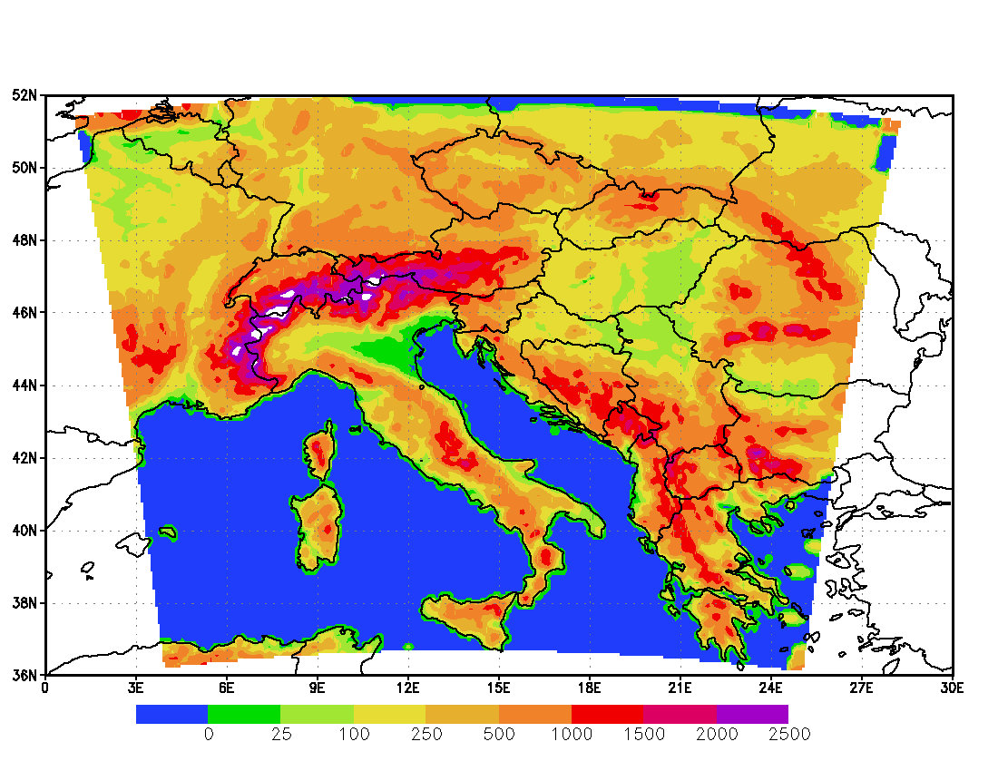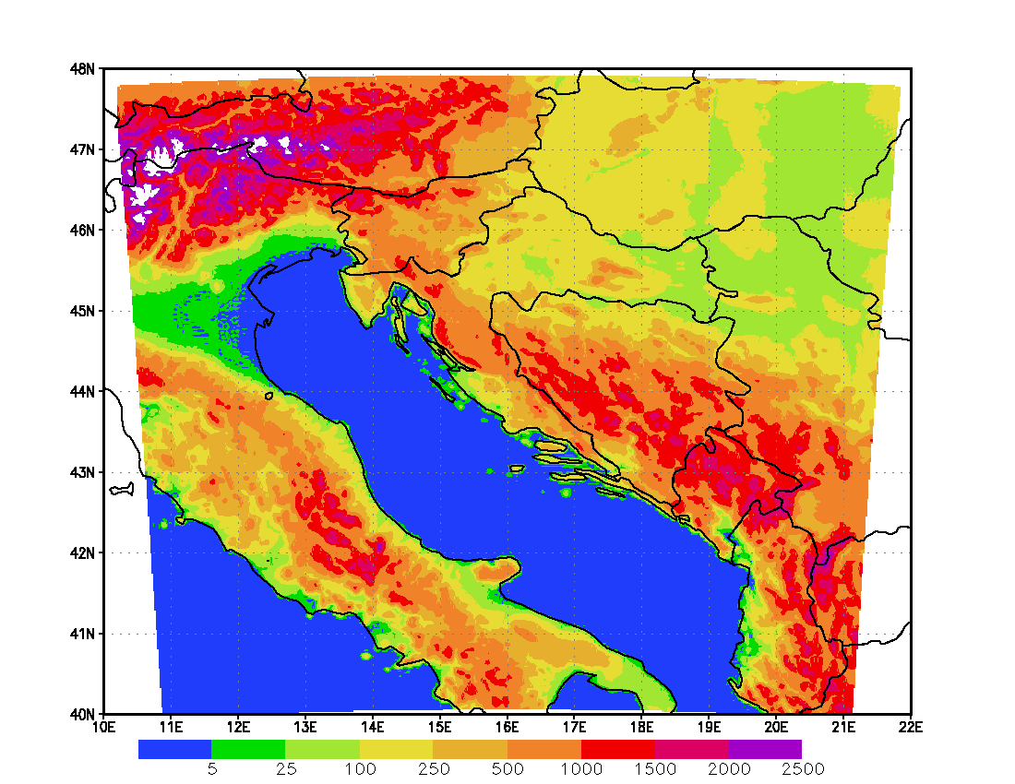
Figure 1. Terrain height in 8 km resolution operational domain (left) and 2km resolution operational domain (right). The 2km resolution domain is used for dynamical adaptation of wind up to 72 hours and non-hydrostatic forecast.

Consecutive runs forecast HPE over NE Adriatic coast – NE Italy, Slovenia and Croatia. The forecast precipitation amounts exceed 30 mm/3hr on considerable area. A warning for HPE and severe wind was issued for Croatia.

A large scale situation preceeding the event was characterized by a deep trough extending from Norwegian Sea to the French-Spanish border on Wednesday 12 Sep 2012 afternoon. The associated front stretched from Norway, across Germany and France. Pronounced 300 hPa jet ran behind the trough. The system moved eastwards. Northern Italy and Northern Adriatic was undergoing the advection of warm and moist air while in the area of Southwestern Alps strong cold advection prevailed. The cyclogenesis was initiated. The intense intrusion of the stratospheric air with high potential vorticity occurred in the cyclogenetic area making the atmosphere highly unstable.

Simultaneously with the Genoa cyclogenesis, a twin cyclone developed in the Northern Adriatic. The Croatian coast of Northern and Middle Adriatic was influenced by the strong moist southwestern flow on the leading side of the cyclone(s).
Due to its specific position deep in Kvarner bay which is open from the southwest and, at the same time, in the very pedestal of the Velebit mountain chain, Rijeka and its suroundings have the geographic preconditions for pronounced convection with extensive precipitation in such specific synoptic conditions.

No casualties – there was a warning issued repeatedly in all media (TV, radio, papers, interner), the event took place in the middle of the night, water flow in the streets carried cars downstream. Heavy rain and acompanying severe SE and then NE wind disturbed organisation of Arena Ice Fever MMXII in Pula on 14th Sep. But the event of the first evening took place with 2 hour delay.
(kad je personal nek je personal … slobodno izbacite)

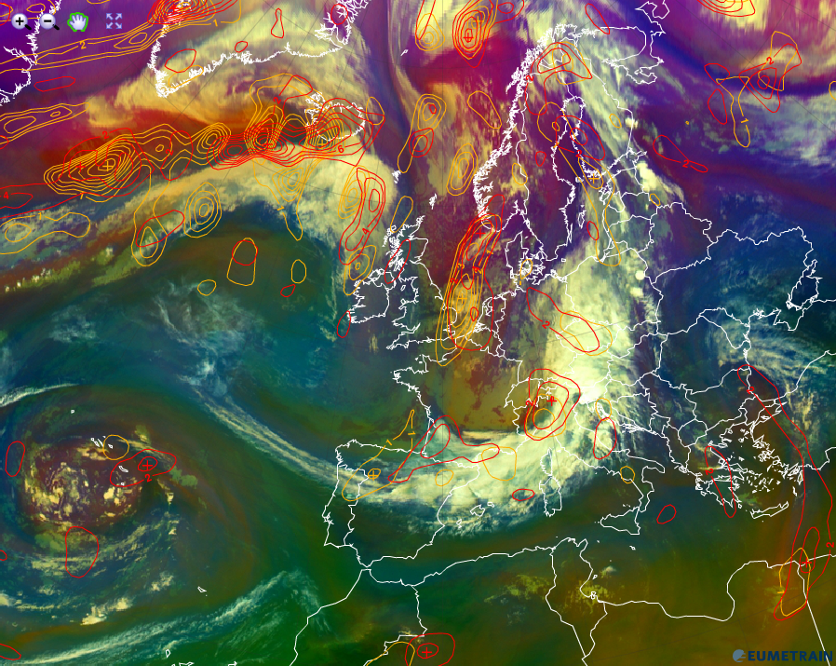
Figure 2. Airmass RGB image for 18 UTC on 12 Sep 2012 overlapped with ECMWF PVA300 (red) and PVA500 (orange) forecast fileds.

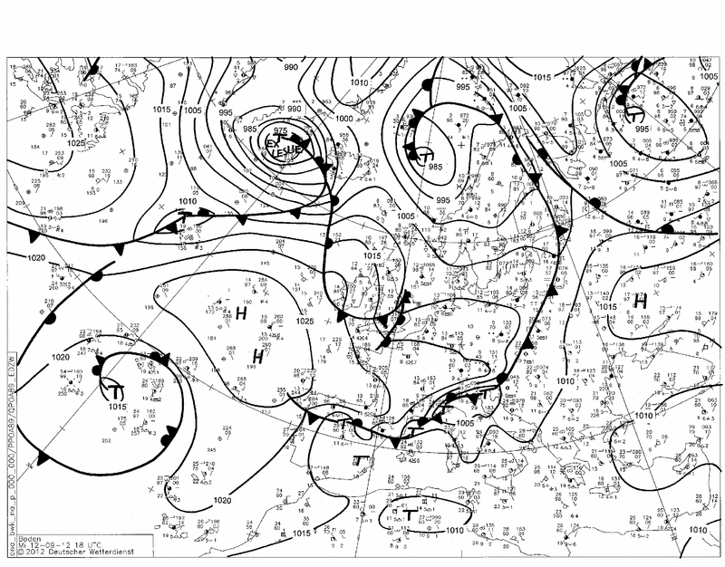
Figure 3. DWD surface analysis for 18 UTC on 12 Sep 2012

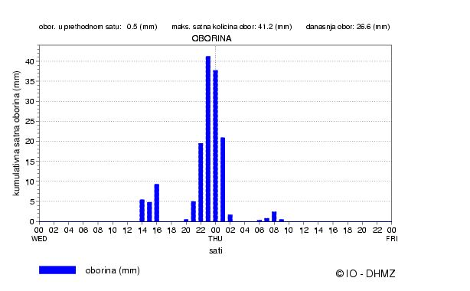
Figure 4. Hourly precipitation measurements, automatic weather station Rijeka for Wed 12 Sep and Thu 13 Sep 2012, LT indicated.

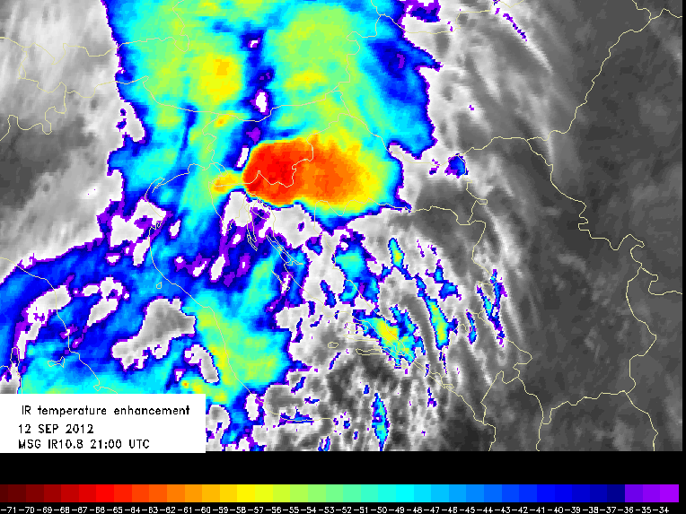
Figure 5. IR temperature enhanced satellite image for 21 UTC on 12 Sep 2012.

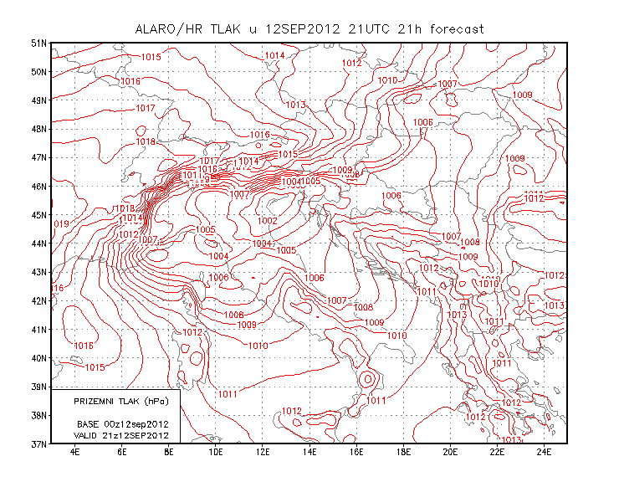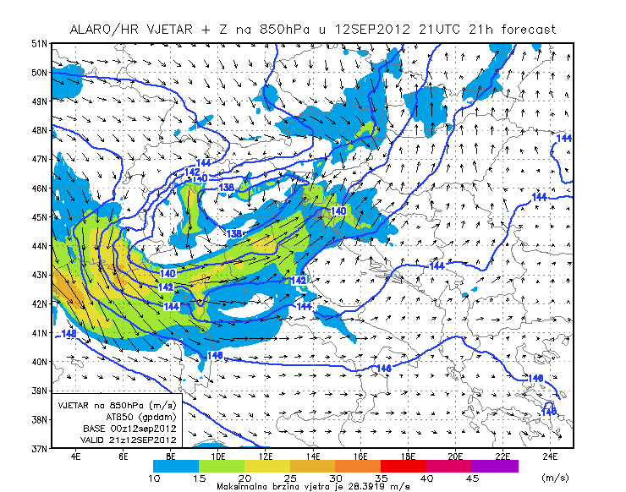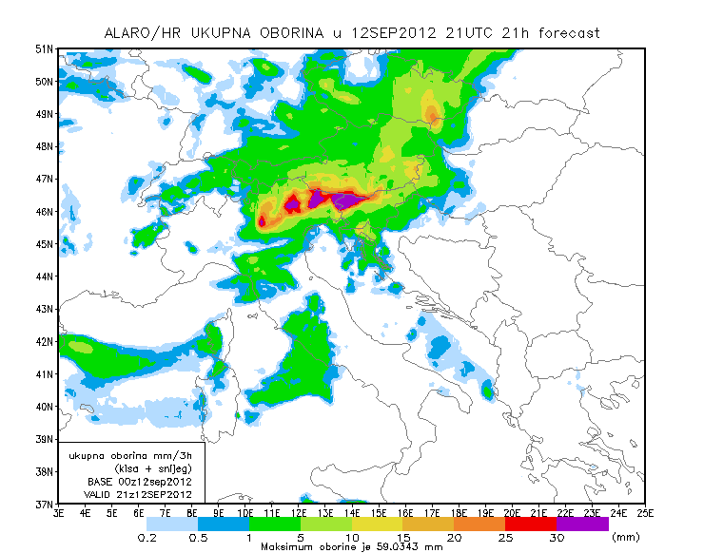Figure 6.

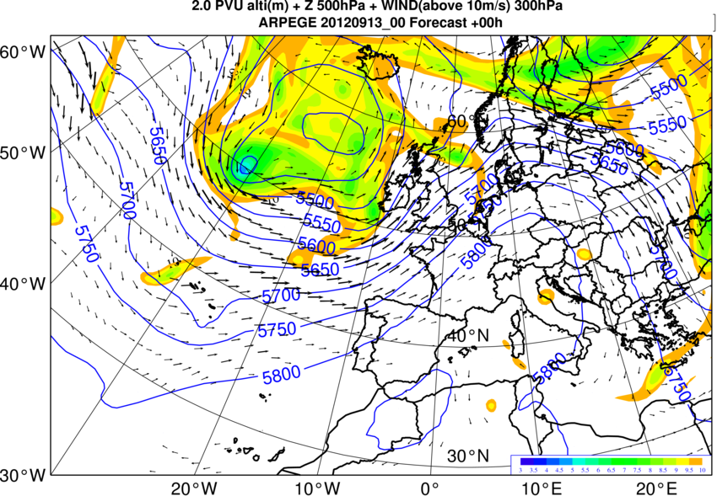
Figure 7. The closest analysis

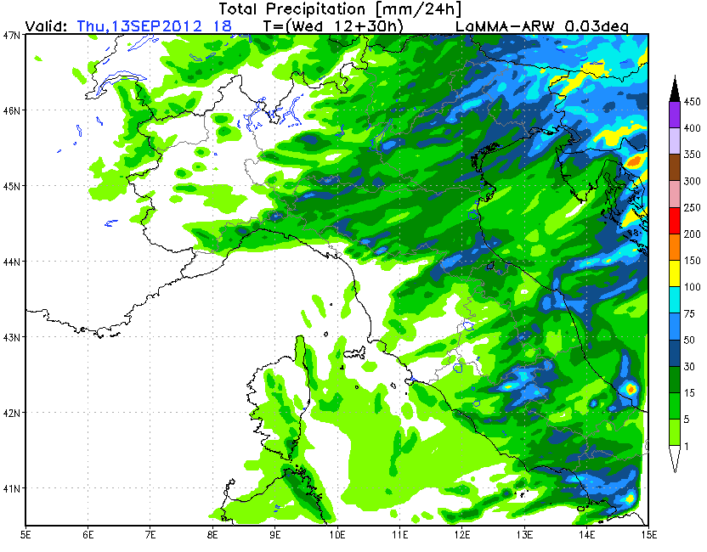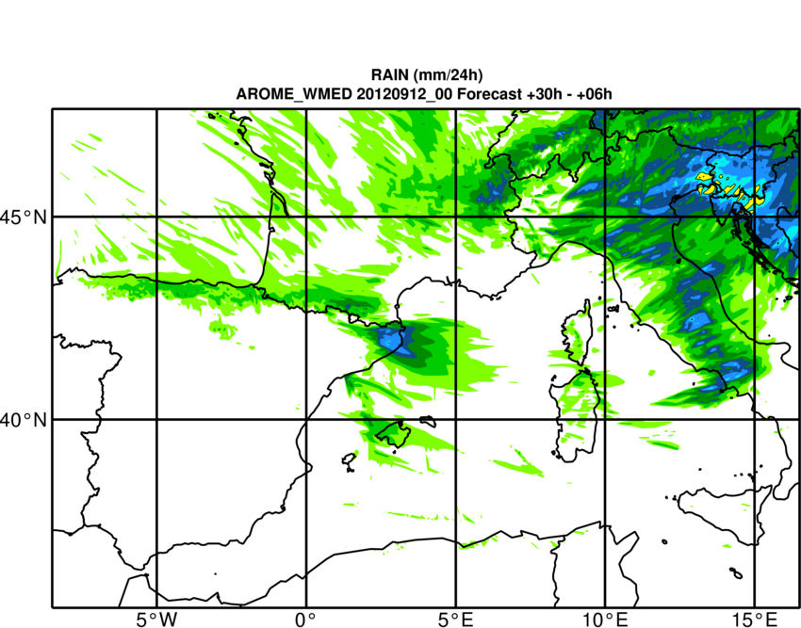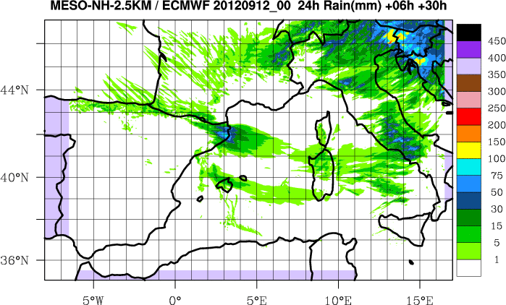
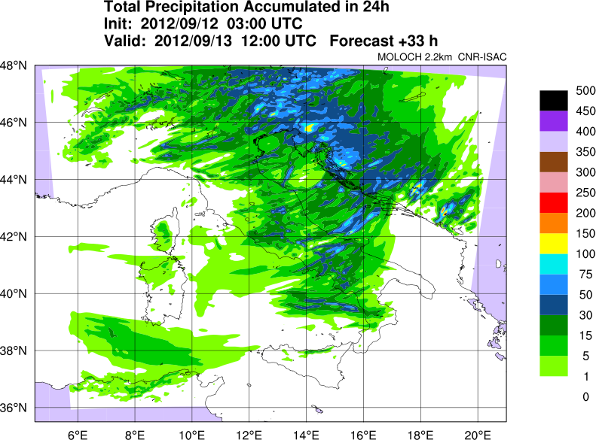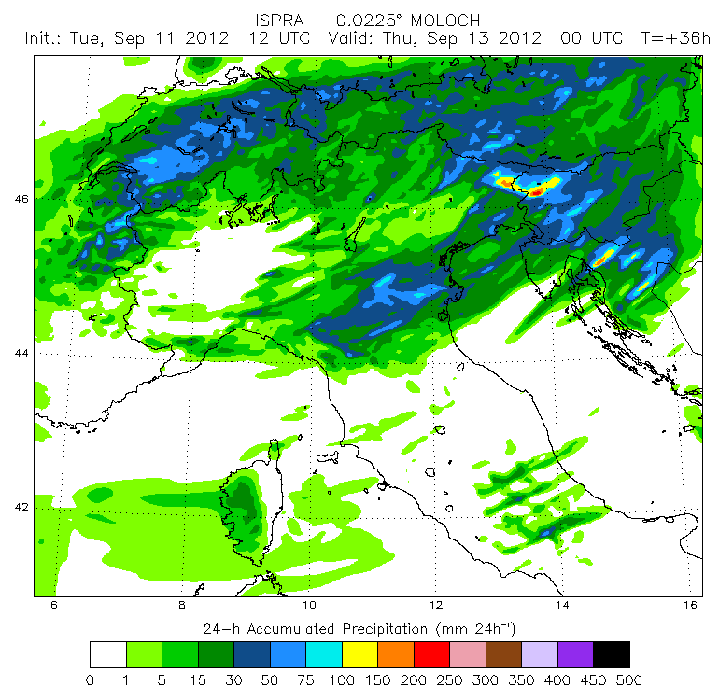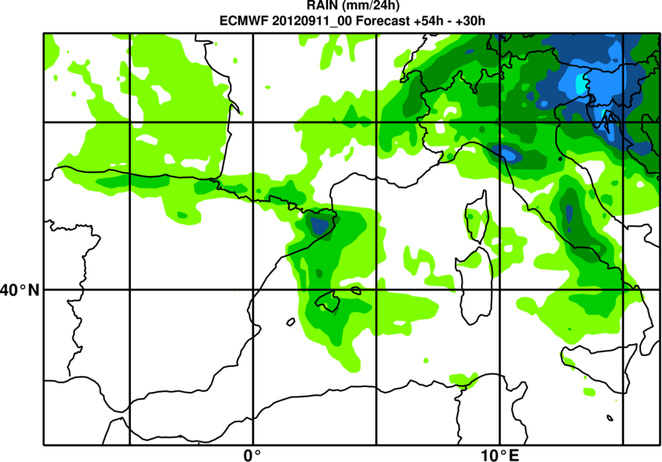
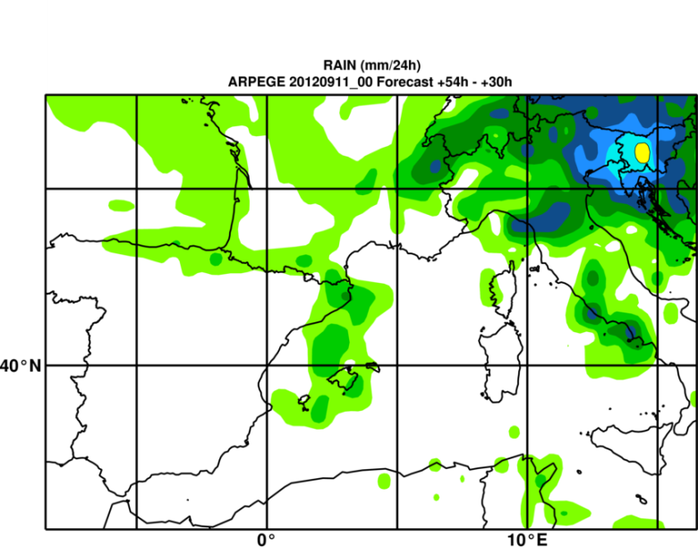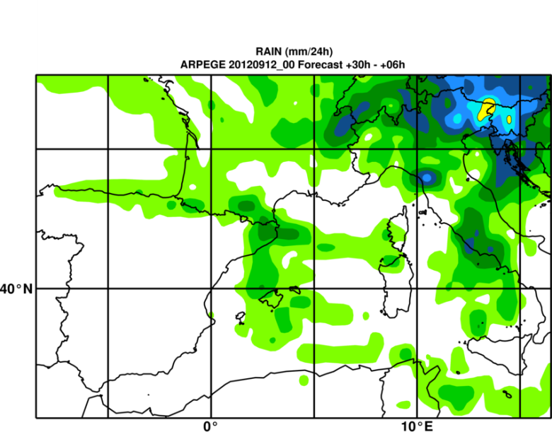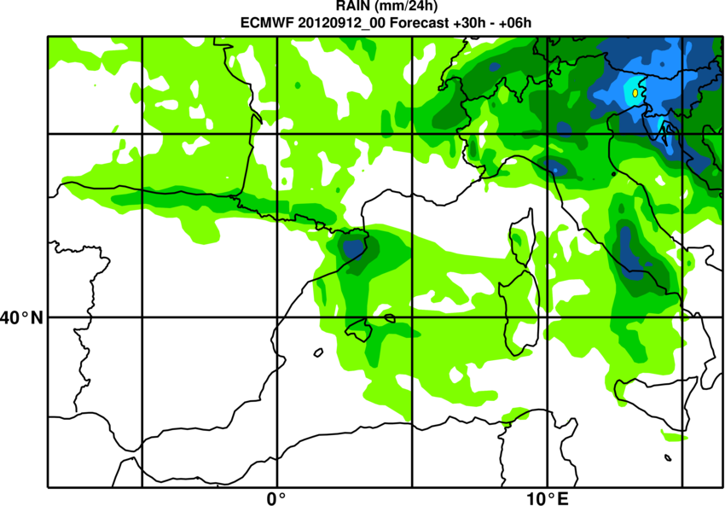
Figure 8. Precipitation forecasts from various models
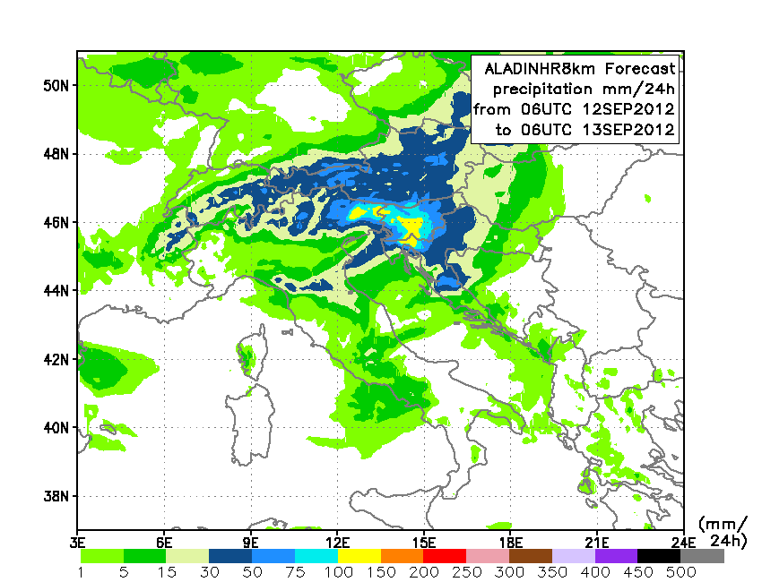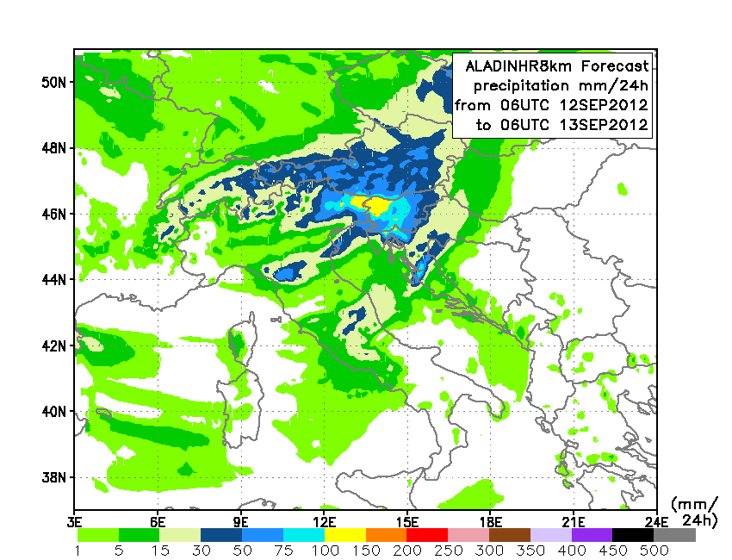
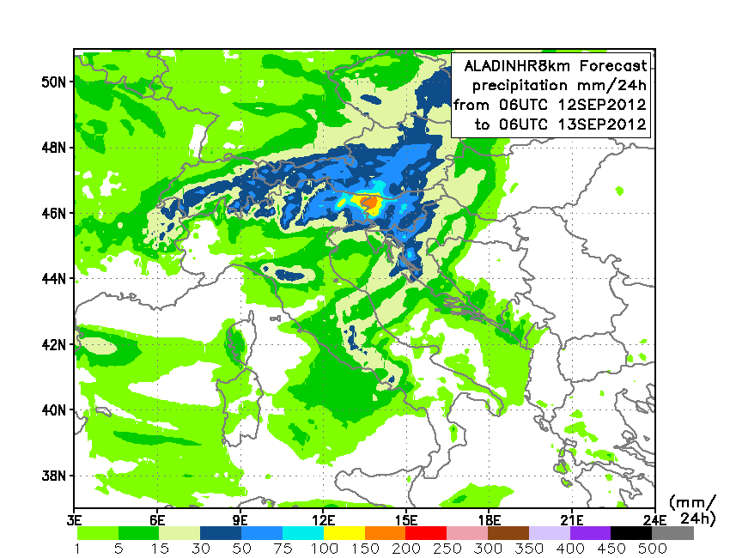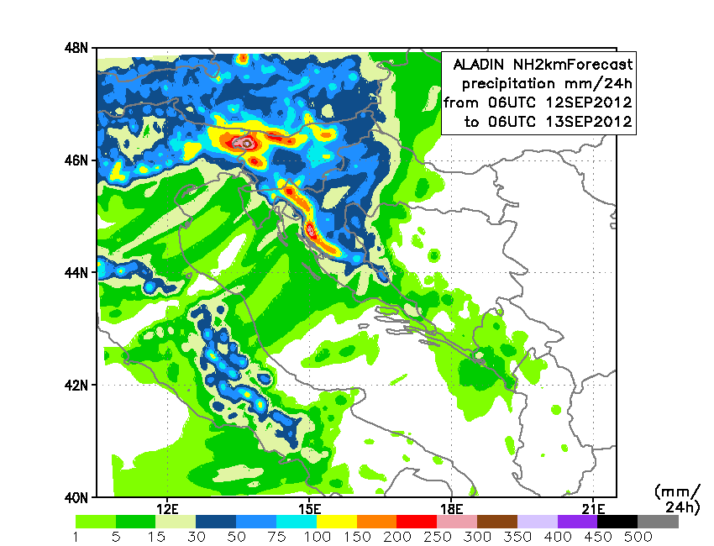
Figure 9. Precipitation forecasts from operational ALADIN.

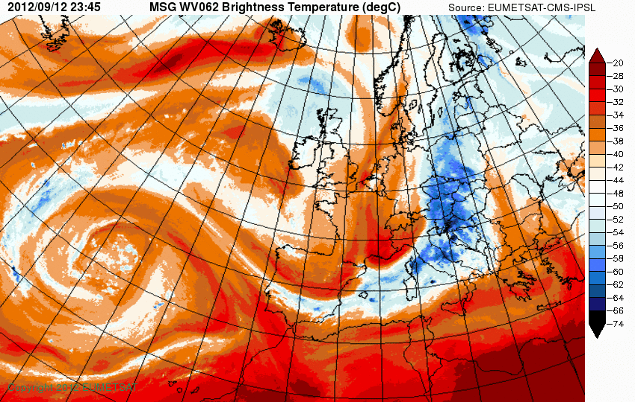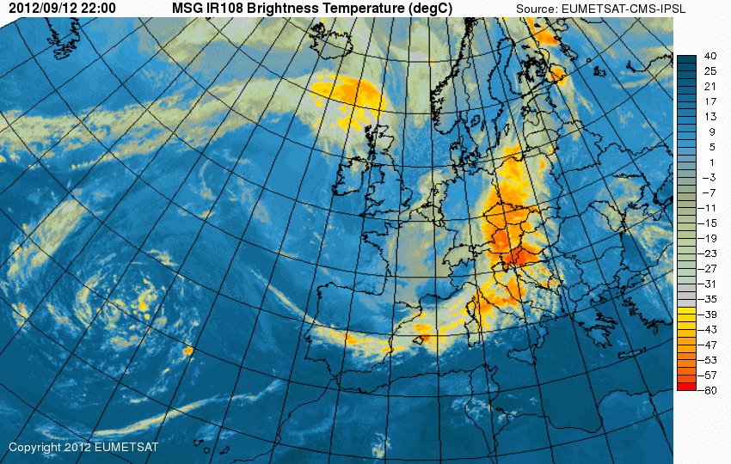
Figure 10.

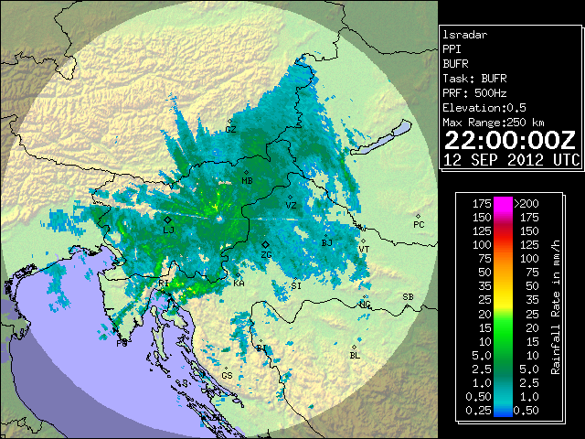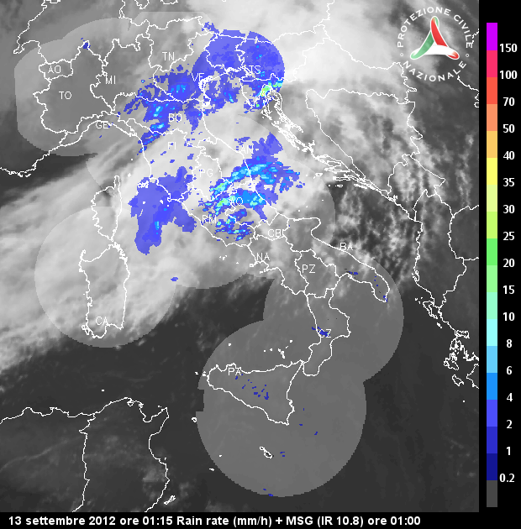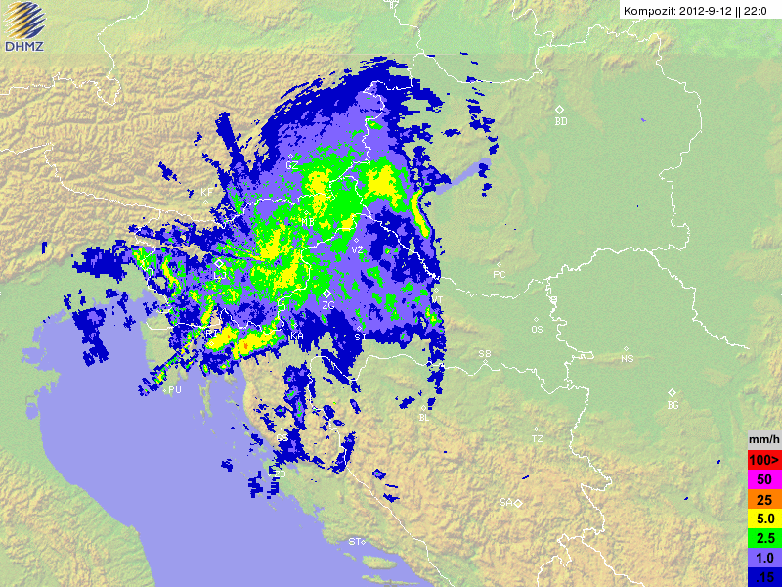
Figure 11. Precipitation intensity estimated using various radars.
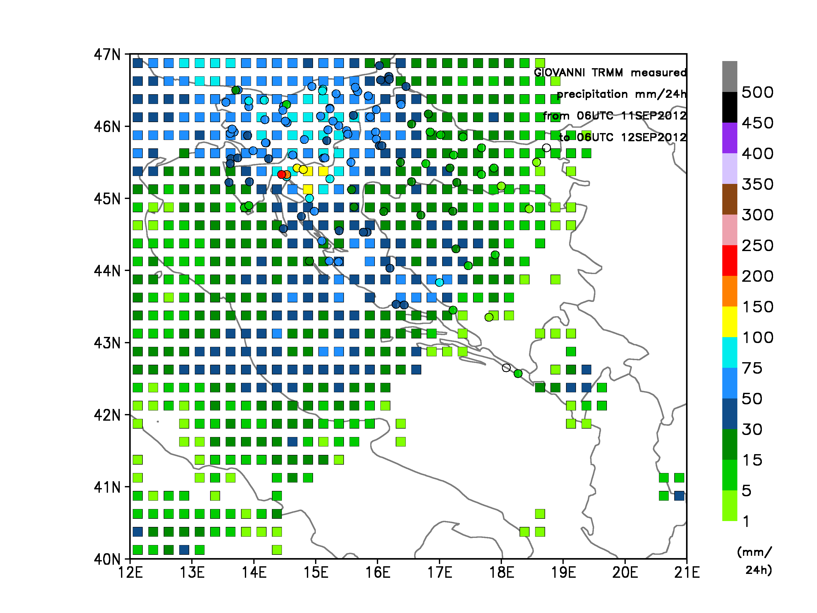

References:

Barthlott, C. and Kirshbaum, D. J. (2013), Sensitivity of deep convection to terrain forcing over Mediterranean islands. Q.J.R. Meteorol. Soc., 139: 1762–1779. doi: 10.1002/qj.2089

Bresson, E., Ducrocq, V., Nuissier, O., Ricard, D. and de Saint-Aubin, C. (2012), Idealized numerical simulations of quasi-stationary convective systems over the Northwestern Mediterranean complex terrain. Q.J.R. Meteorol. Soc., 138: 1751–1763. doi: 10.1002/qj.1911

Brousseau, P., Desroziers, G., Bouttier, F. and Chapnik, B. (2014), A posteriori diagnostics of the impact of observations on the AROME-France convective-scale data assimilation system. Q.J.R. Meteorol. Soc., 140: 982–994. doi: 10.1002/qj.2179

Chaboureau, J.-P., Richard, E., Pinty, J.-P., Flamant, C., Di Girolamo, P., Kiemle, C., Behrendt, A., Chepfer, H., Chiriaco, M. and Wulfmeyer, V. (2011), Long-range transport of Saharan dust and its radiative impact on precipitation forecast: a case study during the Convective and Orographically-induced Precipitation Study (COPS). Q.J.R. Meteorol. Soc., 137, 236–251. doi: 10.1002/qj.719

Drobinski, P., Ducrocq, V., Alpert, P., Anagnostou, E., Béranger, K., Borga, M., Braud, I., Chanzy, A., Davolio, S., Delrieu, G., Estournel, C., Filali Boubrahmi, N., Font, J., Grubišić, V., Gualdi, S., Homar, V., Ivančan-Picek, B., Kottmeier, C., Kotroni, V., Lagouvardos, K., Lionello, P., Llasat, M.C., Ludwig, W., Lutoff, C., Mariotti, A., Richard, E., Romero, R., Rotunno, R., Roussot, O., Ruin, I., Somot, S., Taupier-Letage, I., Tintore, J., Uijlenhoet, R. and Wernli, H. (2014), HyMeX: A 10-Year Multidisciplinary Program on the Mediterranean Water Cycle. Bull. Amer. Meteor. Soc., 95, 1063–1082. doi: http://dx.doi.org/10.1175/BAMS-D-12-00242.1

Ducrocq, V., Braud, I., Davolio, S., Ferretti, R., Flamant, C., Jansa, A., Kalthoff, N., Richard, E., Taupier-Letage, I., Ayral, P.-A., Belamari, S., Berne, A., Borga, M., Boudevillain, B., Bock, O., Boichard, J.-L., Bouin, M.-N., Bousquet, O., Bouvier, C., Chiggiato, J., Cimini, D., Corsmeier, U., Coppola, L., Cocquerez, P., Defer, E., Drobinski, P., Dufournet, Y., Fourrié, N., Gourley, J.J., Labatut, L., Lambert, D., Le Coz, J., Marzano, F.S., Molinié, G., Montani, A., Nord, G., Nuret, M., Ramage, K., Rison, B., Roussot, O., Said, F., Schwarzenboeck, A., Testor, P., Van Baelen, J., Vincendon, B., Aran, M., Tamayo, J., (2013), HyMeX-SOP1, the field campaign dedicated to heavy precipitation and flash flooding in the northwestern Mediterranean. Bull. Amer. Meteor. Soc., 95, 1083-1100. http://dx.doi.org/10.1175/BAMS-D-12-00244.1

Ferretti, R., Pichelli, E., Gentile, S., Maiello, I., Cimini, D., Davolio, S., Miglietta, M.M., Panegrossi, G., Baldini, L., Pasi, F., Marzano, F.S., Zinzi, A., Mariani, S.,Casaioli, M., Bartolini, G., Loglisci, N., Montani, A., Marsigli, C., Manzato, A., Pucillo, A., Ferrario, M.E.,Colaiuda, V., Rotunno, R., (2014), Overview of the first HyMeX special observation period over Italy: observations and model results. Hydrol. Earth Syst. Sci. 18, 1953–1977.

Hally, A., Richard, E. and Ducrocq, V., (2014), An ensemble study of HyMeX IOP6 and IOP7a: sensitivity to physical and initial and boundary condition uncertainties. Nat. Hazards Earth Syst. Sci., 14, 1071-1084.

Hally, A., Richard, E., Fresnay, S. and Lambert, D. (2014), Ensemble simulations with perturbed physical parametrizations: Pre-HyMeX case studies. Q.J.R. Meteorol. Soc., 140: 1900–1916. doi: 10.1002/qj.2257

Manzato, A., Davolio, S., Miglietta, M.M., Pucillo, A. and Setvak, M. (2015), 12 September 2012: A supercell outbreak in NE Italy? Atmospheric Research, 153, 98-118. doi:10.1016/j.atmosres.2014.07.019

Mariani, S., Casaioli, M., Coraci, E. and Malguzzi, P. (2015), A new high-resolution BOLAM-MOLOCH suite for the SIMM forecasting system: assessment over two HyMeX intense observation periods. Nat. Hazards Earth Syst. Sci., 15, 1-24

Pantillon, F., Chaboureau, J.-P. and Richard, E. (2014), Remote impact of North Atlantic hurricanes on the Mediterranean during episodes of intense rainfall in autumn 2012. Q.J.R. Meteorol. Soc.. doi: 10.1002/qj.2419

Rainaud, R., Brossier, C. L., Ducrocq, V., Giordani, H., Nuret, M., Fourrié, N., Bouin, M.-N., Taupier-Letage, I. and Legain, D. (2015), Characterization of air–sea exchanges over the Western Mediterranean Sea during HyMeX SOP1 using the AROME–WMED model. Q.J.R. Meteorol. Soc.. doi: 10.1002/qj.2480

Winschall, A., Pfahl, S., Sodemann, H. and Wernli, H. (2012), Impact of North Atlantic evaporation hot spots on southern Alpine heavy precipitation events. Q.J.R. Meteorol. Soc., 138: 1245–1258. doi: 10.1002/qj.987

Wulfmeyer, V., Behrendt, A., Kottmeier, C., Corsmeier, U., Barthlott, C., Craig, G. C., Hagen, M., Althausen, D., Aoshima, F., Arpagaus, M., Bauer, H.-S., Bennett, L., Blyth, A., Brandau, C., Champollion, C., Crewell, S., Dick, G., Di Girolamo, P., Dorninger, M., Dufournet, Y., Eigenmann, R., Engelmann, R., Flamant, C., Foken, T., Gorgas, T., Grzeschik, M., Handwerker, J., Hauck, C., Höller, H., Junkermann, W., Kalthoff, N., Kiemle, C., Klink, S., König, M., Krauss, L., Long, C. N., Madonna, F., Mobbs, S., Neininger, B., Pal, S., Peters, G., Pigeon, G., Richard, E., Rotach, M. W., Russchenberg, H., Schwitalla, T., Smith, V., Steinacker, R., Trentmann, J., Turner, D. D., van Baelen, J., Vogt, S., Volkert, H., Weckwerth, T., Wernli, H., Wieser, A. and Wirth, M. (2011), The Convective and Orographically-induced Precipitation Study (COPS): the scientific strategy, the field phase, and research highlights. Q.J.R. Meteorol. Soc., 137: 3–30. doi: 10.1002/qj.752

