Operational validation and verification of ALADIN forecast in Meteorological and Hydrological Service of Croatia

Autori: MT, AS, SIS, AB, KH, TK,....

Abstract
The forecast using ALADIN model in Meteorological and Hydrological Service of Croatia is run operationally since July 2000. Over the years, various methods of validation and verification of the operational forecast have been applied. The classical methods using root mean square error, mean absolute error and bias would often penalize the high resolution ALADIN when compared to a low resolution global model forecast due to double penalty paradigm. Therefore, the model was mostly evaluated by direct comparison to the measurements, especially in weather situations that have high impact on the living and traffic conditions in Croatia. Here we show an overview of validation and verification products created operationally.

Introduction

It is important to provide consistent verification information on the Numerical Weather Prediction (NWP) products produced by operational forecast models in order to inform the users of the forecast fields, such as forecasters and to help the research and development team in comparing forecasts computed using different model tunings and improve the forecasts.
The operational model forecast is routinely evaluated, even using automated procedures, in order to provide essential feedback of forecast performance to users and model developers. The model evaluation relies on a range of products, from simple model to data comparison that allows subjective validation as well as detection of specific flaws in the model performance to verification statistics that evaluates the accuracy of the forecasts. Operational monitoring of forecast quality is complemented by in-depth case studies of forecast performance in cases of high impact weather, since prompt and correct forecast of such events has profound benefits for the traffic, safety and society in general. Model evaluation through validation and verification provides a comprehensive understanding of strengths and weaknesses of the forecasting system.
There are several evaluation methods developed within ALADIN and HIRLAM communities that were used for the verification of the operational forecast. The operational forecast fields are sent to a joint LACE center for verification in Ljubljana where the forecasts from 7 counties, members of LACE, are evaluated and their performance compared to other model forecasts.
The methods for verification are further developed. A verification tool developed in ALADIN community, called VERAL was installed in MHS and is used for operational verification as well as testing of new cycles available for operational forecast and various options and tunings before a new model version is introduced to the operational forecast suite. The VERAL program package produces standard deviation, bias and root mean square error of surface variables, such as 2m temperature and relative humidity, mean sea level pressure, wind components as well as wind speed and direction. It also computes the same statistical parameters in vertical-time cross sections for temperature, geopotential height, wind speed and direction and relative humidity on standard isobaric surfaces using vertical soundings available over the model domain.
Recently, HARMONIE verification package has been ported locally. The operational forecast data are also sent to the joint centre for verification using the same package, so this also enables intercomparison of model forecasts from different services (and hence different models, model versions, options, resolutions etc.). This verification package is more advanced and computes more scores when compared to VERAL and offers more flexibility.
Verification is performed using standard GTS data available via global exchange and high‐resolution in‐situ data from the national network (when possible).
It is not yet possible to compute flow dependent scores with a tool available locally. However, forecasts of severe weather are being evaluated through diagnostic studies. Satellite estimates of precipitation are also used to evaluate forecast of precipitation.

The performance of the operational forecast can be monitored on the intranet
http://noa.gric.dhz.hr/~aladinhr/veral-oper-00-06-12-18/HTML-DIR/
where the recent and hystoric products of the VERAL verification package can be accessed. The scores are computed monthly, seasonally and separately for cold/warm part of the year. The scores are computed for both surface and upper air fields, regularly after the period of interest finishes.
The verification products for the operational forecast computed using HARMONIE verification package are also available via intranet on the page
http://noa.gric.dhz.hr/~aladinhr/HARMONIEverif/
where a practical user interface allows a choice in the variable and score to be displayed.
There is a number of potentially useful tools to be implemented, especially for the verification of precipitation. One of them is the SAL method ….
A new verification score, developed by ECMWF is Stable Equitable Error in Probability Space (SEEPS) in order to monitor the long-term trend in the quality of precipitation forecast. The tool evaluates 24 hourly accumulated precipitation against observed precipitation amounts. The precipitation amount is partitioned into three categories: “dry”, “light” and “heavy” precipitation depending on the station climatology. That way, the SEEPS assesses salient features of the local weather and accounts for climate differences between stations.

Model and measured data

The operational ALADIN forecast is run in 8 km resolution since 2000. The domain size increased over the years, the operational model version has been changing, the methods to obtain initial conditions and the global model forecast that is needed for lateral boundary conditions and in 2015, a model set-up run in 4 km resolution has been introduced to run once per day.

The measured data used for validation of model forecast comes from different sources. The in-situ measured data include the hourly SYNOP data and measured data from automatic stations from the operational network in Croatia, and 3 hourly SYNOP measurements from the international exchange. Precipitation is also evaluated a posteriori by comparison to raingauge data from a dense observational network in Croatia (available with delay of several months) and data available from satellite estimates, such as TRMM.

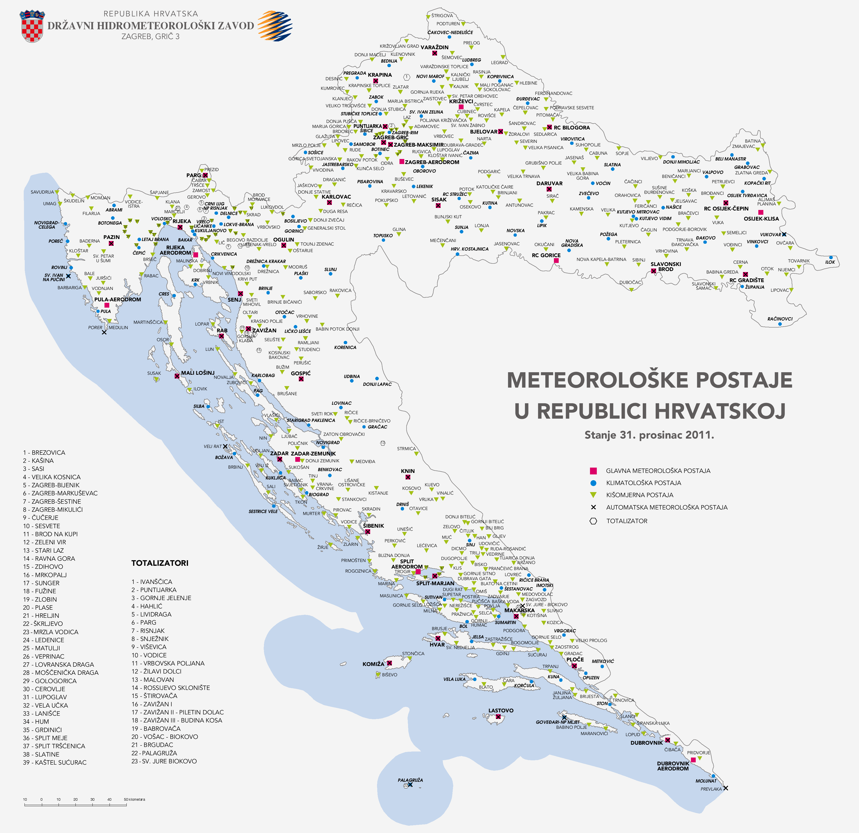
Figure 1. The meteorological observational network in the Republic of Croatia (conditions on 31 December 2011) maintained by MHS, main stations that report measured and observed data with hourly interval (green squares), climatological stations that report measured and observed data three times a day (blue circle), raingauge stations that report precipitation accumulated during previous 24 hours at 6 UTC (green triangle) and automatic stations that report measured data with an interval of 10 minutes (x sign).

Operational products for subjective validation

Every hour, an operational procedure automatically collects raw measured data from SYNOP and automatic stations. The data from SYNOP stations are all aggregated into a single binary file for the whole day, while for each automatic station, a separate binary file is created. These files are used by the GrADS package to plot the evolution of model forecasts and measured values of meteorological parameters for each station in Croatia and chosen SYNOP stations from abroad.

a)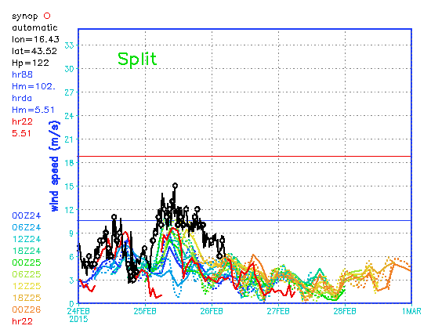b)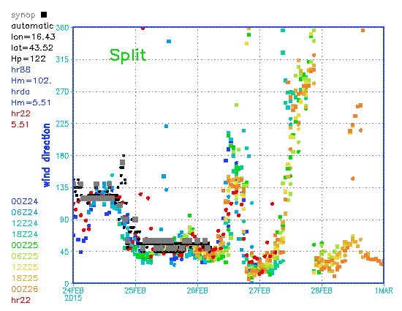c)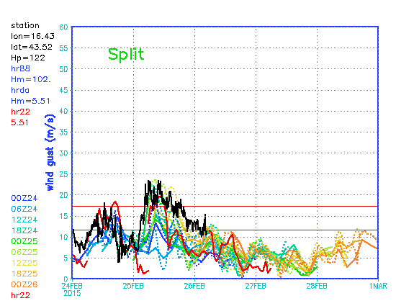
Figure 2. Wind speed on main station Split Marjan (a), direction (b) and gusts (c) as measured by automatic station (black), main station (circles for speed, grey for direction), operational forecasts using Aladin in 8 km resolution starting from different analyses are shown in different colours (full lines for speed, squares for direction), the analyses times are plotted in the same colour on the left, dynamic adaptation of wind field (dotted lines for speed, circles for direction) and 2 km resolution NH forecast (red lines for speed and red circles for direction).

a)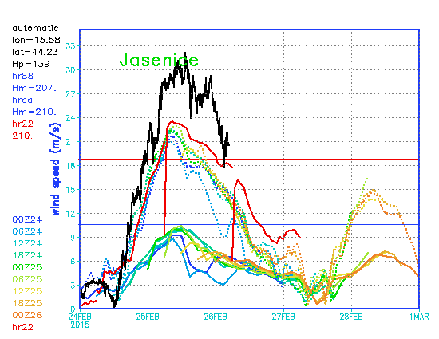b)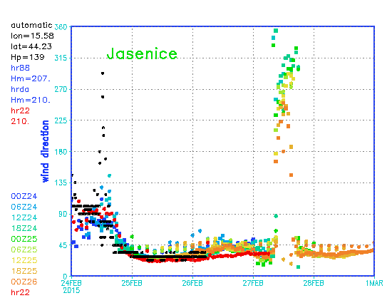c)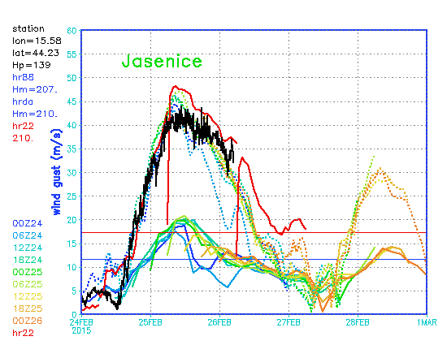
Figure 3. Wind speed on automatic station Jasenice (a), direction (b) and gusts (c) as measured by automatic station (black), operational forecasts using Aladin in 8 km resolution starting from different analyses are shown in different colours (full lines for speed, squares for direction), the analyses times are plotted in the same colour on the left, dynamic adaptation of wind field (dotted lines for speed, circles for direction) and 2 km resolution NH forecast (red lines for speed and red circles for direction).

a)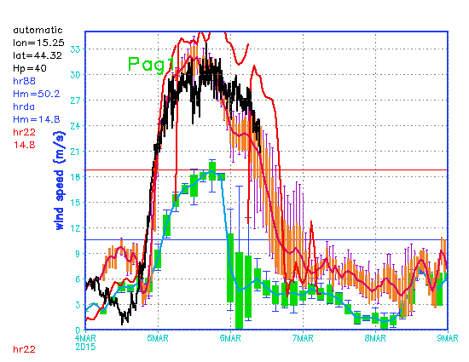b)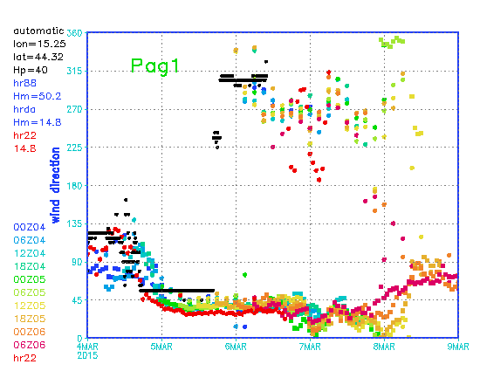 c)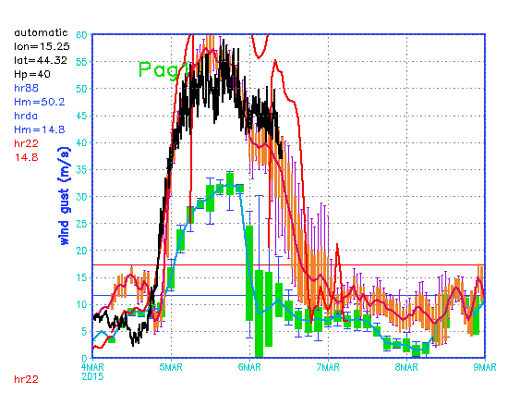
Figure 4. Wind speed on automatic station Pag1 (a), direction (b) and gusts (c) as measured by automatic station (black), operational forecasts using Aladin in 8 km resolution starting from different analyses are shown as an ensemble forecast (full line is average, blue vertical lines minimum and maximum values and green square one standard deviation), dynamic adaptation of wind speed is also shown as an ensemble forecast (full cyan line is average, purple vertical lines minimum and maximum values and orange square one standard deviation) and 2 km resolution NH forecast (red lines for speed and red circles for direction).

a)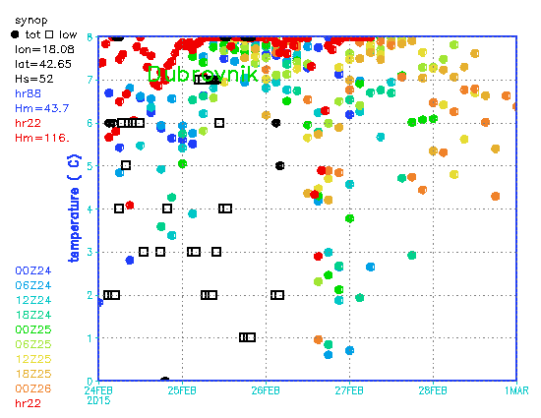 b)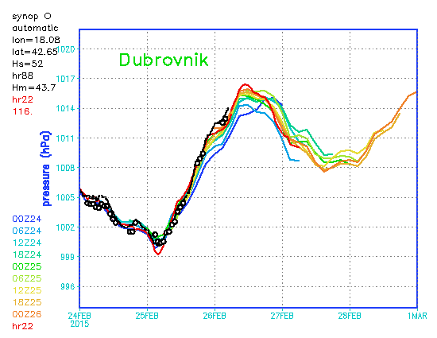 c)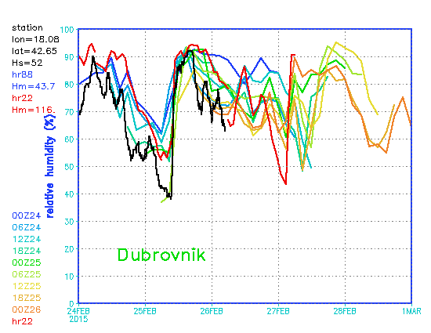 d)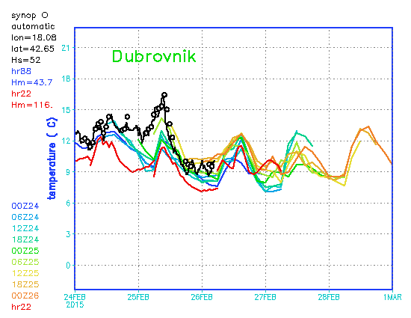
Figure 5. Observed cloudiness (full circle for total and empty square for low clouds) on main station Dubrovnik (a), measured pressure reduced to the mean sea level (b), relative humidity (c), and temperature at 2 meters (d), black circles for data reported in SYNOP, full line for measurements from automatic stations, operational forecasts using Aladin in 8 km resolution starting from different analyses are shown in different colours (full lines for speed, squares for direction), the analyses times are plotted in the same colour on the left, dynamic adaptation of wind field (dotted lines for speed, circles for direction) and 2 km resolution NH forecast (red lines for speed and red circles for direction).

a)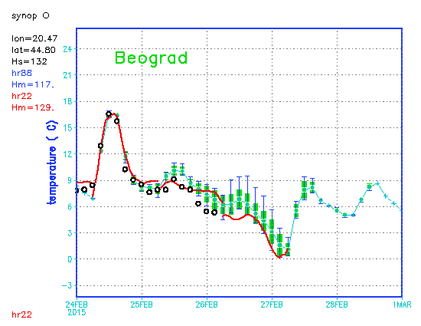 b)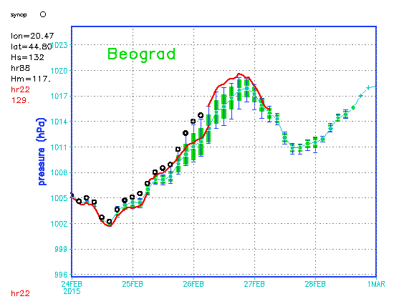 c)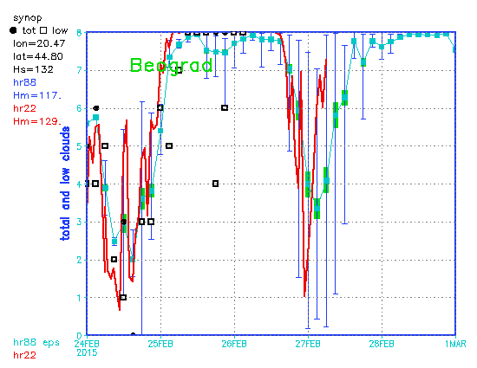 d)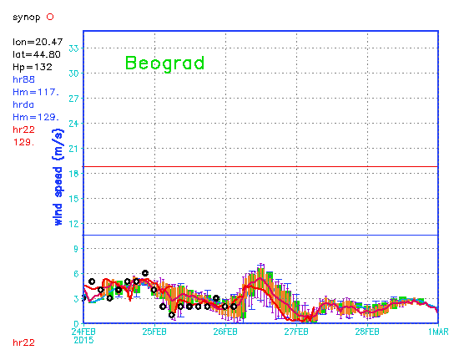 e)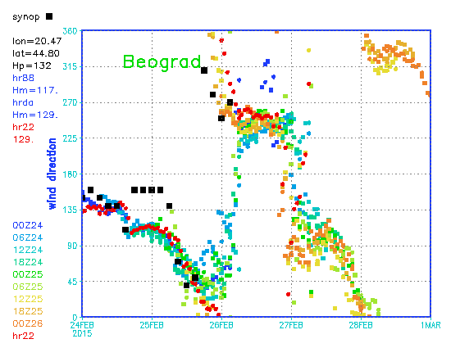
Figure 6. Measured temperature at 2m (black circles) on a station in Belgrade (a), pressure reduced to the mean sea level (b), observed cloudiness (c) full circle for total and empty square for low clouds, wind speed (d), and direction (e), operational forecasts using Aladin in 8 km resolution starting from different analyses are shown as an ensemble forecast (full line is average, blue vertical lines minimum and maximum values and green square one standard deviation), dynamic adaptation of wind speed is also shown as an ensemble forecast (full cyan line is average, purple vertical lines minimum and maximum values and orange square one standard deviation) and 2 km resolution NH forecast (red lines for speed and red circles for direction).

a)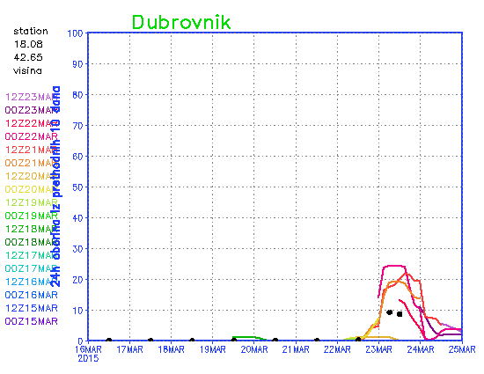 b)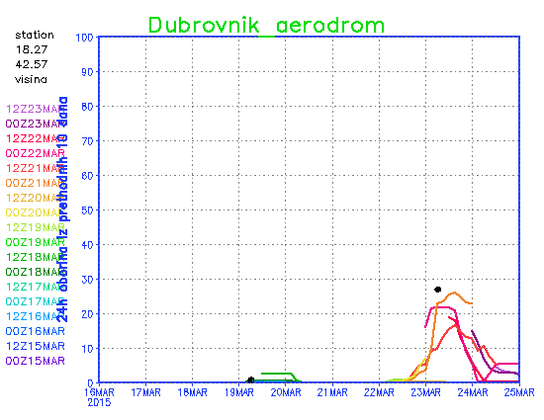 c)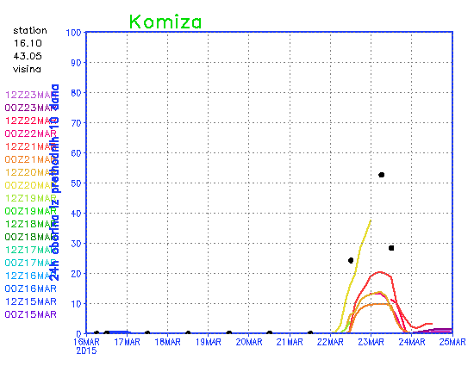 d)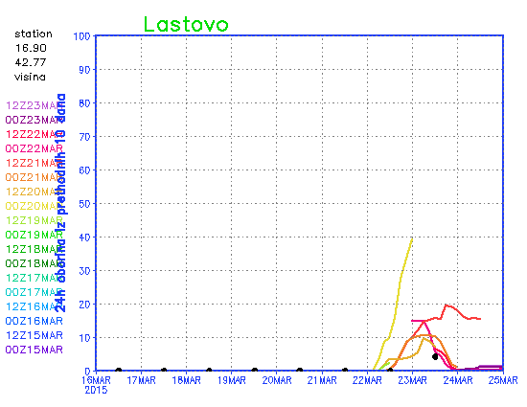 e)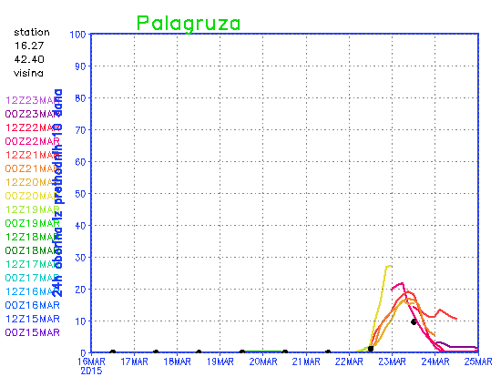
Figure 7. Accumulated precipitation from previous 24 hours for previous 10 days on stations Dubrovnik (a), Dubrovnik airport (b), Komiža (c), Lastovo (d) and Palagruža (e), measured precipitation is shown in black dots, 8km resolution Aladin forecasts starting from different analyses are shown in different colours and the time and date of the analysis is written in the same colour on the left edge of each plot.

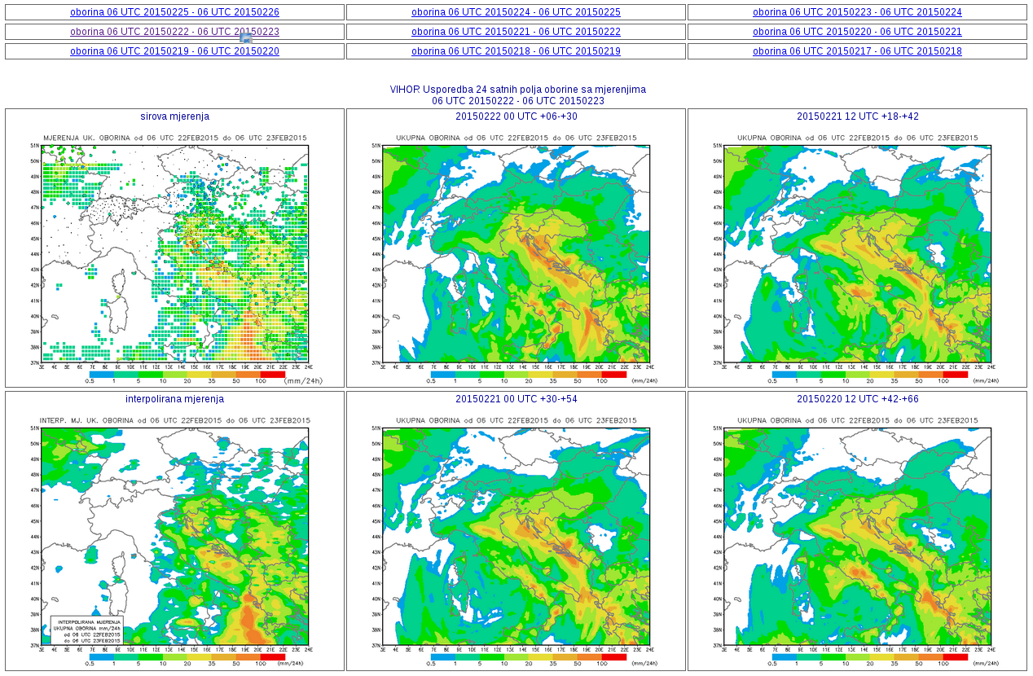
Figure 8. Screenshot of comparison of combination of different measurements and precipitation forecast accumulated during 24 hours for different model runs and forecast times (initial time, start and end of accumulation forecast period are written above figures) for the period from 06 UTC 22 to 06 UTC 23 February 2015 for the whole 8km resolution domain. Upper left figures shows measured precipitation on raingauges as circles and satellite estimate as squares at the point of measurement. Lower left figure shows interpolated measured data.

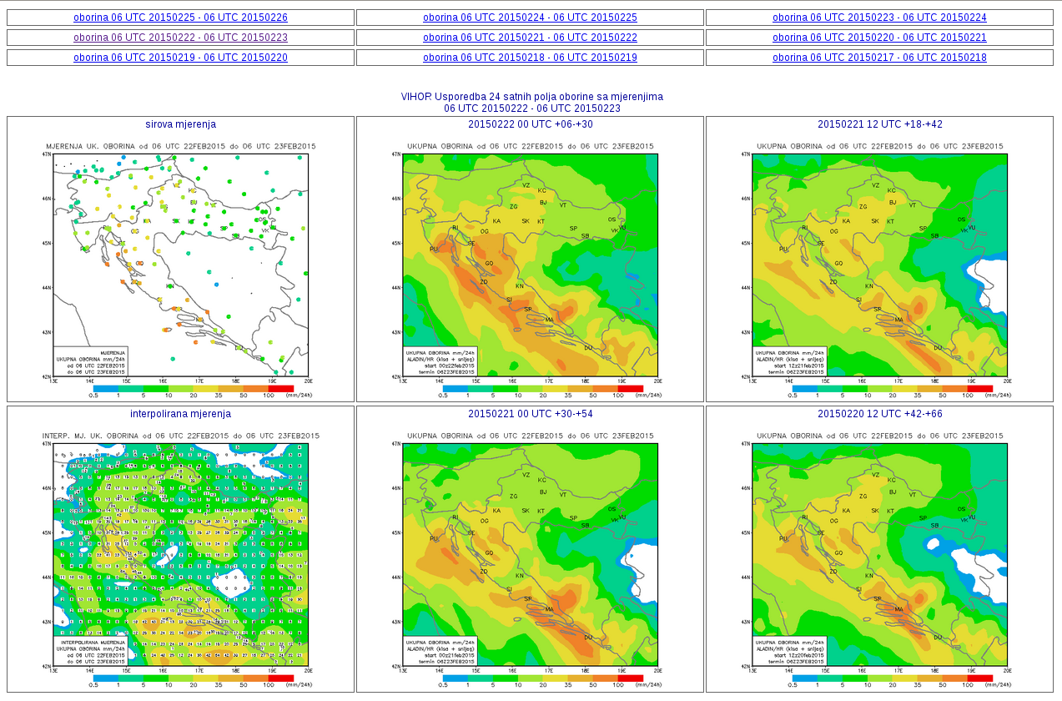
Figure 9. Screenshot of comparison of combination of different measurements and precipitation forecast accumulated during 24 hours for different model runs and forecast times (initial time, start and end of accumulation forecast period are written above figures) for the period from 06 UTC 22 to 06 UTC 23 February 2015, zoomed to Croatia. Upper left figures shows measured precipitation on raingauges as circles and satellite estimate as squares at the point of measurement. Lower left figure shows interpolated measured data and values at points of interpolation.
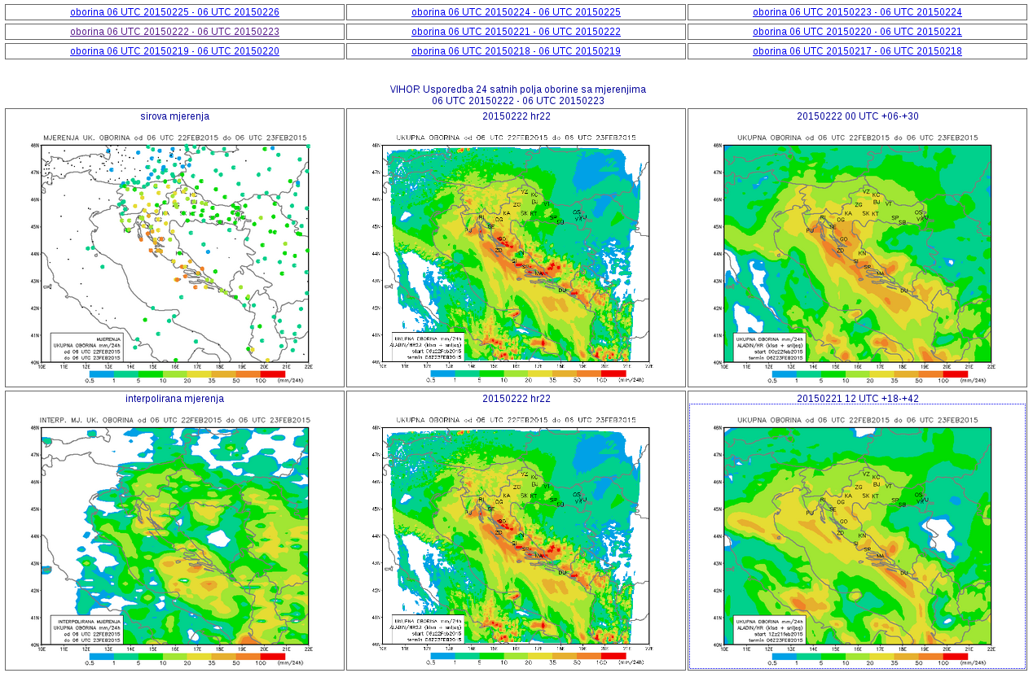
Figure 10. Screenshot of comparison of combination of raingauge measurements and precipitation forecast accumulated during 24 hours for different model runs and forecast times (initial time, start and end of accumulation forecast period are written above figures) for the period from 06 UTC 22 to 06 UTC 23 February 2015 for the whole 8km resolution domain. Upper left figures shows measured precipitation on raingauges as circles and satellite estimate as squares at the point of measurement. Lower left figure shows interpolated measured data. The middle column shows forecast from the 2 km resolution nonhydrostatic run.

Tools for operational objective verification

VERAL verification package

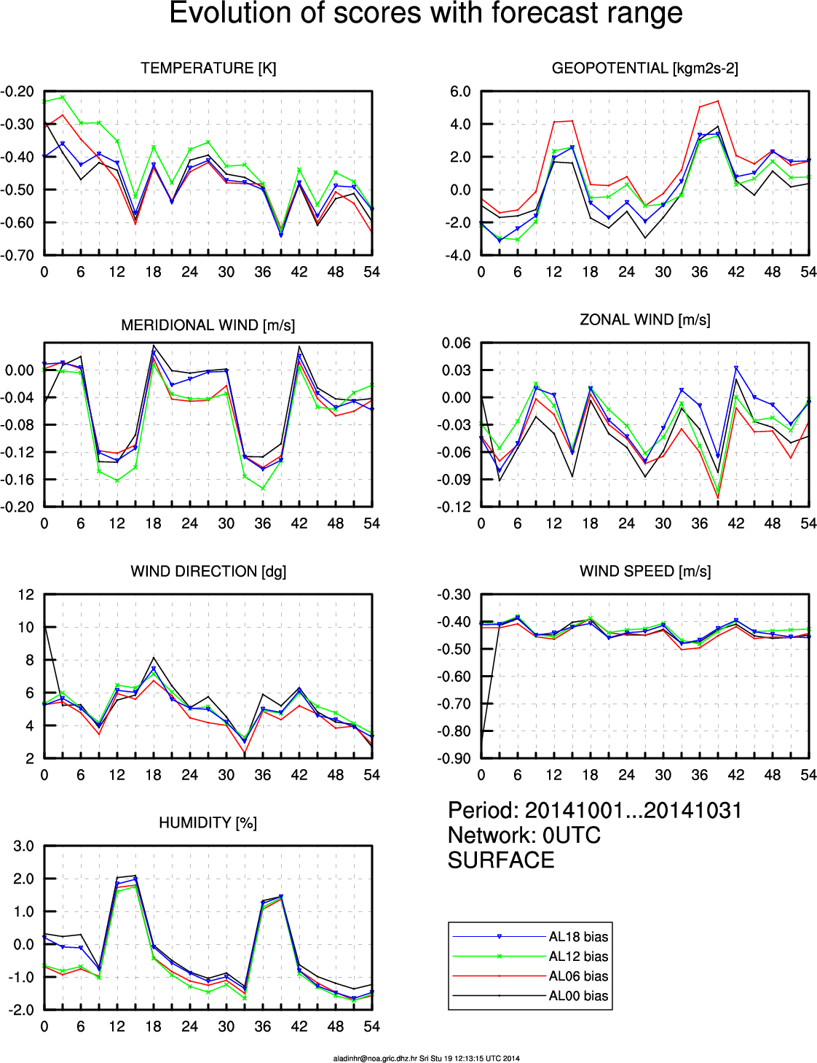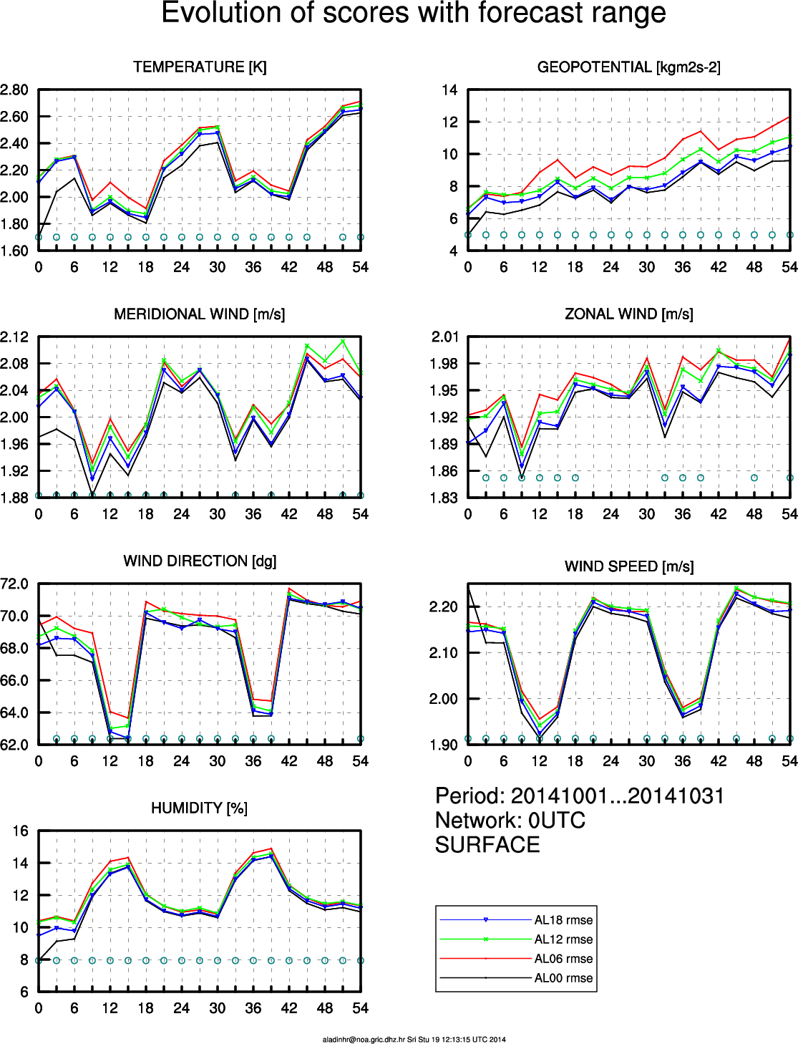
Figure 11. Bias (left) and root mean square error (right) for operational forecast in 8 km resolution initialized at different hours in the day, from 00 (black), 06 (red), 12 (green) and 18 (blue) UTC analyses for temperature (the scale is in Kelvin), mean sea level pressure (titled as geopotential), meridional and zonal wind components (in m/s), wind direction (in degrees) and speed (in m/s) and relative humidity (percent), the scores are computed for all operational forecasts run in for October 2014.

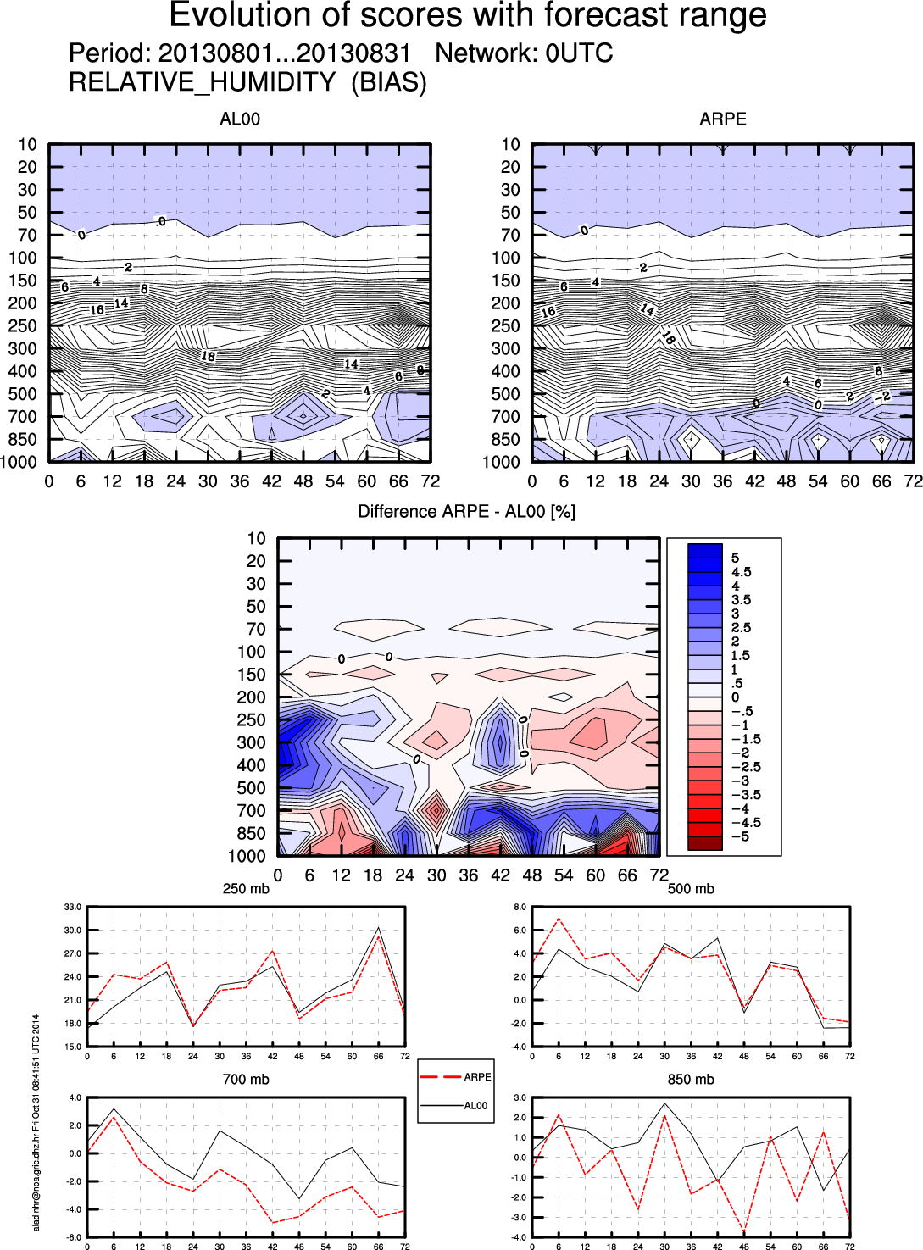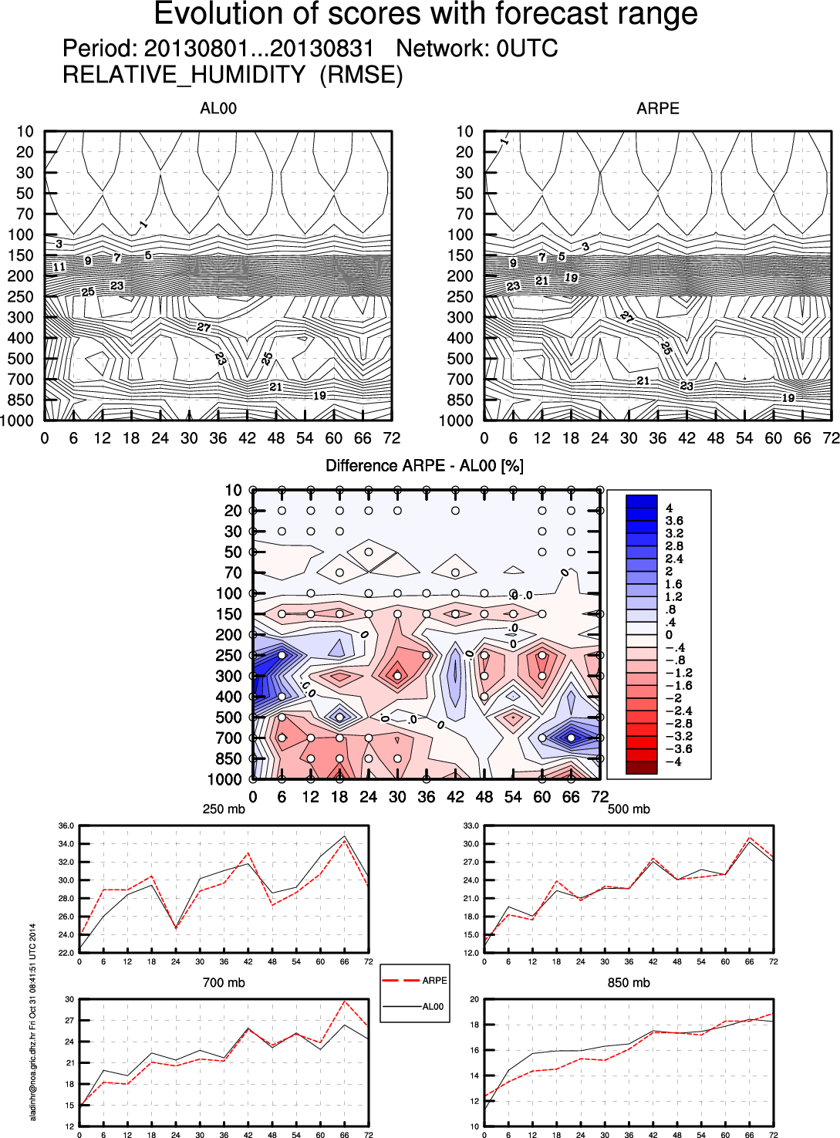
Figure 12. Bias (left) and root mean square error (right) for operational Aladin forecast in 8 km resolution (top left panel and black lines in bottom panels) and Arpege operational forecast (top right panel and red lines in bottom panels) initialized at 00 UTC, the scores are computed for all operational forecasts run in for August 2013 (when operational 8km forecast was coupled to Arpege). Top row shows vertical-time cross section of bias and root mean square error, the panel in the middle shows their difference, the dependence of bias and root mean square error on the forecast hour at different levels in the atmosphere is shown in bottom panels (the pressure on the level is written above the panel).
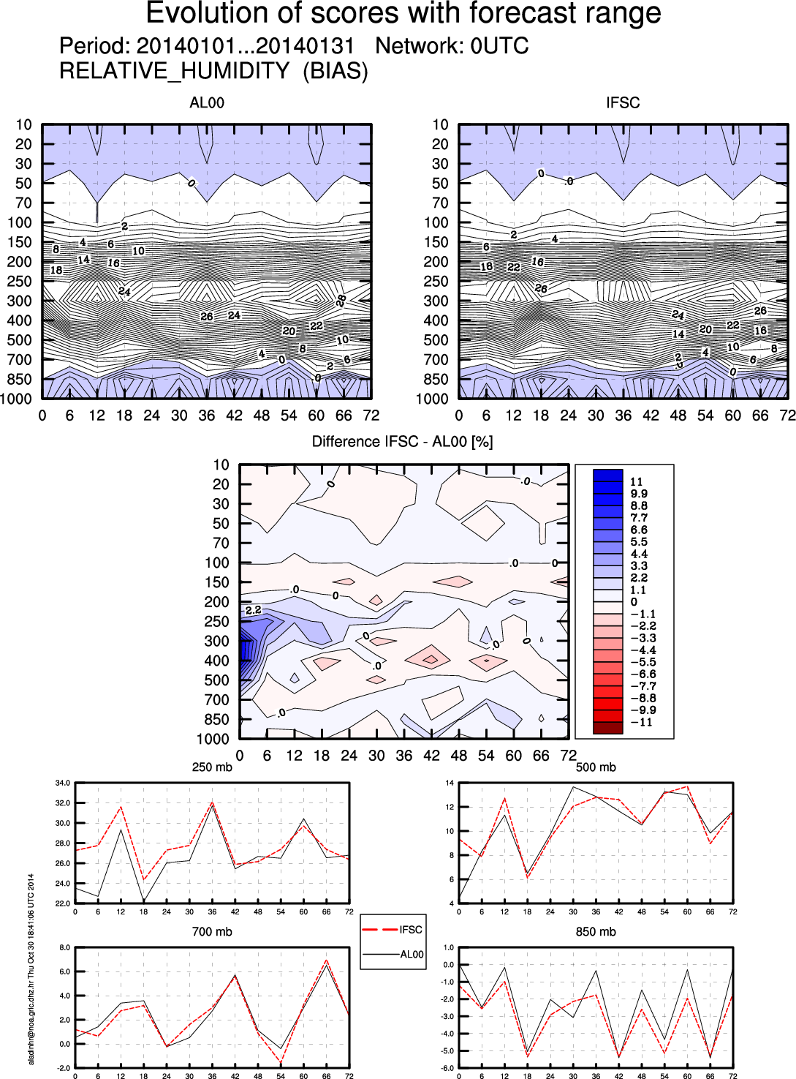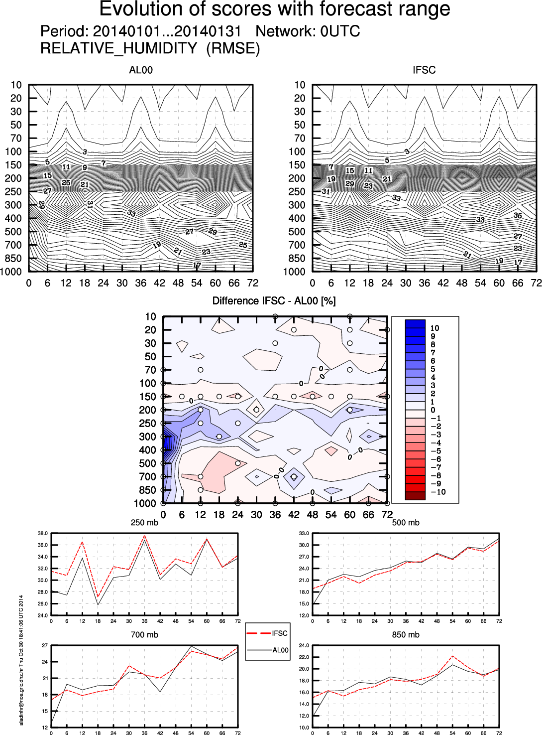
Figure 12. Bias (left) and root mean square error (right) for operational Aladin forecast in 8 km resolution (top left panel and black lines in bottom panels) and IFS operational forecast (top right panel and red lines in bottom panels) initialized at 00 UTC, the scores are computed for all operational forecasts run in for January 2014 (when operational 8km forecast was coupled to IFS). Top row shows vertical-time cross section of bias and root mean square error, the panel in the middle shows their difference, the dependence of bias and root mean square error on the forecast hour at different levels in the atmosphere is shown in bottom panels (the pressure on the level is written above the panel).

HARMONIE verification package

a)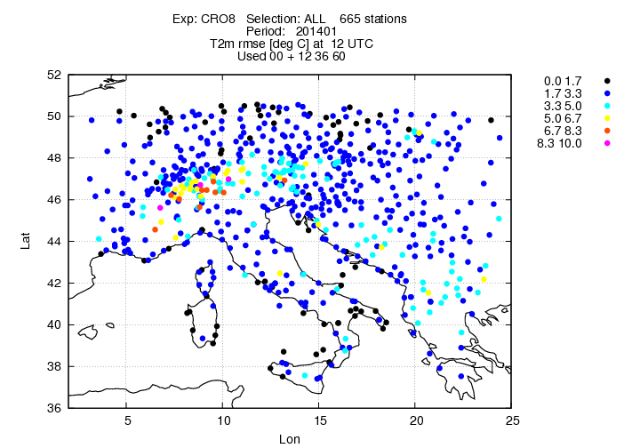 b)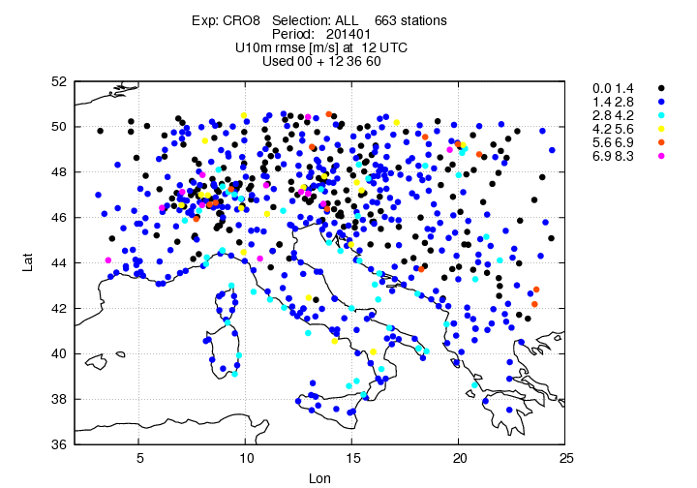

a)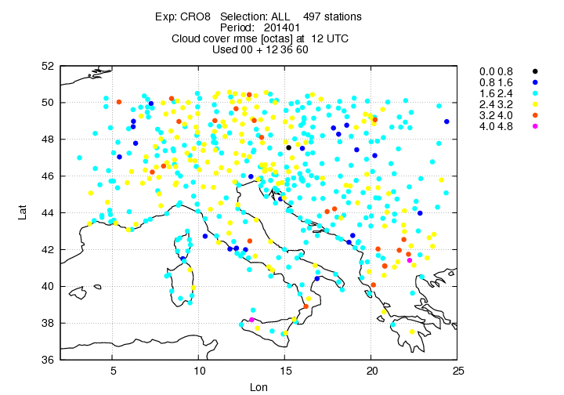 b)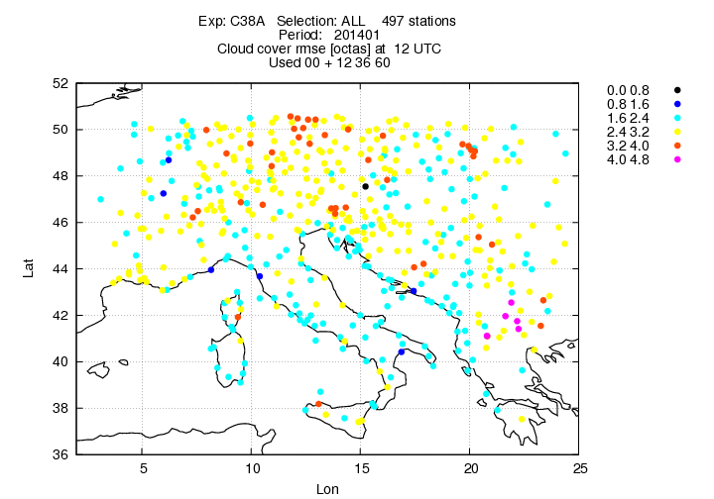

a)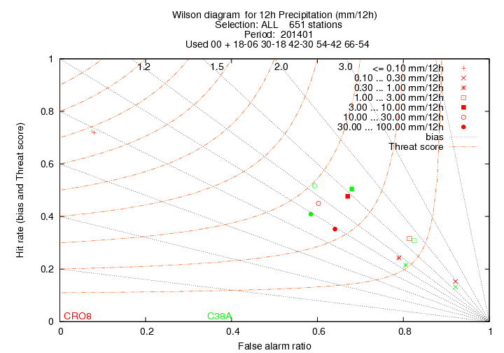 b)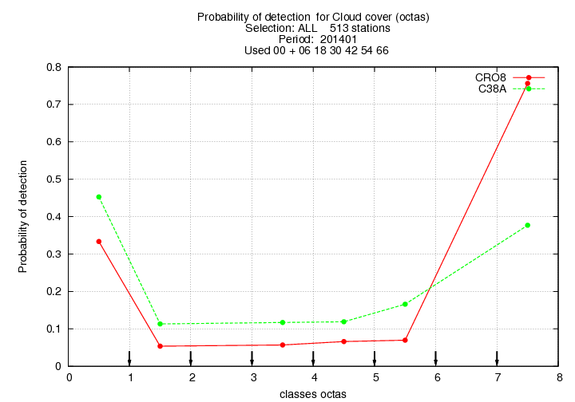

Decomposition of statistical error

Using the forecasts and measurements at stations during the period 2010-2012., we have performed the statistical and spectral evaluation of three tested versions of ALADIN mesoscale NWP model.
Statistical verification included several statistical measures, such as systematic error, mean squared error, mean absolute error and others. The analysis of monthly values of the mean square error from three tested versions of ALADIN mesoscale NWP model on the example of Šibenik station (Fig. 3) has shown that its value for the ALADIN/DADA2 and ALADIN/ALARO2 varies between 1.5ms⁻¹ and 2.5ms⁻¹, depending on the considered month.

The decomposition of the mean squared error on its integral components: the bias of the mean (BM), the bias of the standard deviation (BS) and dispersion or phase error (PHE) shows that the dispersion errors, i.e. phase errors are the main reason for the model error, especially in models of higher resolution. In other words, the analysis indicates that errors in the time of start or end of a certain process, including the creation or disappearance of wind flow, are the main reason for the error in the ALADIN model.

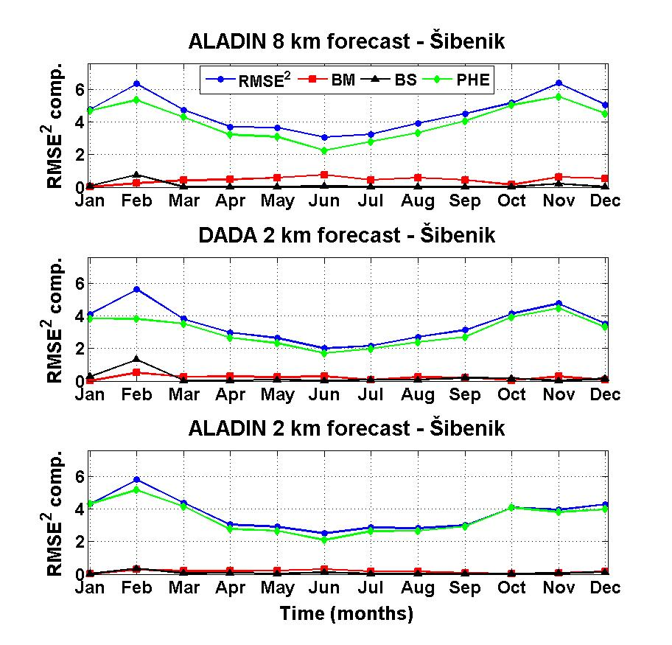
Fig. 3: Decomposition of the mean squared error (MSE) of ALADIN mesoscale NWP model: ALADIN/ALARO8 (upper panel), ALADIN/DADA2 (middle panel) i ALADIN/ALARO2 (lower panel), bias of the mean (BM), bias of the standard deviation (BS) and dispersion error or phase error (PHE). The figure shows squared values of MSE components.
Power spectral density of modelled data (Fig 5.) mostly overestimates measured series (except for Bilogora station) in larger than diurnal part of the spectrum in continental part of Croatia, both for zonal and meridional winds. At majority of continental stations zonal winds seem to be somewhat more energetic than meridional ones. The difference in modelled series arises at scales of 1 day and lower where dynamical adaptation of wind to 2 km and especially ALADIN 8 km start to rapidly lose its energy. Majority of stations have pronounced diurnal and semi-diurnal peaks, and some false peaks appear at lower scales of modelled spectra.

In coastal part of Croatia we have somewhat more complicated behaviour. All types of modelled spectra reasonably well correspond to measured ones at lower than diurnal spectral range, while only non-hydrostatic run at 2 km is good enough at lower scales. At bora dominated stations, such as Jasenice, spectra of cross- and along-mountain components from ALADIN 8 km forecasts severely underestimate those of measurements. The non-hydrostatic forecast 2 km spectra significantly overestimate longer than diurnal parts of both components spectra, but show adequate behaviour at lower scales, while the opposite stands for dynamical adaptation 2 km forecasts. At other stations, cross-mountain component spectra show similar characteristics as those at bora like stations, while along-mountain component spectra are simulated reasonably well (except ALADIN 8 km).

Spectral verification

Spectral verification is performed by spectral decomposition in wave-number and frequency domains. In this paper the example of the spectral verification in frequency domain will be shown. Such spectral decomposition provides an information on the performance of the model in simulating the processes of certain time scales or a certain range of time scales at specific location and it is useful for the physical interpretation of the results.

Power spectral density functions depending on frequency (period) are shown on Fig. 4. Results of the ALADIN/ALARO8 model show the largest departures from the measurements for all scales of motions, other than daily. The total variability of wind energy is undervalued for longer mesoscale, synoptic motions, as well as for subdiurnal motions.

Results of the ALADIN/DADA2 model have been improved primarily for the NE-SW cross-mountain wind component in the direction of bora wind, while for the NW-SE along-mountain component there are no major differences in comparison to the performance of ALADIN/ALARO8 model. The smallest deviations from the measurements are given by the ALADIN/ALARO2 model which accurately simulates the spectral energy density at all time scales, other than those of a few hours. Therefore, these results suggest that the use of ALADIN/ALARO2 model has a potential to improve the results and accuracy of the weather or wind forecasts in the area.

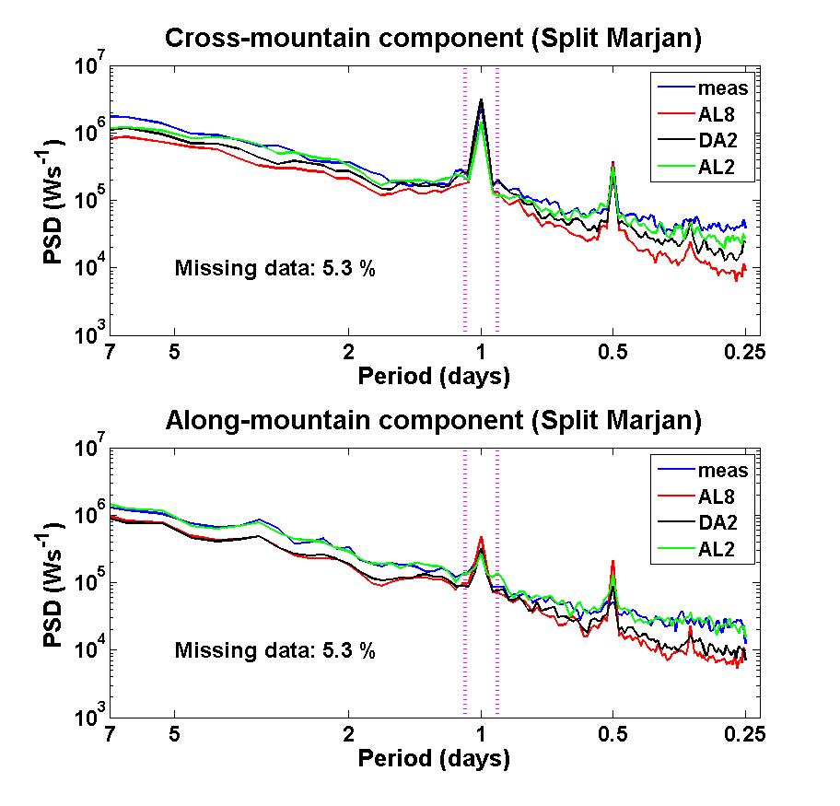
Fig. 4: Spectral decomposition of ALADIN/ALARO8, ALADIN/DADA2 and ALADIN/ALARO2 models and measurements at Split station in the period 2010-2012. for the components in the NE-SW (upper panel) and NW-SE (lower panel) directions.

a)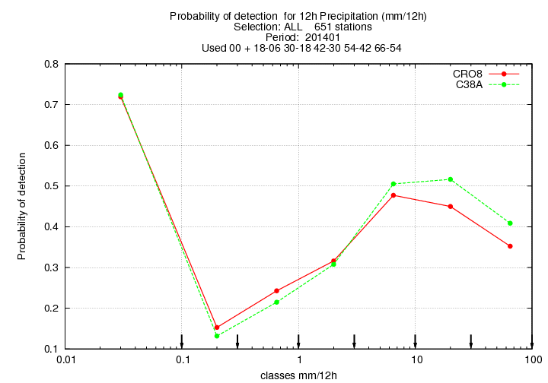 b)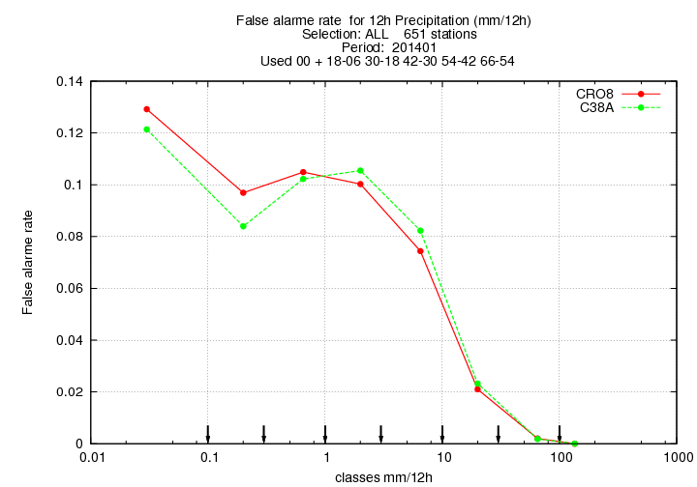

Literature

Haiden, T., M. Rodwell, D. Richardson, A. Okagaki, T. Robinson, and T. Hewson, 2012: Intercomparison of global model precipitation forecast skill in 2010/11 using the SEEPS score. Mon. Wea. Rev., 140, 2720-2733. (Also available as ECMWF Technical Memorandum 665)
Rodwell, M. J., Richardson, D.S., Hewson, T.D. and Haiden, T., 2010. A new equitable score suitable for verifying precipitation in numerical weather prediction. Q.J.R.Meteorol. Soc, 136, 1344-1363. (Also available as ECMWF Technical Memorandum 615)

